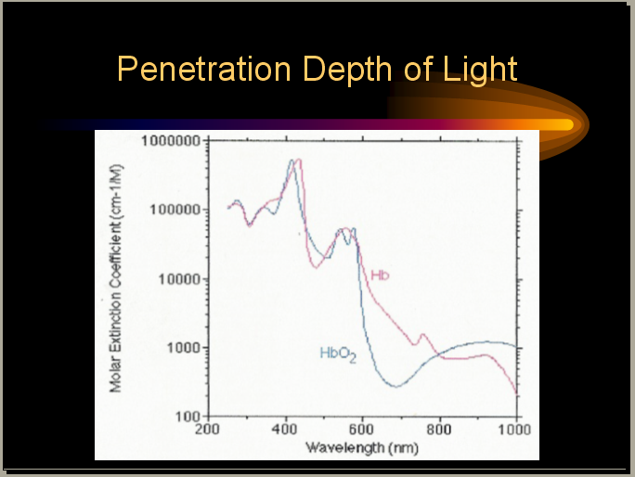

Figure 1
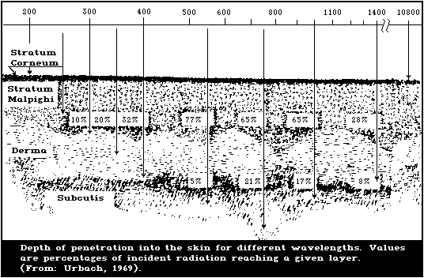
Figure 2
Looking at Fig. 2, it looks like, at 1400nm, 8% makes down to the fat layer and 28% stays in the epidermis (wonder what happens to the rest). Since the capillary bed is in the dermis, why do we get only less than 1% blood signal and 99% ISF signal?

The 3 skin layers: epidermis, dermis, subcutaneous fat

The skin is made up of three distinct layers.
The top layer is called the epidermis. (The word epidermis, and the name of the other main skin layer, the dermis, both come from the name used by the ancient Greeks for the skin, derma. From this we also get the word dermatologist, meaning a doctor who specialises in skin problems.)
The epidermis is translucent. That is, it allows light to pass partially through it, rather as frosted glass does. The epidermis does not contain any blood vessels but gets its oxygen and nutrients from the deeper layers of the skin.
At the bottom of the epidermis is a very thin membrane, called the basement membrane, which attaches the epidermis firmly, though not rigidly, to the layer below.
The second layer lies deeper and is called the dermis. It contains blood vessels, nerves, hair roots and sweat glands.
Below the dermis lies a layer of fat, the subcutaneous fat. The depth of this layer differs from one person to another. It contains larger blood vessels and nerves, and is made up of clumps of fat-filled cells called adipose cells.
The subcutaneous fat lies on the muscles and bones, to which the whole skin structure is attached by connective tissues. The attachment is quite loose, so the skin can move fairly freely. If the subcutaneous tissues fill up with too much fat the
areas of attachment become more obvious and the skin cannot move as easily -this is what gives rise to the notorious cellulite (see pages 32 and 34).
The junction between the epidermis and the dermis is not straight but undulates like rolling hills - more markedly so in some areas of the body than others. A series of finger-like structures called rete pegs project up from the dermis, and similar structures project down from the epidermis. These projections increase the area of contact between the layers of skin, and help to prevent the epidermis from being sheared off. They are not present in the skins of unborn babies but rapidly develop after birth, and are very noticeable in a young person's skin when it is examined under the microscope. As skin ages they get smaller and flatter.
Networks of tiny blood vessels run through the rete pegs, bringing food, vitamins and oxygen to the epidermis. In pale people these vessels can be seen through the epidermis, particularly if the veins widen (so-called 'broken veins'). If the blood carries plenty of oxygen it will be pink and the skin will tend to have a rosy color. If the blood is running sluggishly and has lost most of its oxygen the skin will look bluer. These blood vessels respond to temperature changes. They open up in hot weather, bringing lots of red blood cells - and hence a pink flush -to the skin, and close down in the cold; this is why cold skin often looks blue.

In most areas of the body the epidermis is only 35-50 micrometres thick. (A micrometre is one-millionth of a metre - one-thousandth of a millimetre.) On the palms and the soles it is usually much thicker, up to several millimetres. In the area around the eye it is only about 20 micrometres thick. This helps to explain why the skin around the eye is so very sensitive: irritating substances have to penetrate the epidermis before they can affect the underlying skin, so the thinner the epidermis the less resistant to irritants it will tend to be.
The epidermis around the eye is not only very thin, it also contains many blood vessels; so therefore the dermal/blood vessels below show through the epidermis. Dark undereye 'circles' or dark shadows under the eyes are possibly due to slow blood flow and the resulting build-up of lymph. This may also account for puffy eyes' "morning after" look.

I am not sure if we ever considered probing the area around the eye. It sounds promising in getting more blood signal and less ISF.

The epidermis
All the cells in the epidermis originate ultimately from a single layer of basal cells, called the basal layer, which sits on the basement membrane. The 'daughter cells' produced by this basal layer gradually move upwards, lose their central nucleus, and start to produce skin proteins called keratins (hair is made up of a similar, but harder, material) and fats called lipids. They are now known as keratinocytes. As they move upwards through the skin thickness their form slowly changes. The altered cells form distinct layers, which naturally blend into each other.
As the cells rise into the top layer of the epidermis - the stratum corneum, sometimes called the horny layer or the cornified layer - they take the form of flattened discs, tightly packed together. These flattened cells, now called corneocytes, are effectively dead. The number of layers of cells in the stratum corneum depends on the site on the body; on the sole of the foot the stratum corneum is at its thickest, and is there made up of hundreds of layers of densely packed cells.
The stratum corneum acts as an outer 'covering' to the skin, able to resist scrapes and scratches on the outside and helping to keep water on the inside. In this respect it is rather like the bark of a tree.
Sections of the epidermis, compared: (top) aged 18, (bottom) aged 80. The reasons why the epidermis changes throughout life are discussed in Chapter 4, 'Skin and aging'.

http://www.pg.com/science/skincare/Skin_tws_10.htm

Near-Infrared Reflectance Spectroscopy for Noninvasive Monitoring of Metabolites

Author(s): H. Michael Heise | Andreas Bittner | Ralf Marbach
doi: 10.1515/CCLM.2000.021

View PDF article (266K)
Clinical Chemistry and Laboratory Medicine

Print ISSN: 1434-6621 | CODEN: CCLMFW
Volume: 38 | Issue: 2
Cover date: February 2000
Page(s): 137-145

An important class of substances in clinical chemistry are metabolites in body fluids, which are accessible by near-infrared spectroscopy without sample treatment using reagentless, fast and readily automated in vitro assays. Furthermore, noninvasive sensing systems are under development for the determination of blood glucose, especially for diabetic patients or for monitoring in intensive care and surgery. Near-infrared diffuse reflectance spectrometry of skin was employed allowing a certain tissue volume to be integrally probed. For calibration, the partial least-squares (PLS) algorithm was used either based on wide spectral intervals or using special spectral variable selection. Capillary blood glucose reference concentrations were obtained by finger pricking and an automated laboratory method (hexokinase/G6P-DH). Clear evidence is provided for the physical effect, as manifested by the spectral glucose absorptivities, underlying the individual single-person calibration models, which still require improvements in the methodology in the normo- and hypoglycemic concentration range. In extending the potential of noninvasive blood assays by infrared spectroscopy, a novel technique is presented for probing the intravascular fluid space by using fast spectral near-infrared measurements of skin tissue. The pulsatile blood spectrum can be derived from reflectance spectra of oral mucosa by Fourier analysis (near-infrared plethysmography). Future applications and prospects for noninvasive blood assays are discussed.

This was published in 2002. I owe to ask Ralf about this. I thought looking at “pulsatile blood spectrum” was over for him. I’d like to read the whole article.

http://www.extenza-eps.com/extenza/loadHTML?objectIDValue=49158&type=abstract

NIR radiation between 800 and 1100 nm is known to penetrate deeply into organic
... Marbach also mentions that interaction of NIR radiation and skin at ...
- Similar pages
http://www.blackwell-synergy.com/links/ doi/10.1111/j.1600-0846.2004.00078.x/abs/
F Faris et al 1991 Clin. Phys. Physiol. Meas. 12 353-358

