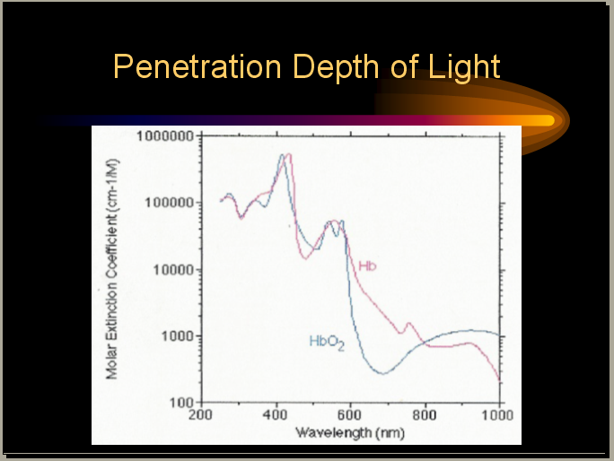

Figure 1
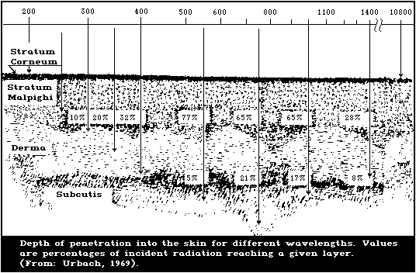
Figure 2
Looking at Fig. 2, it looks like, at 1400nm, 8% makes down to the fat layer and 28% stays in the epidermis (wonder what happens to the rest). Since the capillary bed is in the dermis, why do we get only less than 1% blood signal and 99% ISF signal?

The 3 skin layers: epidermis, dermis, subcutaneous fat

The skin is made up of three distinct layers.
The top layer is called the epidermis. (The word epidermis, and the name of the other main skin layer, the dermis, both come from the name used by the ancient Greeks for the skin, derma. From this we also get the word dermatologist, meaning a doctor who specialises in skin problems.)
The epidermis is translucent. That is, it allows light to pass partially through it, rather as frosted glass does. The epidermis does not contain any blood vessels but gets its oxygen and nutrients from the deeper layers of the skin.
At the bottom of the epidermis is a very thin membrane, called the basement membrane, which attaches the epidermis firmly, though not rigidly, to the layer below.
The second layer lies deeper and is called the dermis. It contains blood vessels, nerves, hair roots and sweat glands.
Below the dermis lies a layer of fat, the subcutaneous fat. The depth of this layer differs from one person to another. It contains larger blood vessels and nerves, and is made up of clumps of fat-filled cells called adipose cells.
The subcutaneous fat lies on the muscles and bones, to which the whole skin structure is attached by connective tissues. The attachment is quite loose, so the skin can move fairly freely. If the subcutaneous tissues fill up with too much fat the
areas of attachment become more obvious and the skin cannot move as easily -this is what gives rise to the notorious cellulite (see pages 32 and 34).
The junction between the epidermis and the dermis is not straight but undulates like rolling hills - more markedly so in some areas of the body than others. A series of finger-like structures called rete pegs project up from the dermis, and similar structures project down from the epidermis. These projections increase the area of contact between the layers of skin, and help to prevent the epidermis from being sheared off. They are not present in the skins of unborn babies but rapidly develop after birth, and are very noticeable in a young person's skin when it is examined under the microscope. As skin ages they get smaller and flatter.
Networks of tiny blood vessels run through the rete pegs, bringing food, vitamins and oxygen to the epidermis. In pale people these vessels can be seen through the epidermis, particularly if the veins widen (so-called 'broken veins'). If the blood carries plenty of oxygen it will be pink and the skin will tend to have a rosy color. If the blood is running sluggishly and has lost most of its oxygen the skin will look bluer. These blood vessels respond to temperature changes. They open up in hot weather, bringing lots of red blood cells - and hence a pink flush -to the skin, and close down in the cold; this is why cold skin often looks blue.

In most areas of the body the epidermis is only 35-50 micrometres thick. (A micrometre is one-millionth of a metre - one-thousandth of a millimetre.) On the palms and the soles it is usually much thicker, up to several millimetres. In the area around the eye it is only about 20 micrometres thick. This helps to explain why the skin around the eye is so very sensitive: irritating substances have to penetrate the epidermis before they can affect the underlying skin, so the thinner the epidermis the less resistant to irritants it will tend to be.
The epidermis around the eye is not only very thin, it also contains many blood vessels; so therefore the dermal/blood vessels below show through the epidermis. Dark undereye 'circles' or dark shadows under the eyes are possibly due to slow blood flow and the resulting build-up of lymph. This may also account for puffy eyes' "morning after" look.

I am not sure if we ever considered probing the area around the eye. It sounds promising in getting more blood signal and less ISF.

The epidermis
All the cells in the epidermis originate ultimately from a single layer of basal cells, called the basal layer, which sits on the basement membrane. The 'daughter cells' produced by this basal layer gradually move upwards, lose their central nucleus, and start to produce skin proteins called keratins (hair is made up of a similar, but harder, material) and fats called lipids. They are now known as keratinocytes. As they move upwards through the skin thickness their form slowly changes. The altered cells form distinct layers, which naturally blend into each other.
As the cells rise into the top layer of the epidermis - the stratum corneum, sometimes called the horny layer or the cornified layer - they take the form of flattened discs, tightly packed together. These flattened cells, now called corneocytes, are effectively dead. The number of layers of cells in the stratum corneum depends on the site on the body; on the sole of the foot the stratum corneum is at its thickest, and is there made up of hundreds of layers of densely packed cells.
The stratum corneum acts as an outer 'covering' to the skin, able to resist scrapes and scratches on the outside and helping to keep water on the inside. In this respect it is rather like the bark of a tree.
Sections of the epidermis, compared: (top) aged 18, (bottom) aged 80. The reasons why the epidermis changes throughout life are discussed in Chapter 4, 'Skin and aging'.

http://www.pg.com/science/skincare/Skin_tws_10.htm

Near-Infrared Reflectance Spectroscopy for Noninvasive Monitoring of Metabolites

Author(s): H. Michael Heise | Andreas Bittner | Ralf Marbach
doi: 10.1515/CCLM.2000.021

View PDF article (266K)
Clinical Chemistry and Laboratory Medicine

Print ISSN: 1434-6621 | CODEN: CCLMFW
Volume: 38 | Issue: 2
Cover date: February 2000
Page(s): 137-145

An important class of substances in clinical chemistry are metabolites in body fluids, which are accessible by near-infrared spectroscopy without sample treatment using reagentless, fast and readily automated in vitro assays. Furthermore, noninvasive sensing systems are under development for the determination of blood glucose, especially for diabetic patients or for monitoring in intensive care and surgery. Near-infrared diffuse reflectance spectrometry of skin was employed allowing a certain tissue volume to be integrally probed. For calibration, the partial least-squares (PLS) algorithm was used either based on wide spectral intervals or using special spectral variable selection. Capillary blood glucose reference concentrations were obtained by finger pricking and an automated laboratory method (hexokinase/G6P-DH). Clear evidence is provided for the physical effect, as manifested by the spectral glucose absorptivities, underlying the individual single-person calibration models, which still require improvements in the methodology in the normo- and hypoglycemic concentration range. In extending the potential of noninvasive blood assays by infrared spectroscopy, a novel technique is presented for probing the intravascular fluid space by using fast spectral near-infrared measurements of skin tissue. The pulsatile blood spectrum can be derived from reflectance spectra of oral mucosa by Fourier analysis (near-infrared plethysmography). Future applications and prospects for noninvasive blood assays are discussed.

This was published in 2002. I owe to ask Ralf about this. I thought looking at “pulsatile blood spectrum” was over for him. I’d like to read the whole article.

http://www.extenza-eps.com/extenza/loadHTML?objectIDValue=49158&type=abstract

NIR radiation between 800 and 1100 nm is known to penetrate deeply into organic
... Marbach also mentions that interaction of NIR radiation and skin at ...
- Similar pages
http://www.blackwell-synergy.com/links/ doi/10.1111/j.1600-0846.2004.00078.x/abs/
F Faris et al 1991 Clin. Phys. Physiol. Meas. 12 353-358

Non-invasive in vivo near-infrared optical measurement of the penetration depth in the neonatal head
F Faris, M Thorniley, Y Wickramasinghe, R Houston, P Rolfe, N Livera and A Spencer
Dept. of Biomed. Eng. & Med. Phys., Keele Univ., Stoke-on-Trent, UK
Print publication: Issue 4 (November 1991)

Abstract. The non-invasive optical technique of near-infrared spectroscopy (NIRS) was used to measure the depths of light penetration at four wavelengths in the NIR region. Near-infrared absorbance measurements were carried out on ten preterm infants. The apparent absorbance data (in optical density units) collected at 775, 805, 845, and 904 nm were measured at different positions on the head. Linear relationships that satisfy the Lambert law were obtained when the apparent absorbance at a given wavelength was plotted against the inter-optrode distance. From the slopes of the resulting straight lines, the depth of penetration of the NIR light was calculated and found to be independent of the position of the probes on the head. Calculated average values of the depth of penetration of near-infrared light in the whole neonatal head ranged between 6.3 and 8.5 mm.

doi:10.1088/0143-0815/12/4/005
URL: http://stacks.iop.org/0143-0815/12/353

http://www.iop.org/EJ/abstract/0143-0815/12/4/005

CCLM homepage
IFCC
Forum of the European Societies of Clinical Chemistry
IFCC, FESCC and EC4 Publications - free online manuscript submission

Penetration depth of light in tissue

The primary absorbers in soft tissues are oxygenated and deoxygenated hemoglobin. The absorbance of these two molecules decreases on average with increasing wavelength. This implies that tissues are more transparent at longer wavelengths. It has been shows that the penetration depth of light in tissue ranges from several hundred microns in the UV to several centimeters (photon migration) in the NIR wavelength range.

http://homepages.cae.wisc.edu/~speclab/research.htm

Skin Research and Technology
Volume 11 Issue 1 Page 27 - February 2005
doi:10.1111/j.1600-0846.2005.00093.x

Depth profile of diffuse reflectance near-infrared spectroscopy for measurement of water content in skin
Hidenobu Arimoto1, Mariko Egawa2 and Yukio Yamada1,3
Background/purpose: The penetration depth of light in diffuse reflectance near-infrared spectroscopy for measuring water content in skin is assessed both from theoretical and experimental points of view.

Methods: The Monte Carlo simulation was implemented to investigate the dependencies of the light penetration depth on a sourcedetector distance. To compare with the simulation results, an in vivo experiment for water contents of skin was performed introducing two different optical fiber probes.

Results: It is found that the minimum separation between a source and detector fibers influences largely the measurement depth. The larger separation leads to a deeper measurement depth at a particular wavelength. The measurement depth is also influenced fairly by the absorption coefficient of the tissue. The larger absorption coefficient results in a shallower measurement depth.

Conclusion: The correlations between the water contents measured by the optical and capacitance techniques were discussed. The dependencies of the light penetration depth on the source-detector geometry and wavelength are presented.

http://www.blackwell-synergy.com/links/doi/10.1111/j.1600-0846.2005.00093.x/abs/

Depth profile of diffuse reflectance near-infrared spectroscopy for measurement of water content in skin
Authors: Hidenobu Arimoto1; Mariko Egawa2; Yukio Yamada

Source: Skin Research and Technology, February 2005, vol. 11, no. 1, pp. 27-35(9)

Publisher: Blackwell Publishing

< previous article | next article > View Table of Contents

full text options

Abstract:

Background/purpose:

The penetration depth of light in diffuse reflectance near-infrared spectroscopy for measuring water content in skin is assessed both from theoretical and experimental points of view. Methods:

The Monte Carlo simulation was implemented to investigate the dependencies of the light penetration depth on a source–detector distance. To compare with the simulation results, an in vivo experiment for water contents of skin was performed introducing two different optical fiber probes. Results:

It is found that the minimum separation between a source and detector fibers influences largely the measurement depth. The larger separation leads to a deeper measurement depth at a particular wavelength. The measurement depth is also influenced fairly by the absorption coefficient of the tissue. The larger absorption coefficient results in a shallower measurement depth. Conclusion:

The correlations between the water contents measured by the optical and capacitance techniques were discussed. The dependencies of the light penetration depth on the source-detector geometry and wavelength are presented.
Keywords: measurement depth; near-infrared spectroscopy; stratum corneum; water content

Language: Unknown

Document Type: Research article

DOI: 10.1111/j.1600-0846.2005.00093.x

Affiliations: 1: National Institute of Advanced Industrial Science and Technology, Ibaraki, Japan, 2: Life Science Research Center, SHISEIDO, Yokohama, Japan and

The full text article is available for purchase

$38.11 plus tax

The exact price (including tax) will be displayed in your shopping cart before you check out. You will be able to remove this item from your shopping cart at any time before you have completed check-out.

http://www.ingentaconnect.com/content/mksg/srt/2005/00000011/00000001/art00004

