Automatic External Defibrillator : Overview

System and equipment manufacturers and designers are responsible to ensure that their systems (and any TI devices incorporated in their systems) meet all applicable safety, regulatory and system-level performance requirements. All application-related information on this website (including application descriptions, suggested TI devices and other materials) is provided for reference only. While we have taken care to assure it is accurate, this information is subject to customer confirmation, and TI disclaims all liability for system designs and for any applications assistance provided by TI. Use of TI devices in life support and/or safety applications is entirely at the buyer´s risk, and the buyer agrees to defend, indemnify and hold harmless TI from any and all damages, claims, suits or expense resulting from such use.

The automated external defibrillator (AED) is a highly sophisticated microprocessor-based device that monitors, assesses and automatically treats patients with life-threatening heart rhythms. It captures ECG signals from the therapy electrodes, runs an ECG-analysis algorithm to identify shockable rhythms, and then advises the operator about whether defibrillation is necessary. A basic defibrillator contains a high-voltage power supply, storage capacitor, optional inductor and patient electrodes (see block diagram). It develops an electrical charge in the capacitor to a certain voltage, creating the potential for current flow. The higher the voltage, the more current can potentially flow. The AED outputs audio instructions and visual prompts to guide the operator through the defibrillation procedure. In a typical defibrillation sequence, the AED provides voice prompts to instruct the user to attach the patient electrodes and starts acquiring ECG data. If the AED analyzes the patient´s ECG and detects a shockable rhythm, the capacitor is charged according to energy stored in the capacitor, Wc = ½CVc²; and capacitor voltage, Vc(t) = Vc(0)e-t/RC, where R = R(lead) + R(chest).

Then, following the instructions, the operator presses the shock button to deliver the high-voltage pulse; and current begins flowing through the body to depolarize most of the heart cells, which often re-establishes coordinated contractions and normal rhythm. The amount of flowing current is determined by the capacitor and body impedance. The accompanying graph shows the level of current and the length of time the current flows through the body.

Many jurisdictions and medical directors also require that the AED record the audio from the scene of a cardiac arrest for post-event analysis. All AEDs include a means to store and retrieve patient ECG patterns.

The front-end signals of the AED comes from the ECG electrodes placed on the patient, which requires an instrumentation amplifier to amplify its very small amplitude (<10 mV). The instrumentation amplifiers INA118/128/326 are designed to have:</p /><10 mV). The instrumentation amplifiers INA118/128/326 are designed to have:
- capability to sense low-amplitude signals from 0.1 mV to 10 mV,
- very high input impedance (>5 MΩ),
- very low input leakage current (<1 µA),
- flat frequency response of 0.1 Hz to 100 Hz and
- high common-mode rejection ratio (CMRR) (>100 dB).
The other front-end signal of the AED is the microphone input for recording the audio from the scene of a cardiac arrest. Both ECG and microphone input are digitized and processed by a DSP. Most AED designs use a 16-bit processor and therefore work well with 16-bit ADCs to digitize ECG and voice input. The amplified ECG signal has a bandwidth of 0.1 Hz to 100 Hz and requires a minimum SNR of 50 dB. The audio recording/playback signal typically has a bandwidth of 8 kHz and requires a minimum SNR of 65 dB. The microphone input also needs to be amplified with a maximum programmable gain of 40 dB. The AED can have synthesized audio instruction with volume control output to either the headphone speaker or the 8-Ω speaker. System designers will find that the TLV320AIC20 makes the AED front-end digitization very easy and simple because it integrates two ADCs, two DACs, a microphone amplifier, a headphone driver and an 8-Ω driver with volume control; and it can be gluelessly interfaced to a DSP.

Typical AED drive current:
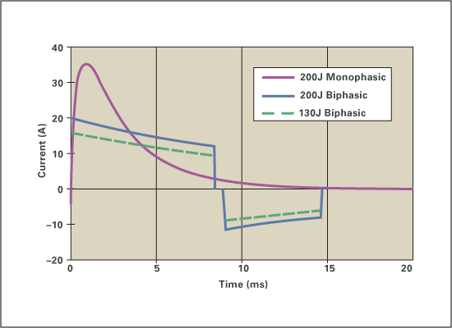

AED featured products:

TLV320AIC20 - Low-Power, Programmable 16-Bit, 26-kSPS Dual-Channel Codec
OMAP5910 and OMAP5912 - OMAP™ Processors for Portable Medical Devices
UCC38C4x - Next-Generation, Current-Mode PWM Controllers Offer Lowest Power and Improved Efficiency
MSC1210 - Lowest Noise Precision Data-Acquisition System-On-a-Chip
REF31xx - 15-ppm/°C Max, 100-µA, SOT23-3 Series Voltage Reference
REF3112 - 1.25V REF3120 - 2.048V REF3125 - 2.5V REF3130 - 3.0V REF3133 - 3.3V REF3140 - 4.096V

