Readout Method 1: Fast Sampling
In the fastest readout method, speed is considered more important than accuracy so we take only one sample per pixel and reference this voltage to electrical ground (Vss). The detector node voltage applicable in readout method 1 is shown schematically in Figure 25. The unit cell is reset, integrated, and sampled once at the end of the integration ramp.
This method should be used for imaging in the 3-4 m band and at M where the high thermal background flux significantly fills the detector wells in of order the frame readout time. In this situation, the dominant noise source is photon shot noise from the background flux, so readout noise is not an issue.
The minimum readout time for this method is 0.2 sec.

Readout Method 2: Relative Sampling
Under less extreme background conditions, significant improvement in stability can be made by referencing the signal level to the reset level, instead of electrical ground. This is done in readout method 2. The detector node voltage applicable to readout method 2 is shown schematically in Figure 26.
Note that the detector node voltage jumps when the reset FET is switched off, and this pedestal level is not removed in readout method 2. The pedestal level is different for each pixel in the array so this imprints a pedestal structure on the image, which is difficult to remove completely. The uncertainty in the value of this pedestal is known as kTC noise .
For direct imaging through broad band filters with high sky levels, the dominant noise source is still the photon shot noise of the background flux so readout method 2 gives acceptable performance.
The minimum readout time for this method is 0.3 sec.

Readout Method 3: Double-Correlated Sampling
The pedestal structure can be removed using a readout method which references the detector node voltage at the end of the integration to the voltage at the beginning of the integration. The detector node voltage applicable to readout method 3 is shown schematically in Figure 27.
In principle, this readout method is susceptible to electrical 1/f noise since it differences two samples separated in time by the duration of the integration. In practice, this is unlikely to be an important noise source.
This is the preferred readout method for broad band imaging because it does not imprint the pedestal pattern on the data.
The minimum readout time for this method is 0.4 sec.

Readout Method 4: Triple Correlated Sampling
The potential 1/f noise problem with readout method 3 can be overcome, at the expense of two more reads, by referring both the start and end reads to their respective reset levels. The detector node voltage applicable to readout method 4 is shown schematically in Figure 28.
Naively, this should be the most accurate readout method to adopt. However, we must now delve into the more obscure operating characteristics of the CRC463 array to see why other effects dominate.
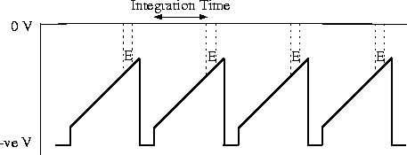
Figure 25: Detector node voltage applicable to readout method 1.
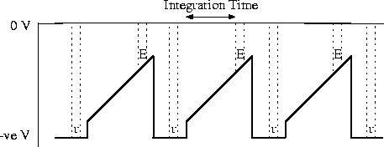
Figure 26: Detector node voltage applicable to readout method 2.
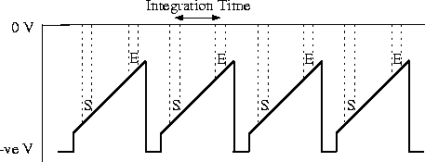
Figure 27: Detector node voltage applicable to readout method 3.
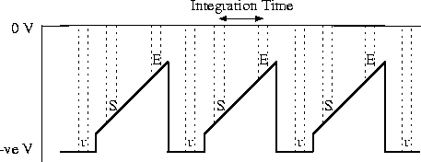
Figure 28: Detector node voltage applicable to readout method 4.

Kabal
Thu Jun 5 16:44:21 EST 1997

