It appears that normalization lowers MARD and 58 pixel data lowers MARD in below set of all (universal) but not necessarily with Pam’s data. See below.

All below are onetouch/verio

C:\Users\HP\Documents\MATLAB\WIP\Mike_Regression7_d1c0r0\session_0119and2022revisitDC2!
data0_process158.m
gid=15; xind=x1pd2022n(:,[1:28 35:64]); yind=y2v2022; xo=x1pd0119n(:,[1:28 35:64]); yo=y2v0119;
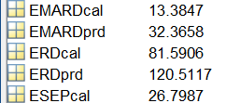

C:\Users\HP\Documents\MATLAB\WIP\Mike_Regression7_d1c0r0\session_0119and2022revisitDC2!
data0_process158.m
gid=17; xind=x1dc2022n; yind=y2v2022; xo=x1dc0119n; yo=y2v0119;
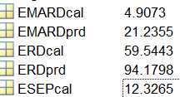

C:\Users\HP\Documents\MATLAB\WIP\Mike_Regression7_d1c0r0\session_0119and2022revisitDC2!
data0_process164
gid=14; xind=x1pd2022n; yind=y2v2022; xo=x1pd0119n; yo=y2v0119;
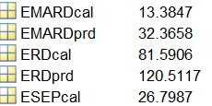

C:\Users\HP\Documents\MATLAB\WIP\Mike_Regression7_d1c0r0\session_0119and2022revisitDC2!
data0_process164
%gid=16; xind=x1dc2022n; yind=y2v2022; xo=x1dc0119n; yo=y2v0119;
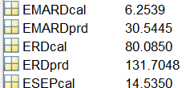

NOTE Therse are 58 pixel dc
spect_d1s0122DC58cn and spect_d1s0122cn
spe_d1c0r0s0122DC58cn contain Dc data even named x01
All spe_d1r0c0sAll64n are 64 pixel

Best Original with onetouch/verio
This is best but not sure of conditions. Can’t recreate
Mike_Regression1!
session_0119and2022revisitDC1!
prd_d1r0c0svAllDConet1Group0!.mat
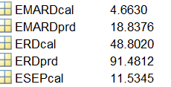
data_id_spectra6.m
regres_cal6.m
regres_pred6.m

This is second best I can get
:\Users\HP\Documents\MATLAB\WIP\Mike_Regression1!\session_0119and2022revisitDC1!
spect_d1s0122cn.mat
data_id_spectra6
regres_cal6
regres_pred6
xtest=x2022;
ytest=y2022;
xo=x0119;
yo=y0119;
regres_pred6
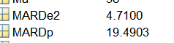

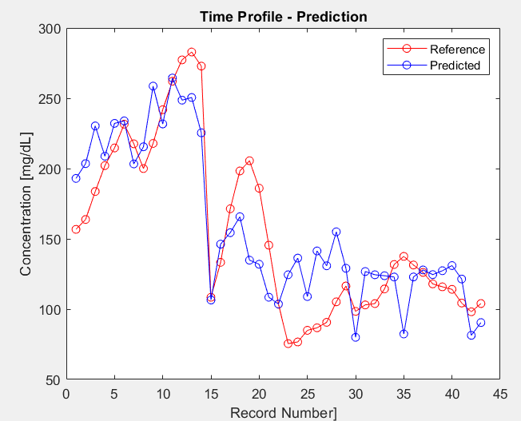

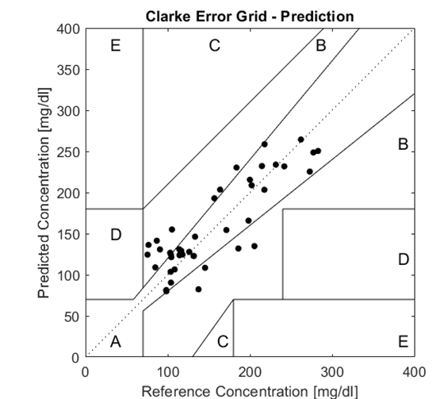

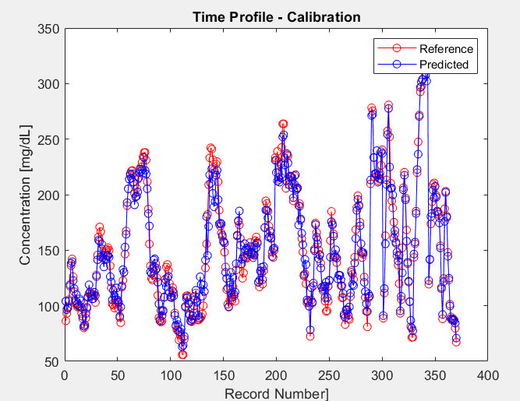

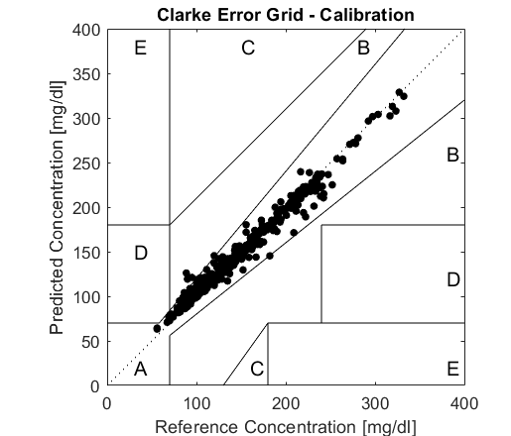

Best using all PDS data with onetouch/verio ACTUALLY NOT REALLY PDS but DC. X0119n and X2022n in
Mike_Regression7_d1c0r0
session_0119and2022revisitDC1!
prd_d1r0c0svAllonet1Group202!!
load('spe_d1r0c0sAlln'); %64 pixell pds x0122n
load('sgl_vall');
%gid=202; xind=x2022n; yind=y2022; xo=x0119n; yo=y0119; %58 PDS
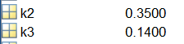
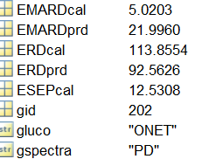

Best pred Pam data DC cal and pred with cgm
Mike_Regression7_d1c0r0
C:\Users\HP\Documents\MATLAB\WIP\Mike_Regression7_d1c0r0\session4_PamDCcgmAnom258
data0_process158.m
prd_d1r0c0sPamDCcgm1Group5!.mat

session4_PamDCcgmAnom2!!
prd_d1r0c0sPamDCcgmGroup5!
load('spe_d1r0c0sAlln'); %64 pixell pds x0122n
load('sgl_vall');
gid=5; xind=x1dc20n; yind=y1v20; xo=x1dc06101417n; yo=y1v06101417;

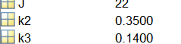

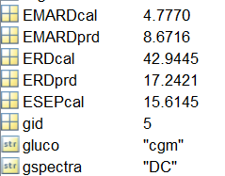

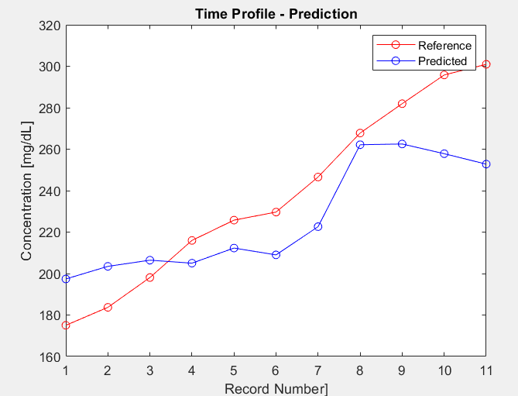

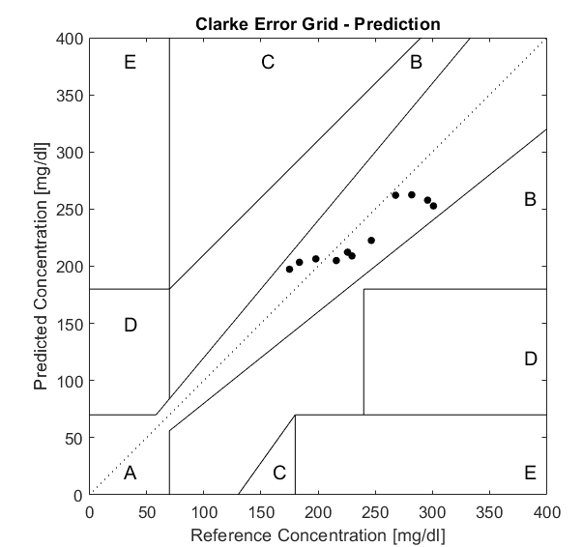

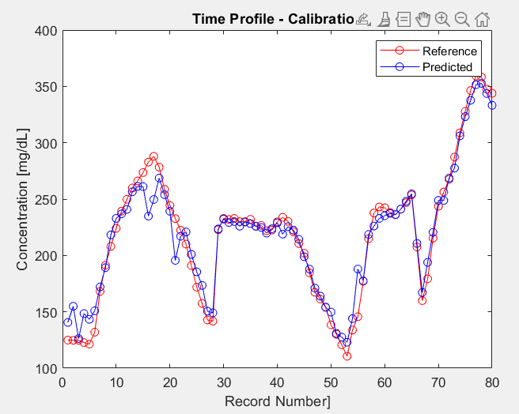

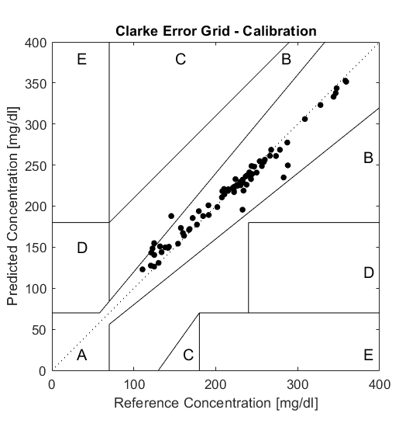

prd_d1r0c0sPamPDcgm1Group5.mat

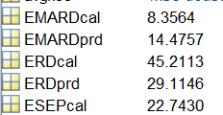

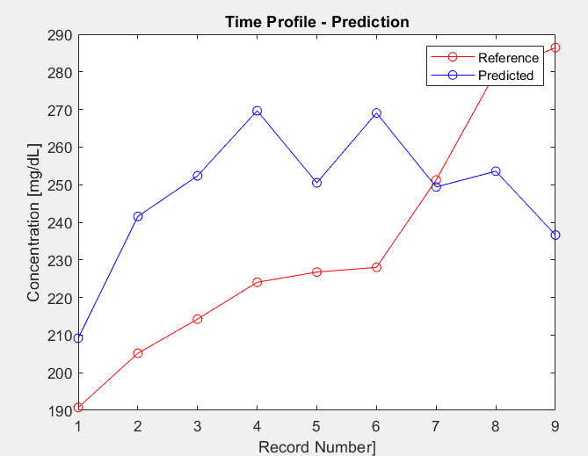

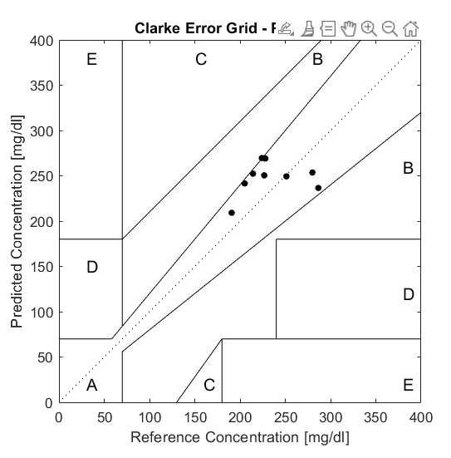

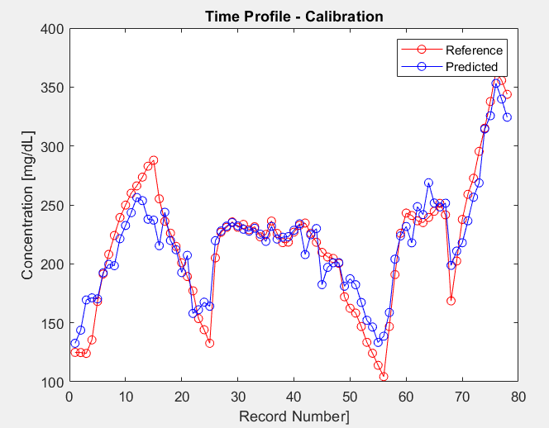

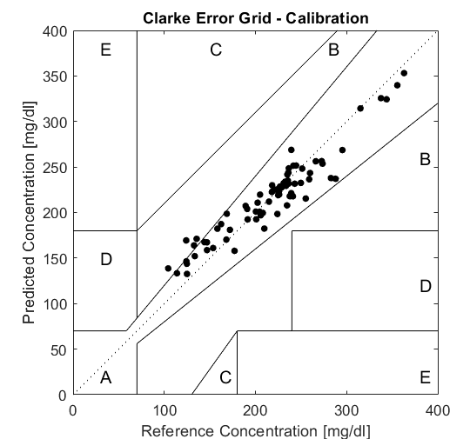

Cross Test 1
Mike_Regression7_d1c0r0
session_0119and2022revisitDC1!
prd_d1r0c0svAllonet1Group50!
gid=50; xind=x1dc20n; yind=y2v20; xo=x1dc0119n; yo=y2v0119;
k3 = 0.14; %select possible fraction of anomalies
k2 = 0.35; %select % mg/dL threshold value for residuals
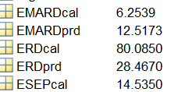

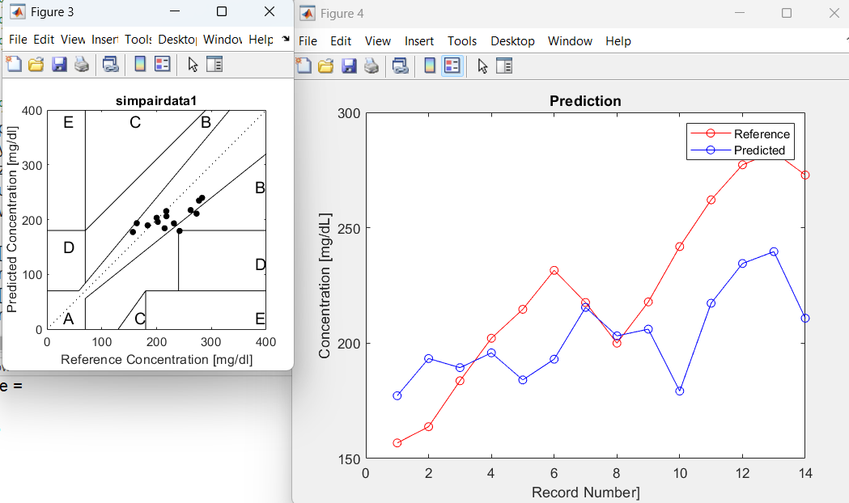

Cross Test 2
Mike_Regression7_d1c0r0
session_0119and2022revisitDC1!
prd_d1r0c0svAllonet1Group51!
gid=51; xind=x1dc20n; yind=y1v20; xo=x1dc0119n; yo=y2v0119;
k3 = 0.14; %select possible fraction of anomalies
k2 = 0.35; %select % mg/dL threshold value for residuals

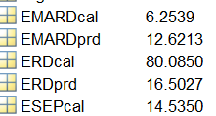

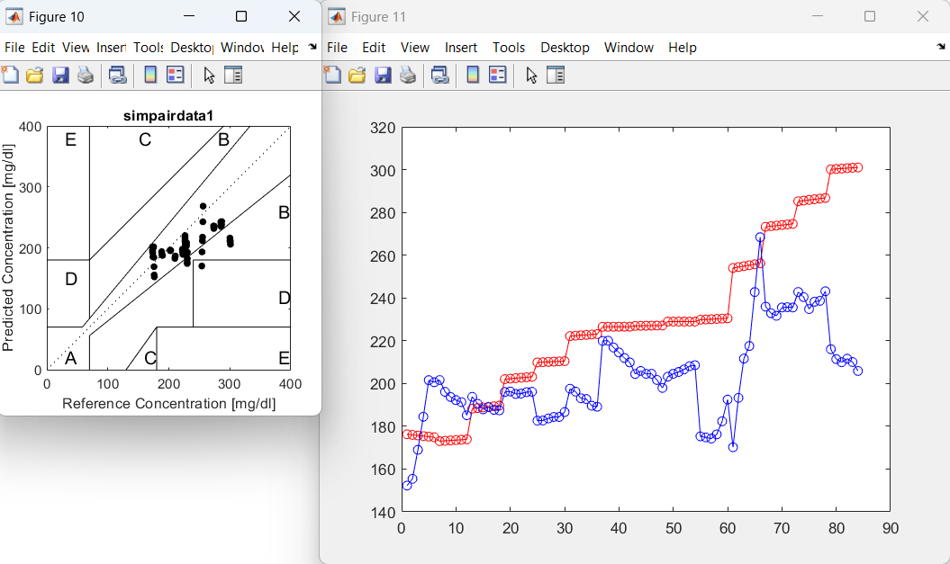

Error in Glucose Reference Array
Detected error in glucose reference onetouch/verio array y220 in glu_all compared to original y20 and fixed. New array is y2v220 in glu_new. Found no difference between y120 and y20 but changed name to y1v20 t stay consistent with (also in glu_new).
NOTE: I fixed this
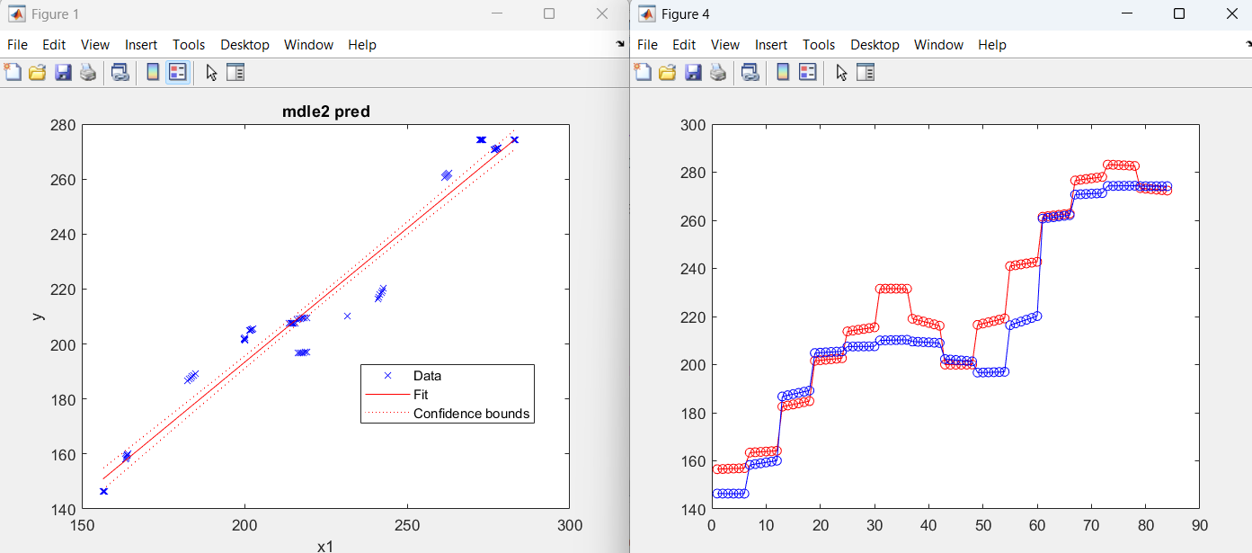
y220 vs y2v20

Regarding the following, the cgm yields lower prediction error than onetouch/verio. Also it appears that verio is closer to cgm. We have no means to determine which is closer to reality. Perhaps cgm reads closer to pds.

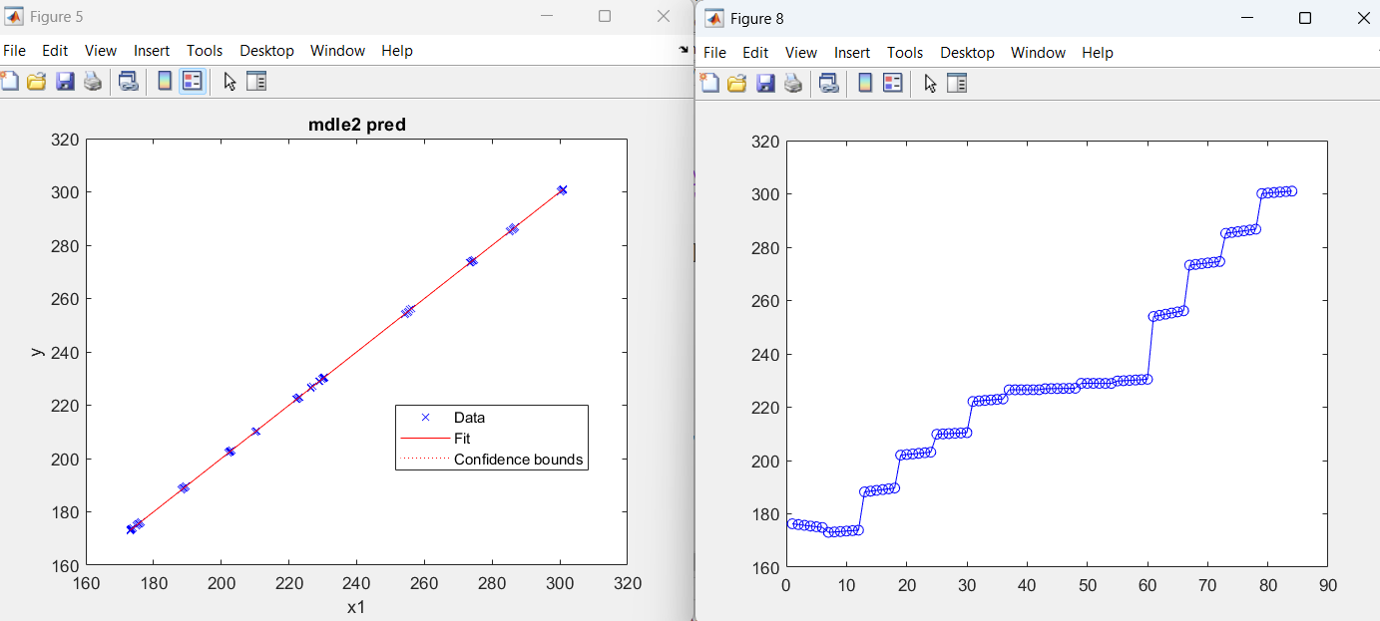
y120 vs y1v220

Difference between One touch and CGM
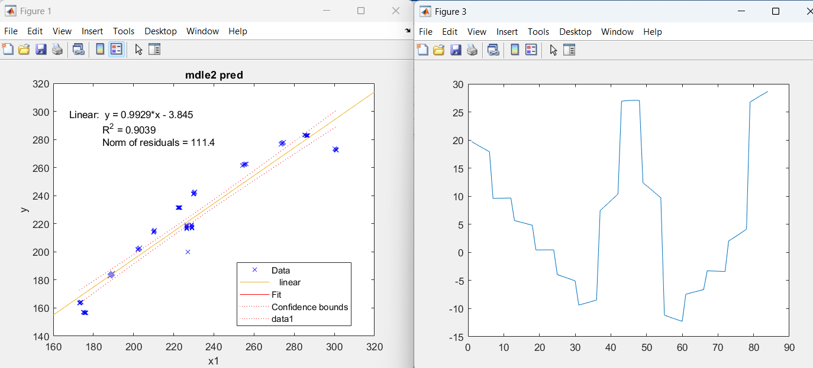
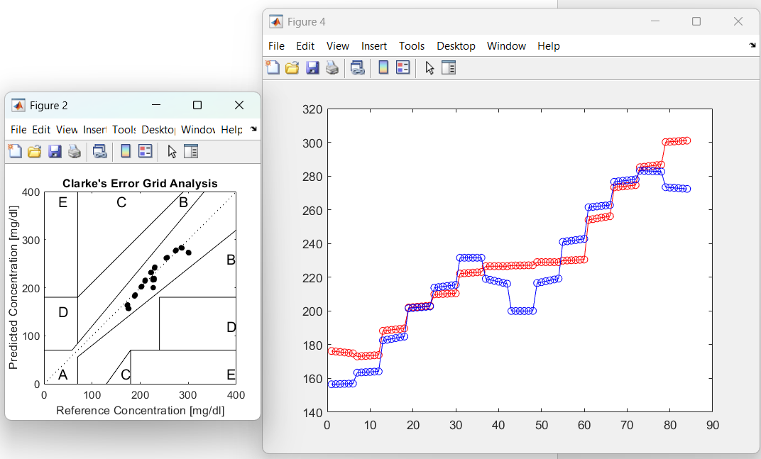
Y1v20 (red) vs y2v20 (blue)

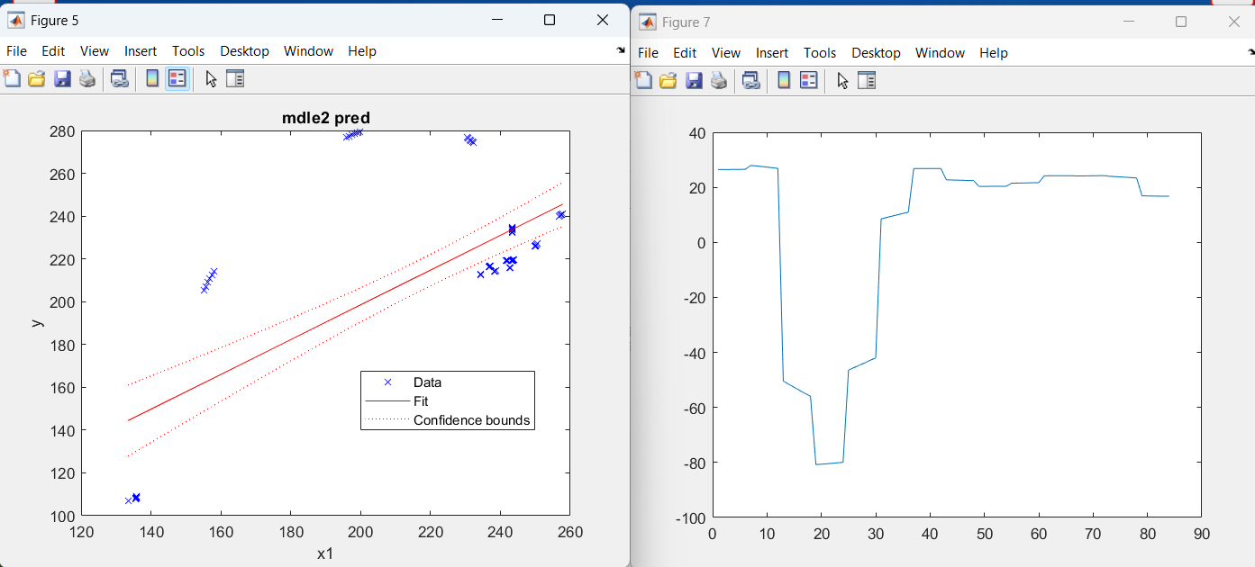

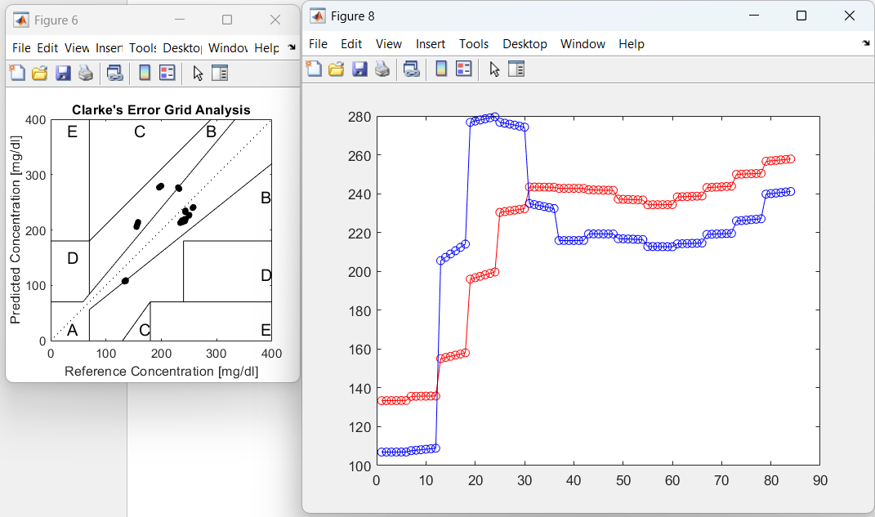

y1v14 vs y2v14

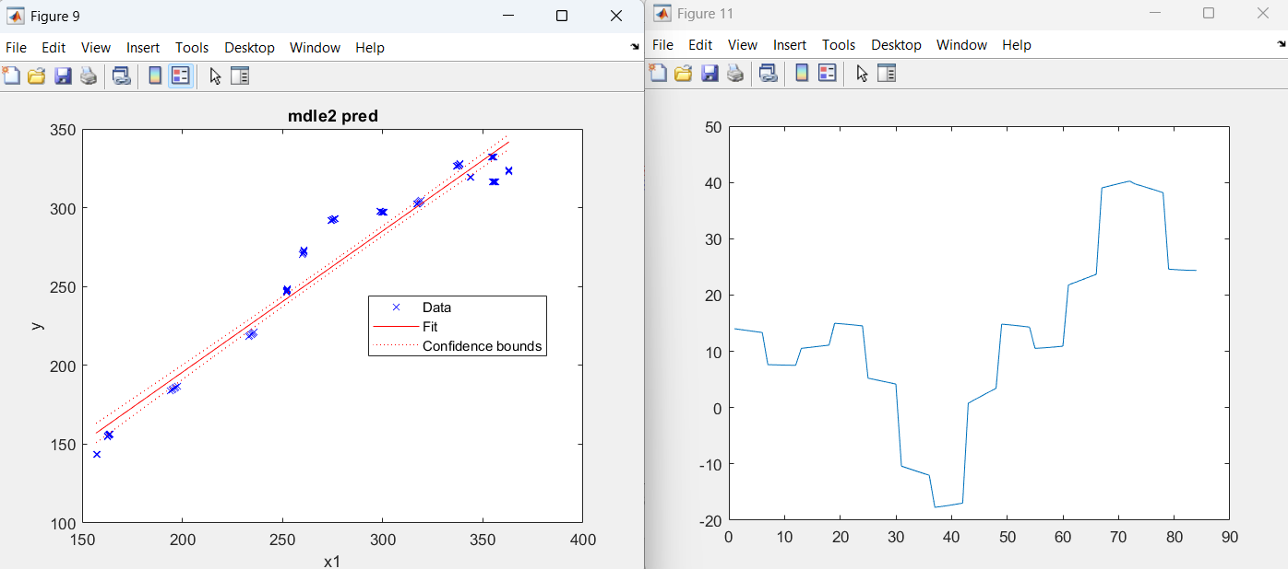

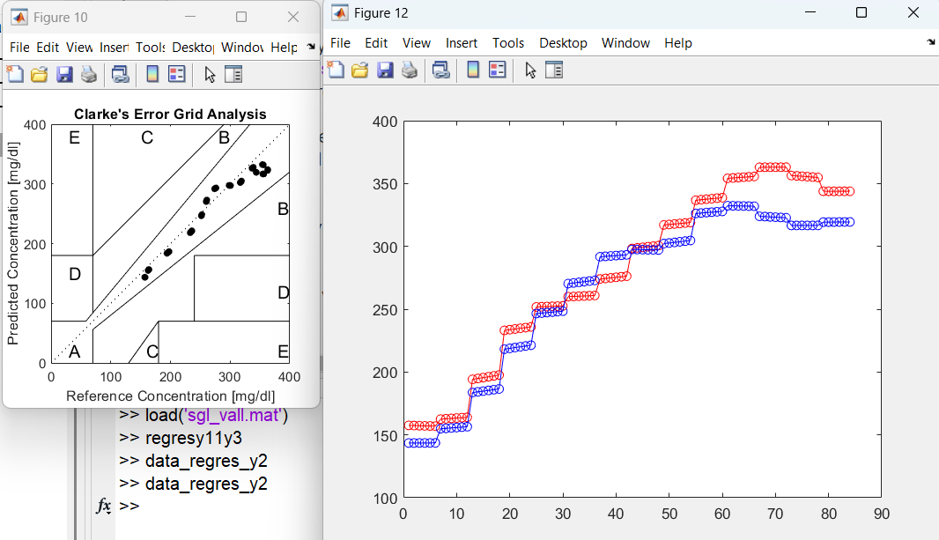

Y1v17 vs y2v17

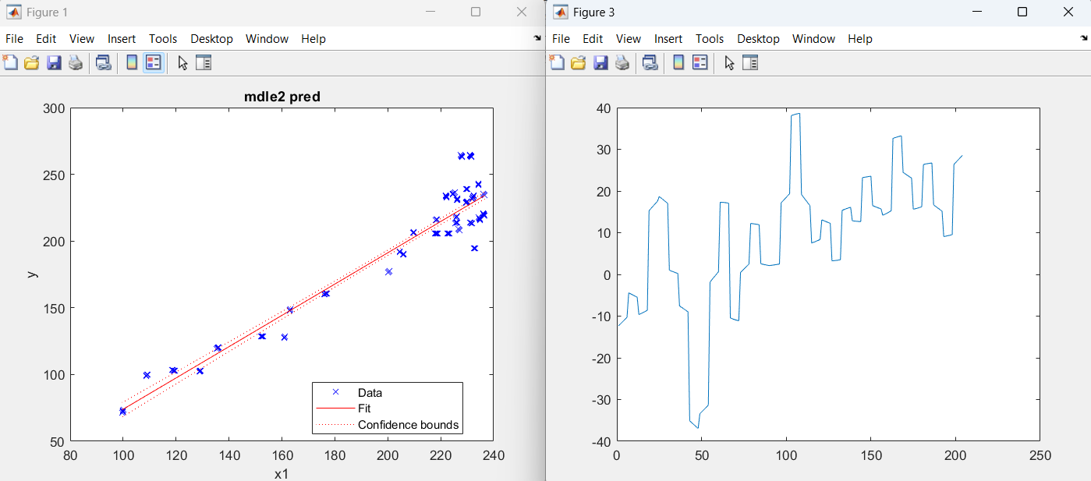

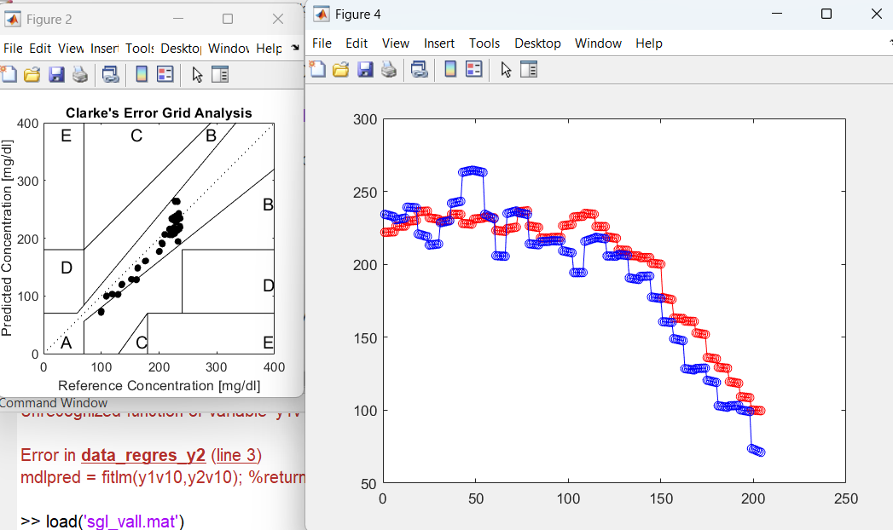

Y1v10 vs y2v10

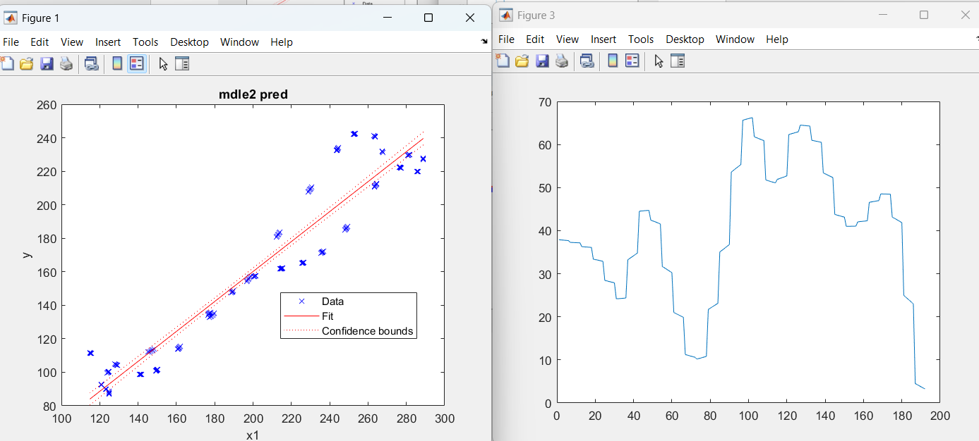

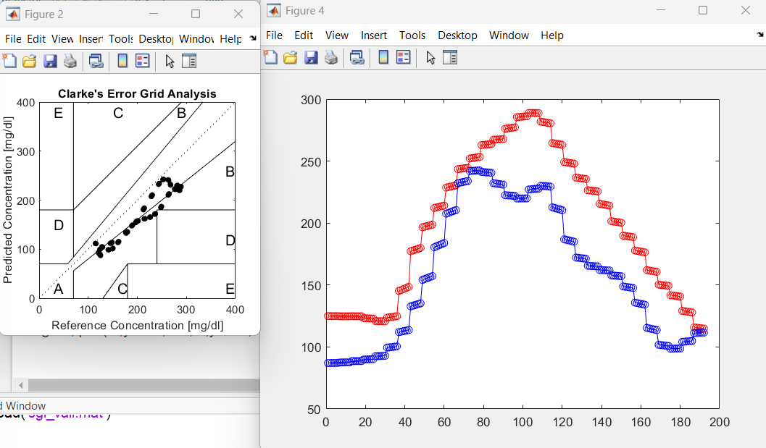

Y1v06 vs y2v06

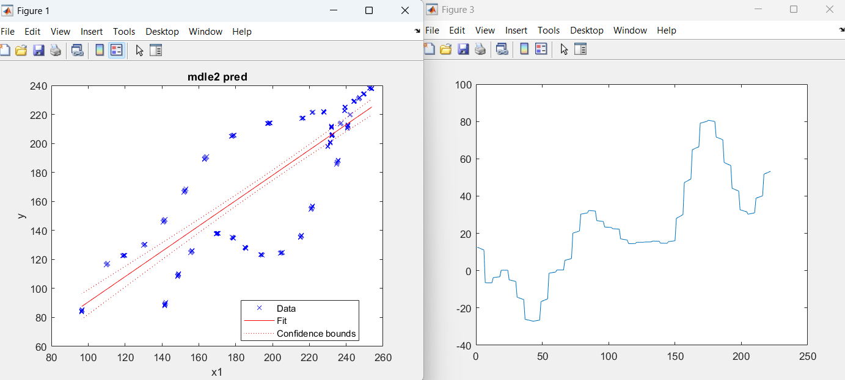

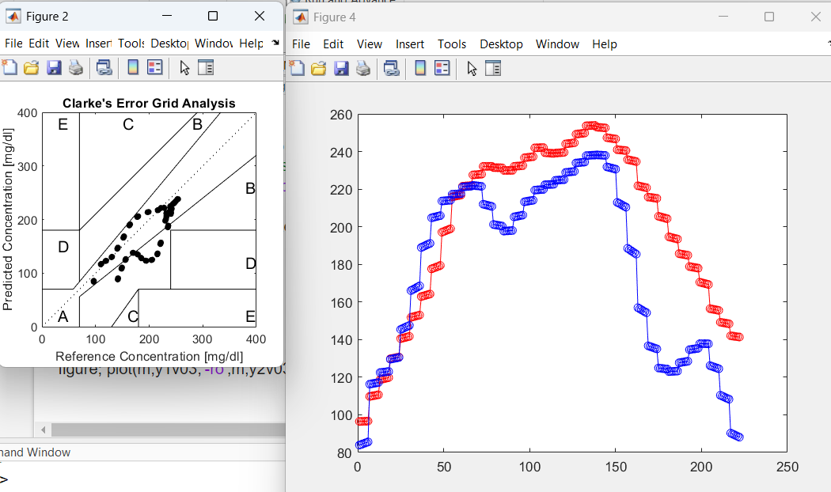

yY1v03 vs y2v03

session_PamDCIso1!_cgm2
% Definitions spectra and glucose reading arrays to operate on ********************
load('spe_d1r0c0s0122b', 'x1dc0306101417n','x1dc20n');
load('sgl_d1r0c0s20122b','y10306101417','y120');
xo=x1dc0306101417n;
yo=y10306101417;
idtest=25*[1:30]; %these test spectra to remove before bad spectra removal
%******************************************************************************
Pam sessions 3, 6,10,14,17 used for calibration minus test spectra of 6 sittings and session 20 for predictions with CGM reference glucose readings

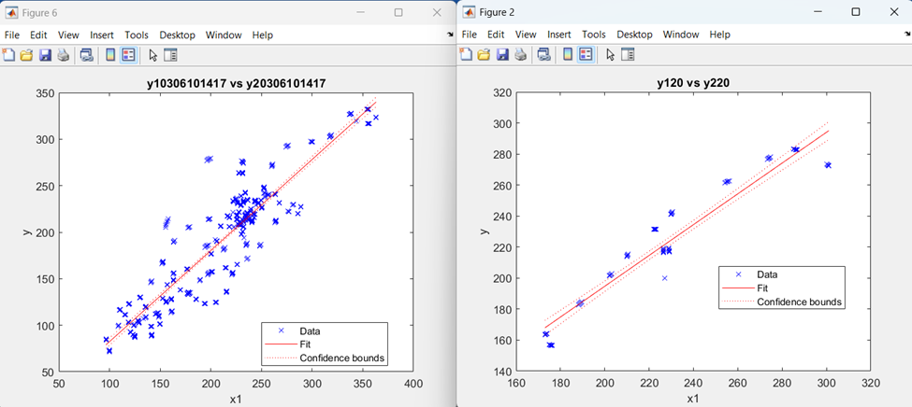
L) Predictions using CGM vs predictions using Onetouch
R) Reference glucose readings CGM vs Onetouch

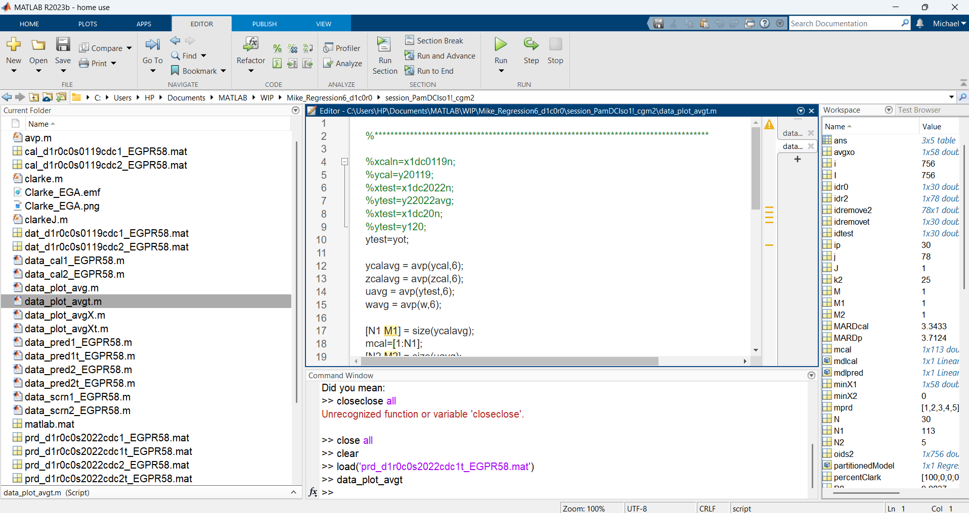
Zoom in to see MARD for test spectra prediction (CGM meter)

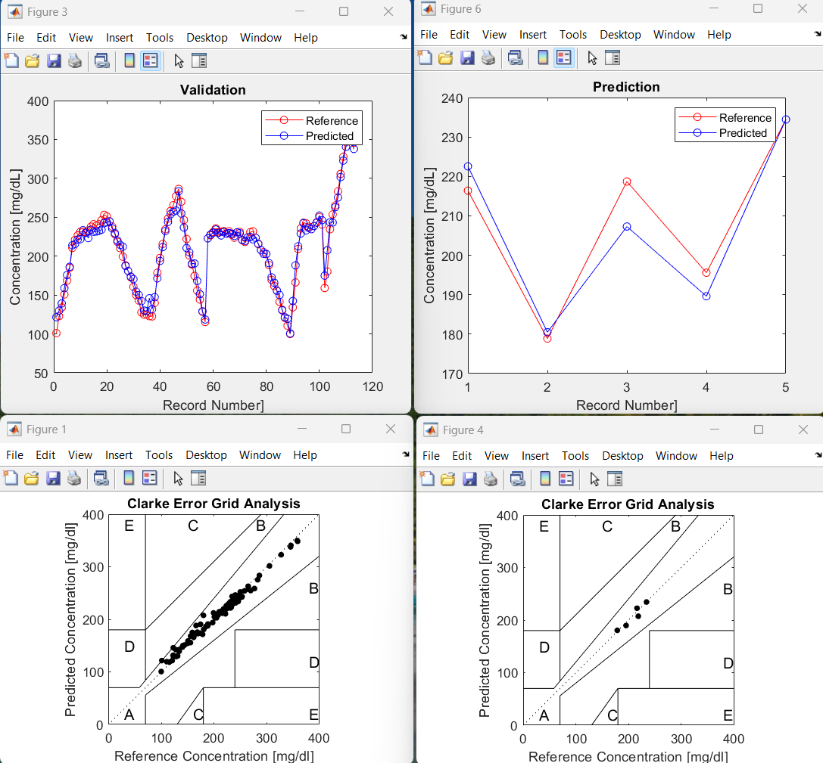

L) Validation results using CGM
R) Prediction of test spectra (CGM)
Zoom in to see MARD for session 20 (CGM meter)

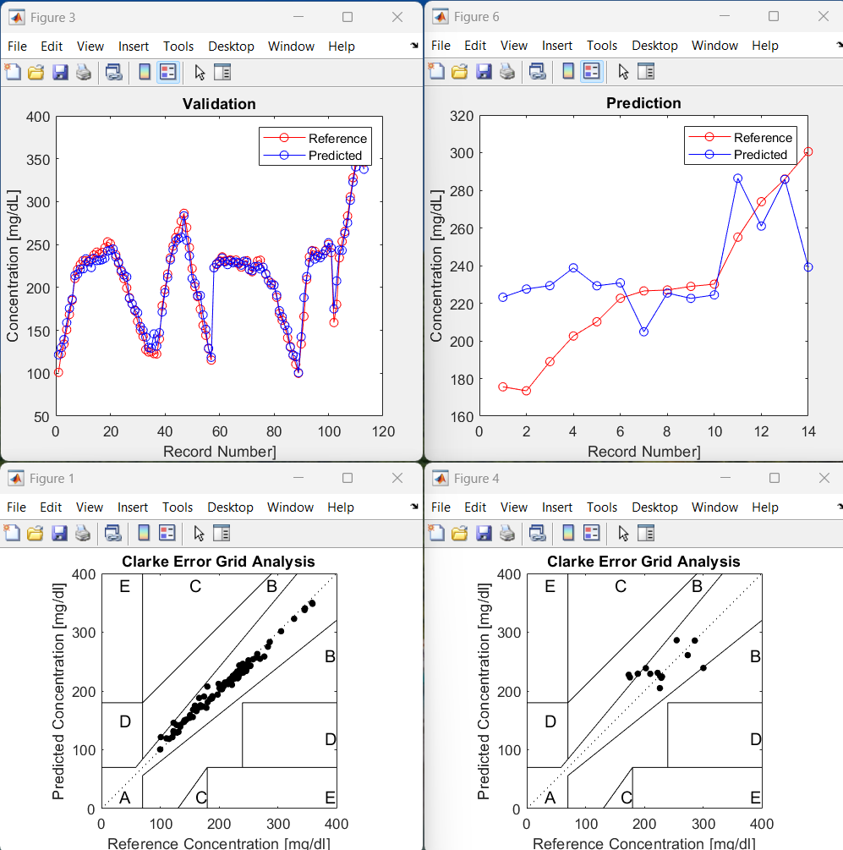

L) Validation results using CGM
R) Prediction of session 20 (CGM)

session_PamDCIso2!_onetouch2
% Definitions spectra and glucose reading arrays to operate on ********************
load('spe_d1r0c0s0122b', 'x1dc0306101417n','x1dc20n');
load('sgl_d1r0c0s20122b','y20306101417','y220');
xo=x1dc0306101417n;
yo=y20306101417;
idtest=25*[1:30]; %these test spectra to remove before bad spectra removal
%*******************************************************************************
Pam sessions 3, 6,10,14,17 used for calibration minus test spectra of 6 sittings and session 20 for predictions with Onetouch reference glucose readings

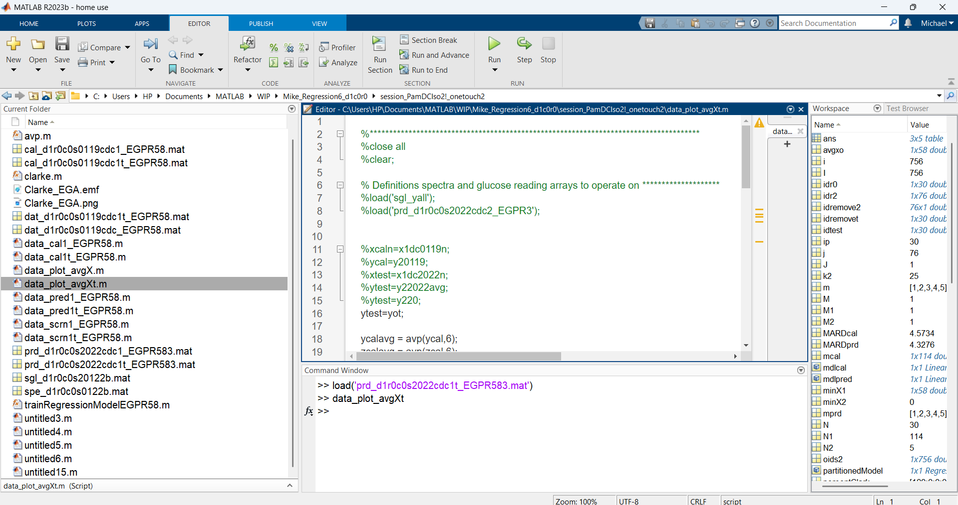
Zoom in to see MARD for test spectra prediciton (CGM meter)
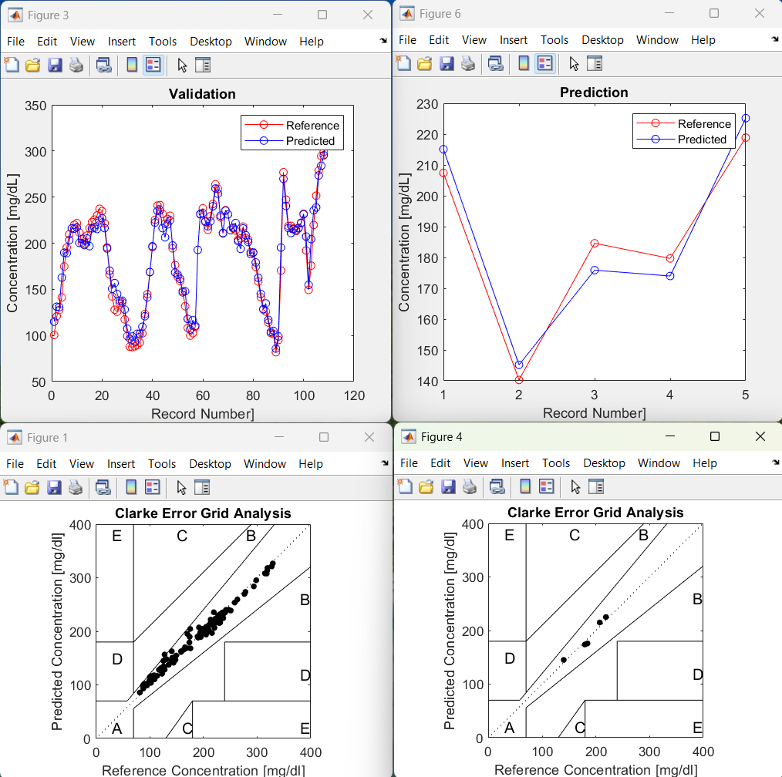

L) Validation results using Onetouch
R) Prediction of test spectra (Onetouch)
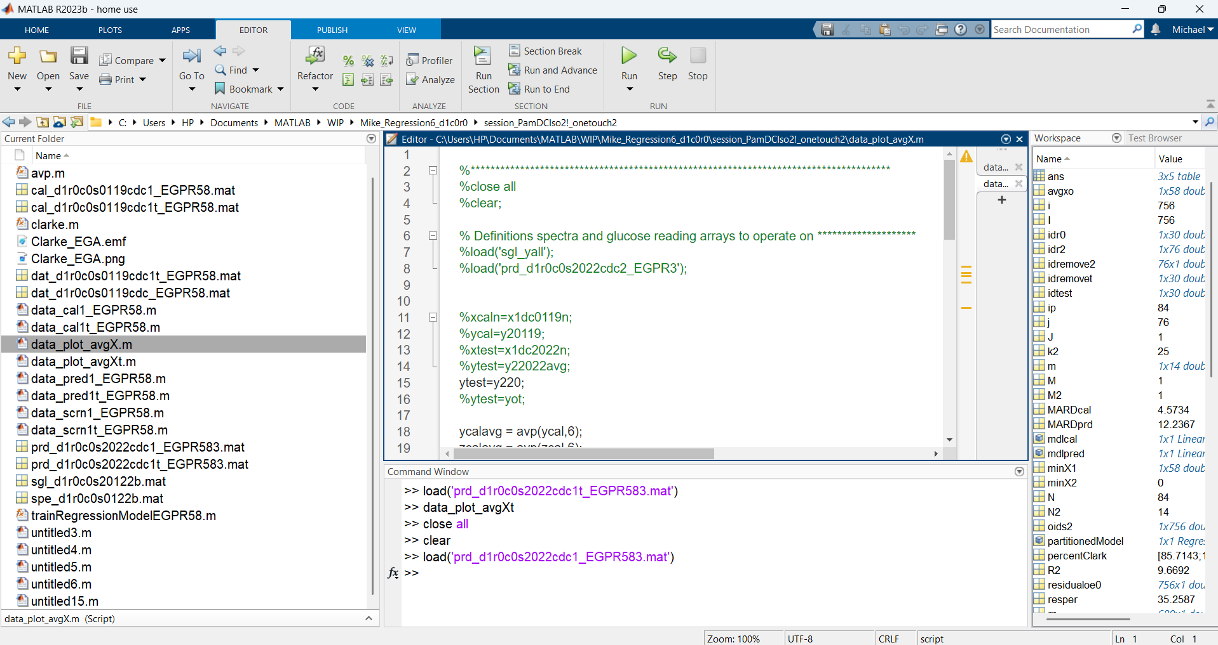
Zoom in to see MARD for session 20 prediction (Onetouch meter)
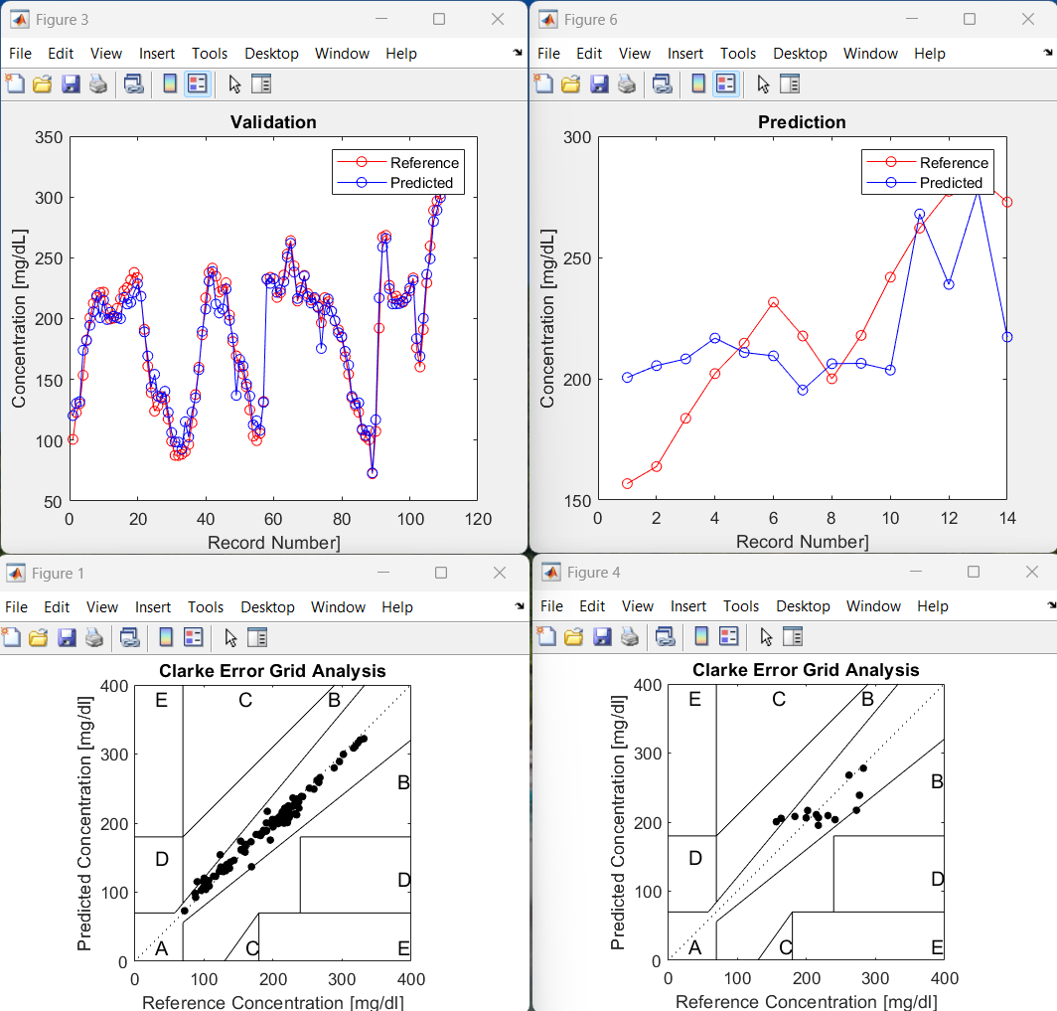

L) Validation results using Onetouch
R) Prediction of session 20 (Onetouch)
Investigation Findings Needing Confirmation and Ways for Improving Prediction MARD
- Use compact Insion devices for data collection.
- Use a precise glucometer for reference readings as it affects calibration and prediction MARD.
- Collect data from many diabetics of various ages, gender, race body type to build a universal model.
- Use Exponential Gaussian Process Regression (EGPR) as it appears to yield lowest MARD.
- Use nonisotropic EGPR instead of isotropic if computation time is tolerable since it yields lower MARD.
- Use 64 wavelength spectra (256 averaged by 4 for the model). It appears to yield lower MARD.
- Use spectra that are averaged in time by 6 (10s segments) as this yields lower MARD.
- Use 1700nm range as it appears to yield slightly lower MARD at 25% lower cost. However, compare data taken with insion 1100 – 1900nm device compared to Insion 1000 – 1700nm device to confirm.
- Use fewer data from each diabetic for calibration to avoid overfilling model (primarily screen outliers)
- Use outlier detection such as Anomalies or equivalent and screening to use good data for calibration.
- Use outlier detection such as Novelties or equivalent to screen data used for prediction on the fly.

DC all 01-19 sessions and EGPR58NonIsotropic
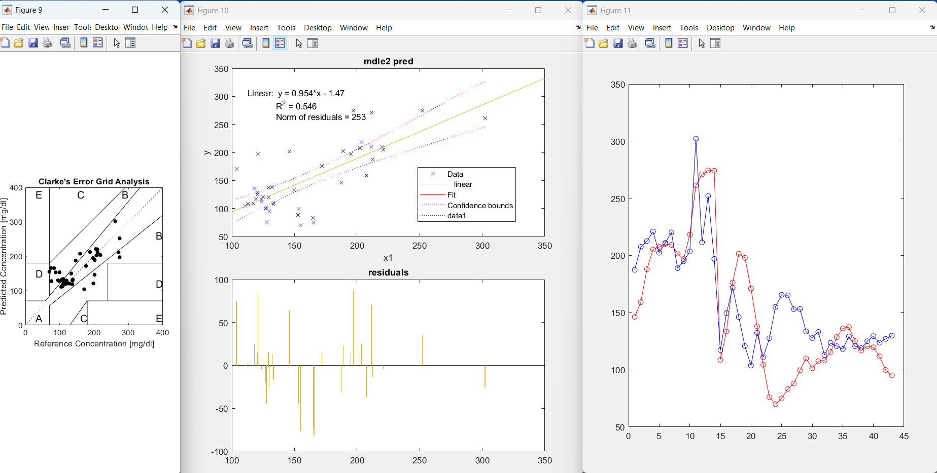
Prediction sittings
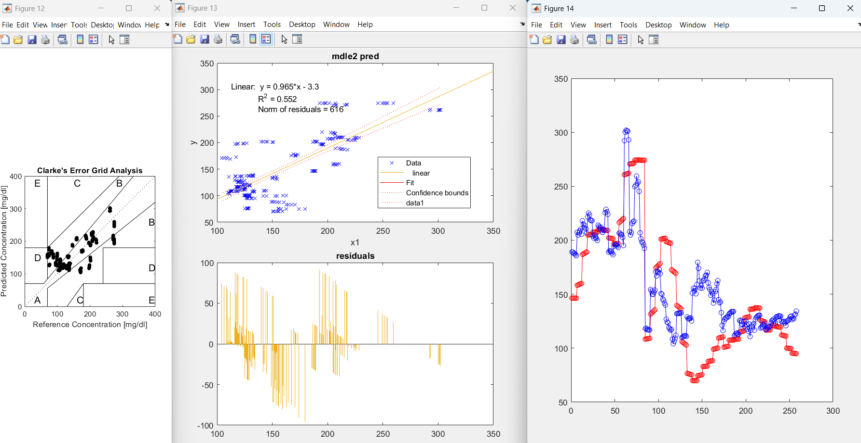
Prediction full

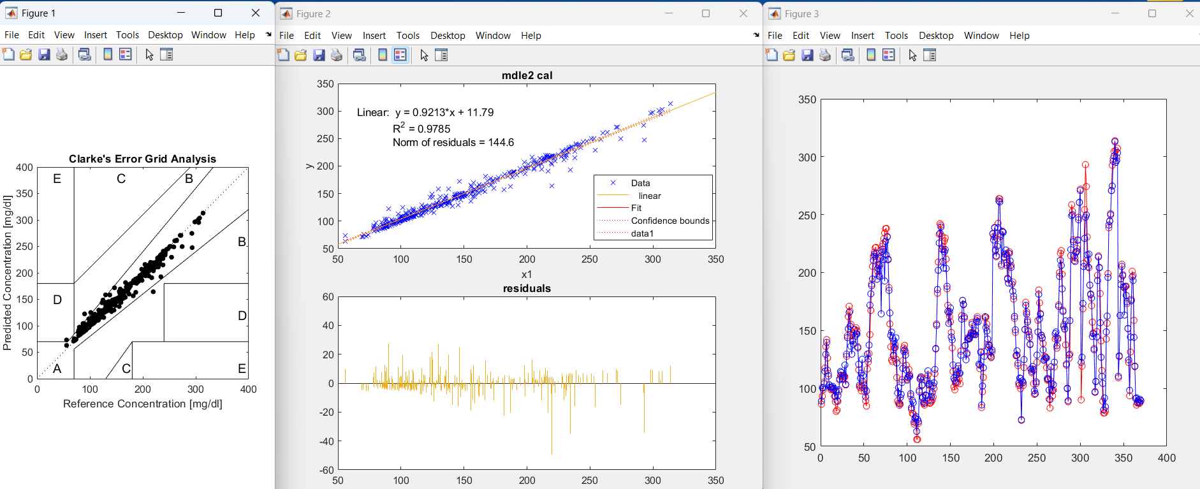
Calibration: : Pam CGM using 3 6 10 14 17

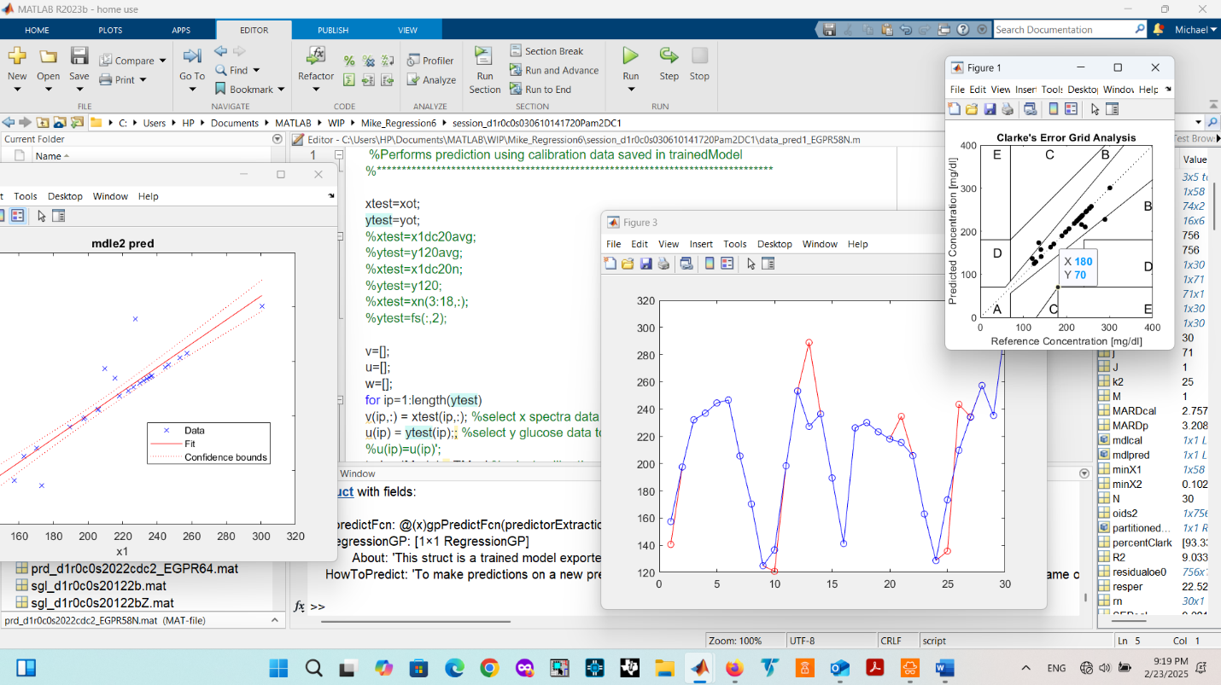
Prediction: Pam CGM independent test set used is taken from sessions 3 6 10 14 17 and not used for calibration

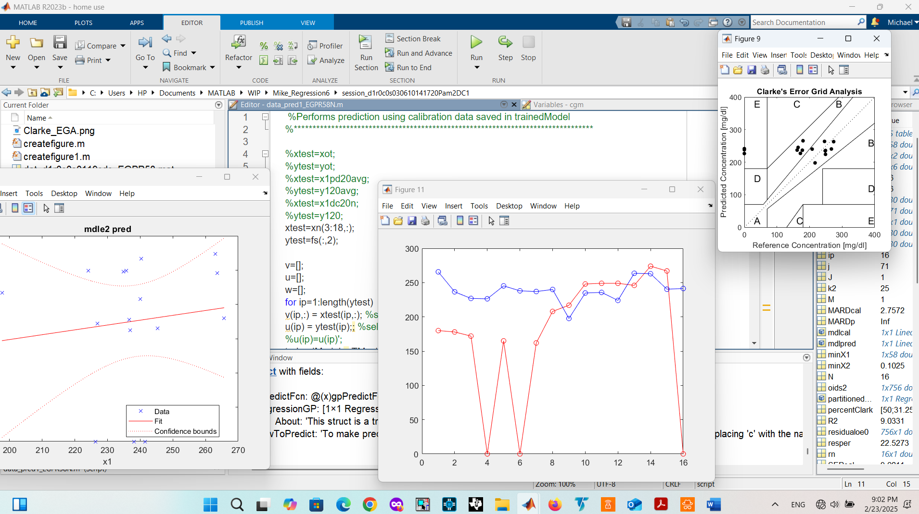

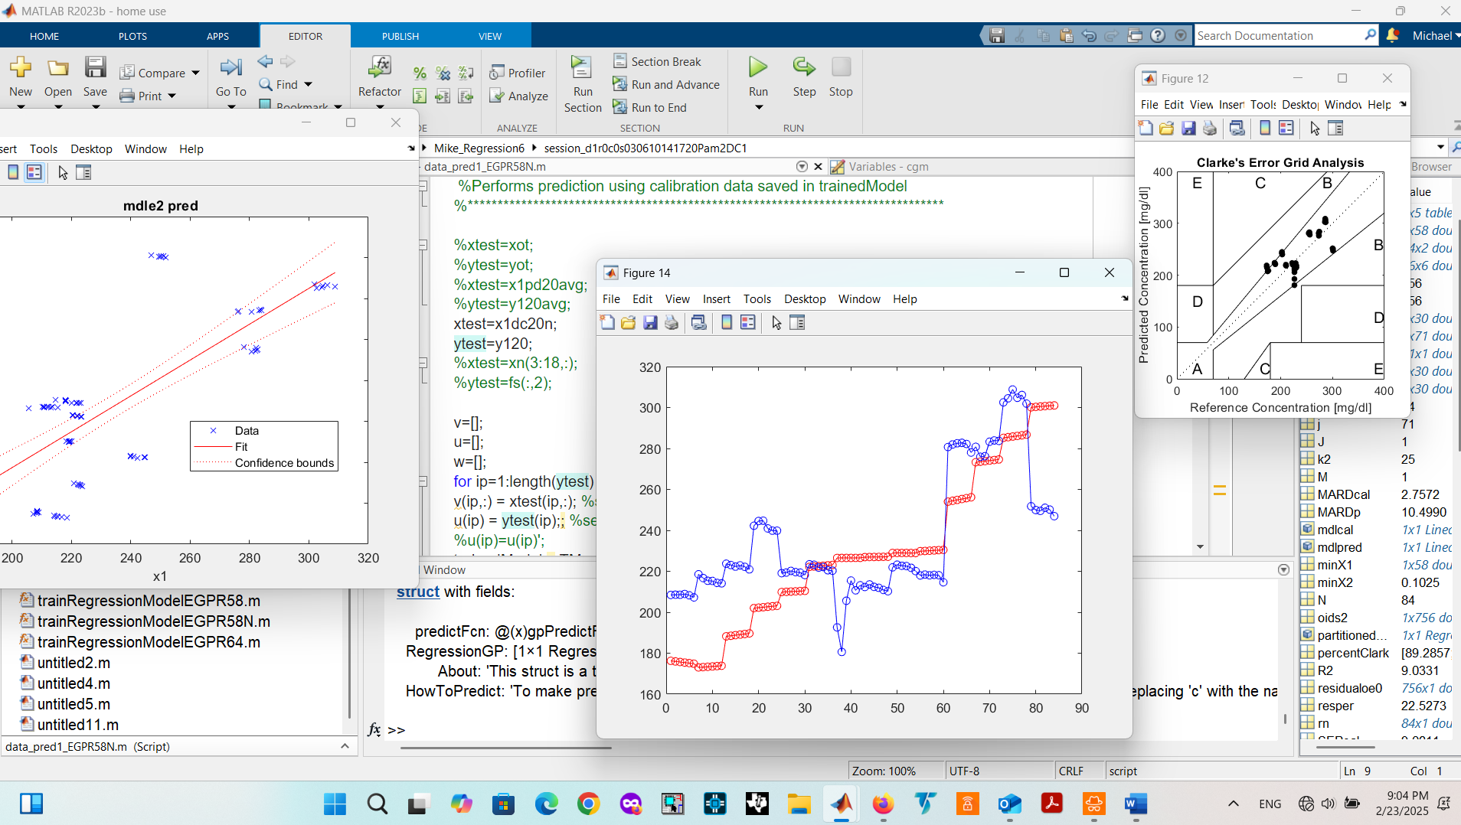
Prediction: Pam CGM independent test set is session 20 which is not used for calibration
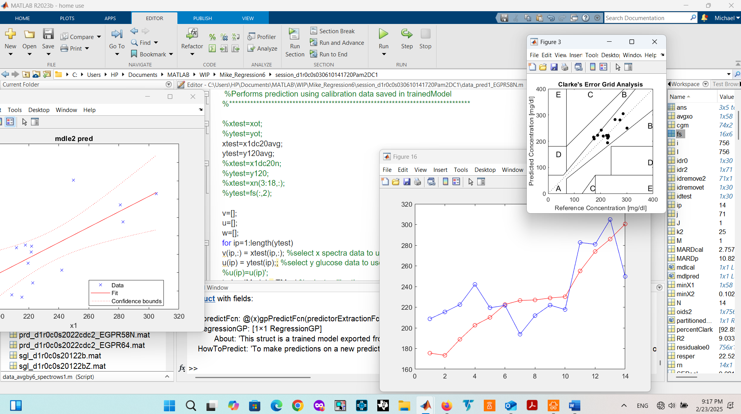

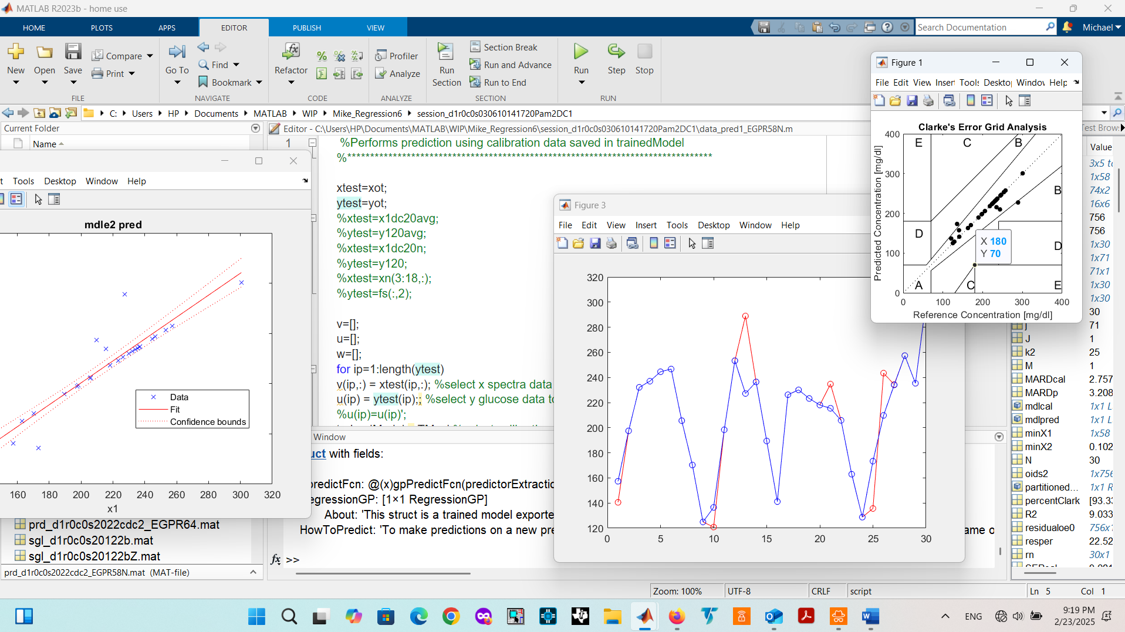

Pam PD1 pred using EGPR58 on x1pd20avg (14 sittings vs 84 spectra)
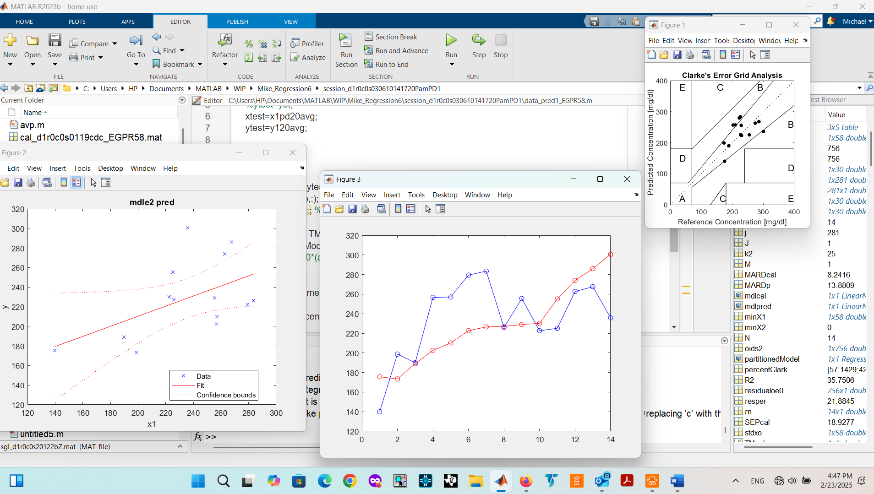

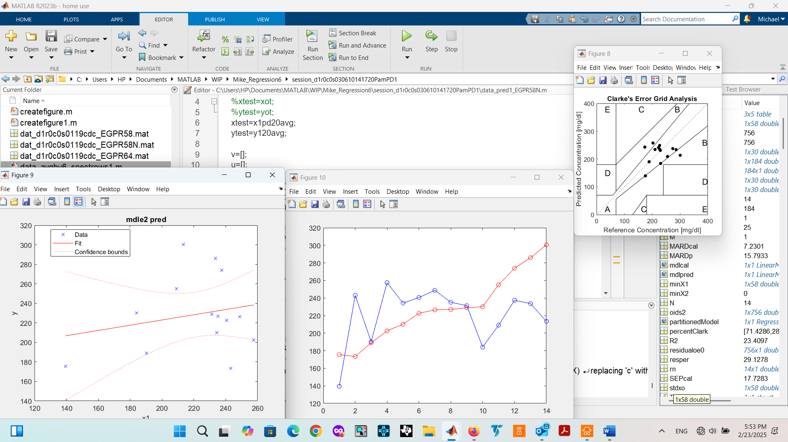

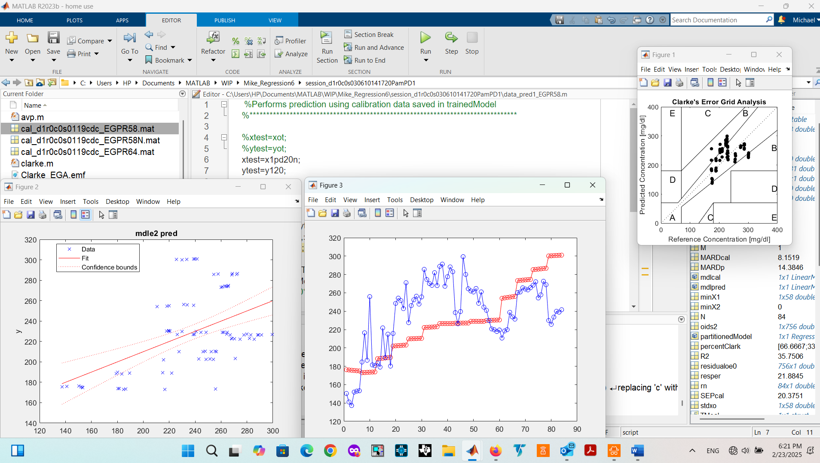

Comparison of Pam EGPR with nonisotropic kernel to isotropic using original sitabs PDS data and CGMs readings
Nonisotropic wins but takes a lot longer to compute
C:\Users\HP\Documents\MATLAB\WIP\Mike_Regression6\session_d1r0c0s030610141720PamPD1sitabs
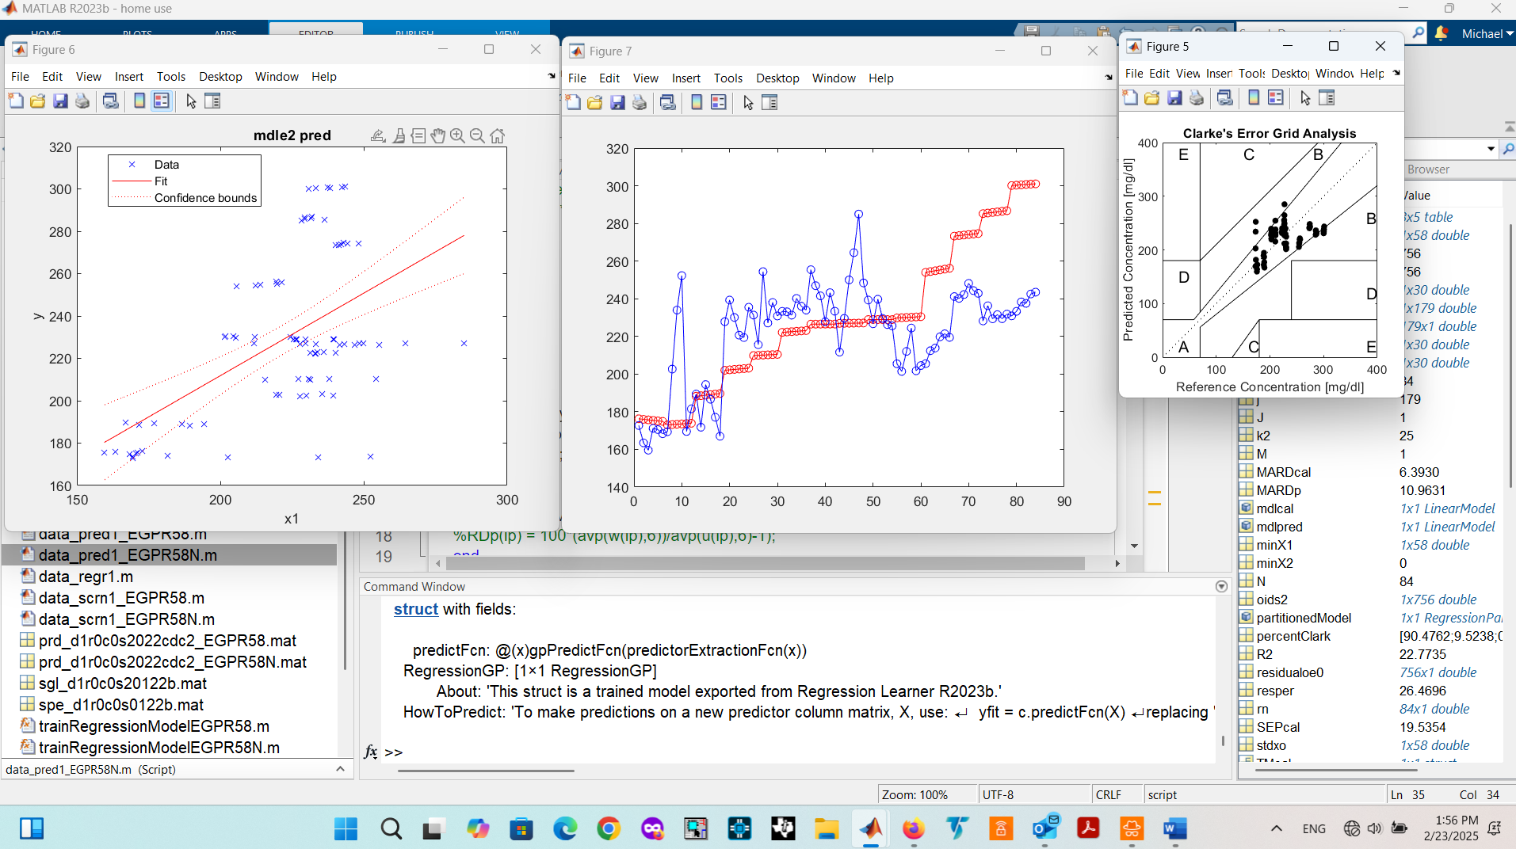
Using data_scrn1_EGPR58N (N for nonisotropic) Note screening took 32 min
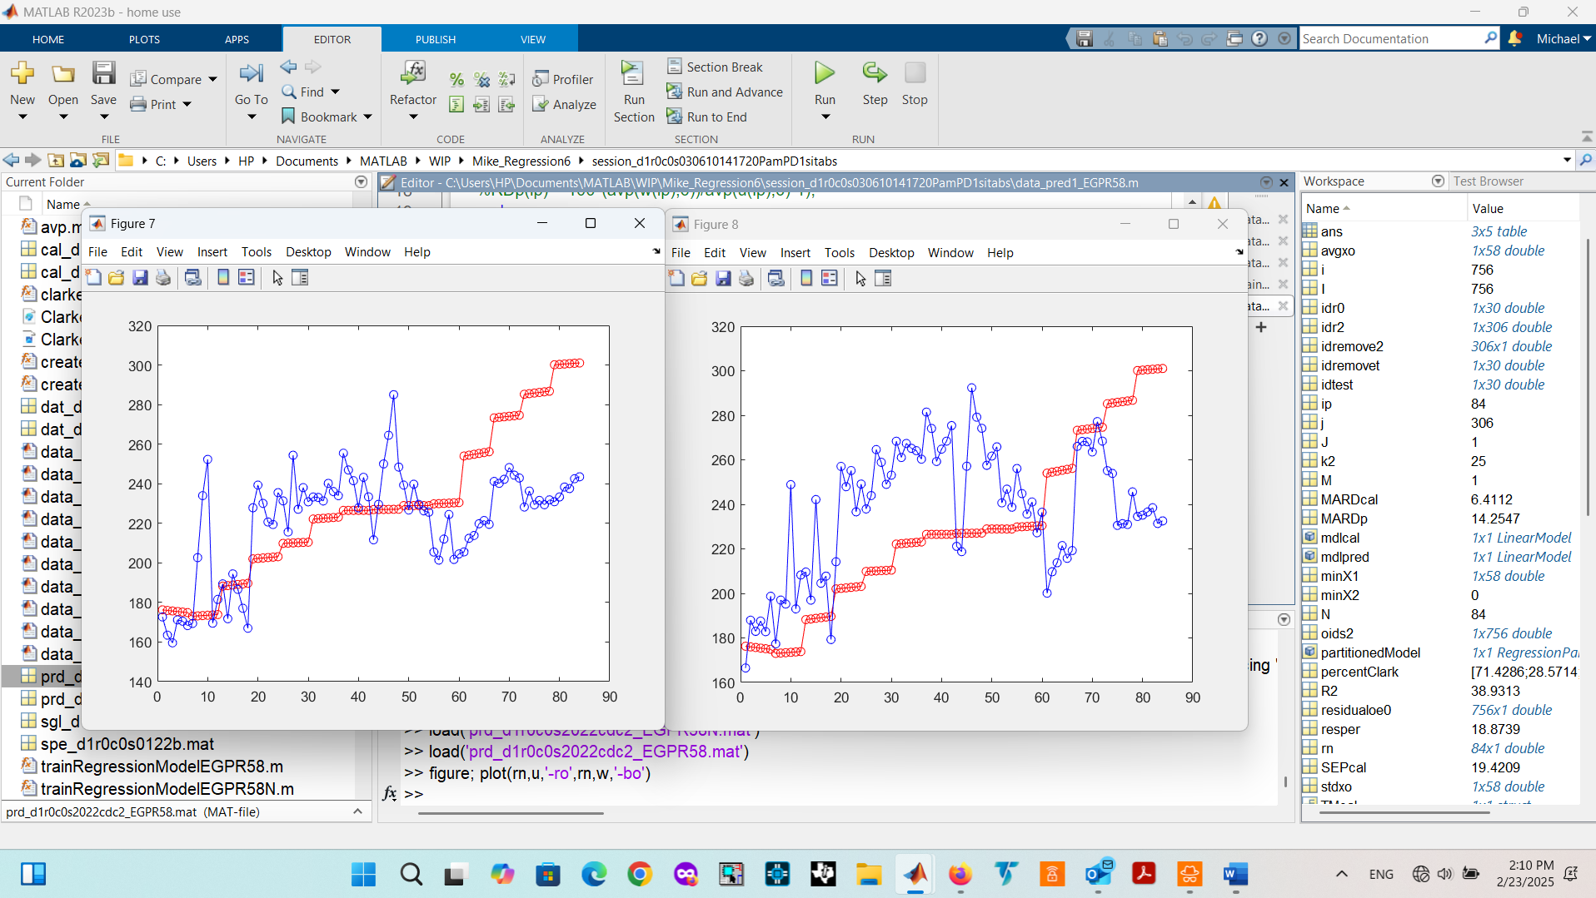
Using data_scrn1_EGPR58 (isotropic default)

Comparison of EGPR to SEGPR isotropic
SEGPR yields lower MARD for calibration validation but higher for predictions
Materhorn competes with SE

Comparison of EGPR to other ML models
EGPR performs better than the rest including QR GPR

Comparison of 64 vs 58 pixels
Small or no difference with DC or AD but difference with PD and PDS

Comparison of PDS sitabs to PD
C:\Users\HP\Documents\MATLAB\WIP\Mike_Regression6\session_d1r0c0s030610141720PamPD1sitabs
C:\Users\HP\Documents\MATLAB\WIP\Mike_Regression6\session_d1r0c0s030610141720PamPD2sitabs
Effect of kfold number in calibration (default=5)
Increasing kfold increase computation time but reduces MARD

mdlcal = fitlm(mean(x0306101417n),mean(x1pd0306101417n));

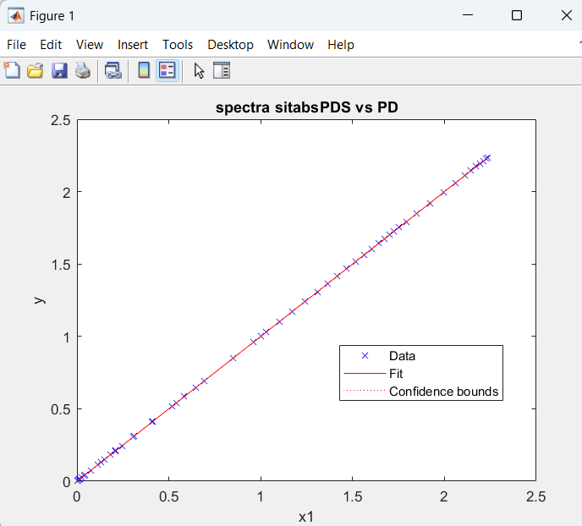
Average x0306101417n vs average x1pd0306101417n

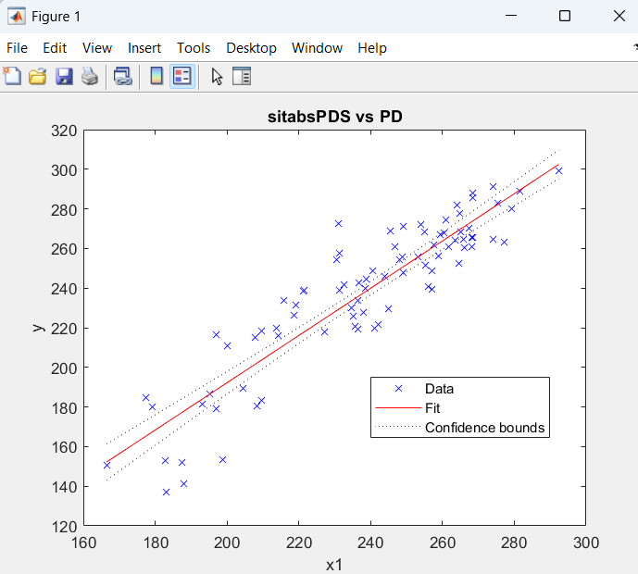
Model output (w) using Pam PDS vs PD data and CGM readings
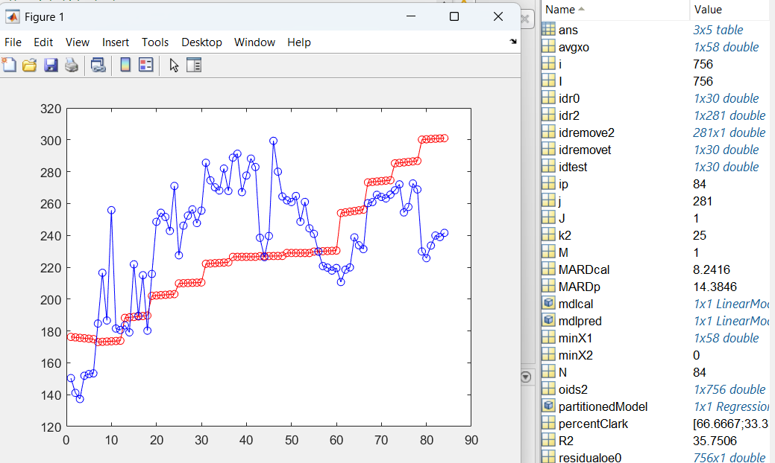
C:\Users\HP\Documents\MATLAB\WIP\Mike_Regression6\session_d1r0c0s030610141720PamPD1
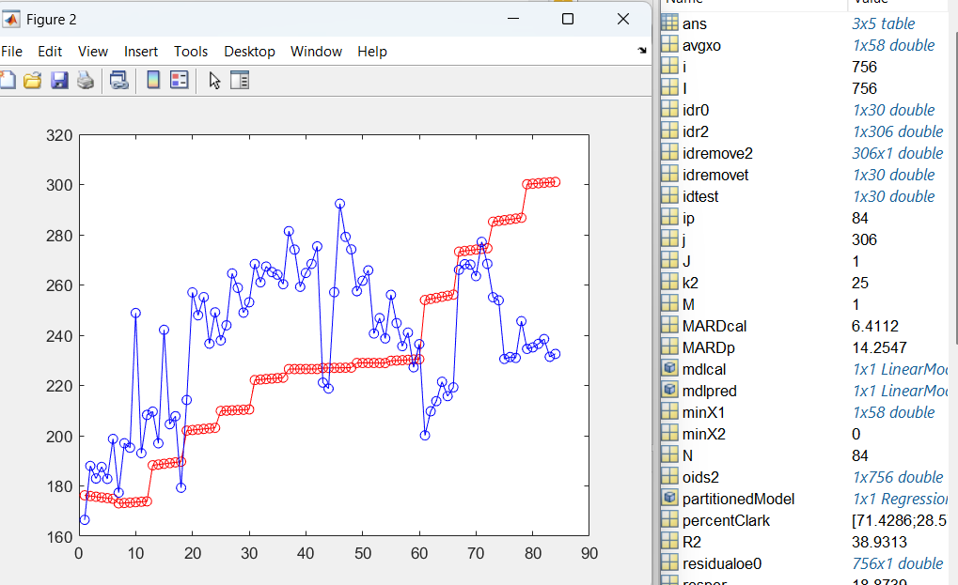C:\Users\HP\Documents\MATLAB\WIP\Mike_Regression6\session_d1r0c0s030610141720PamPD1sitabs
Comparison of Pam DC1 to DC2
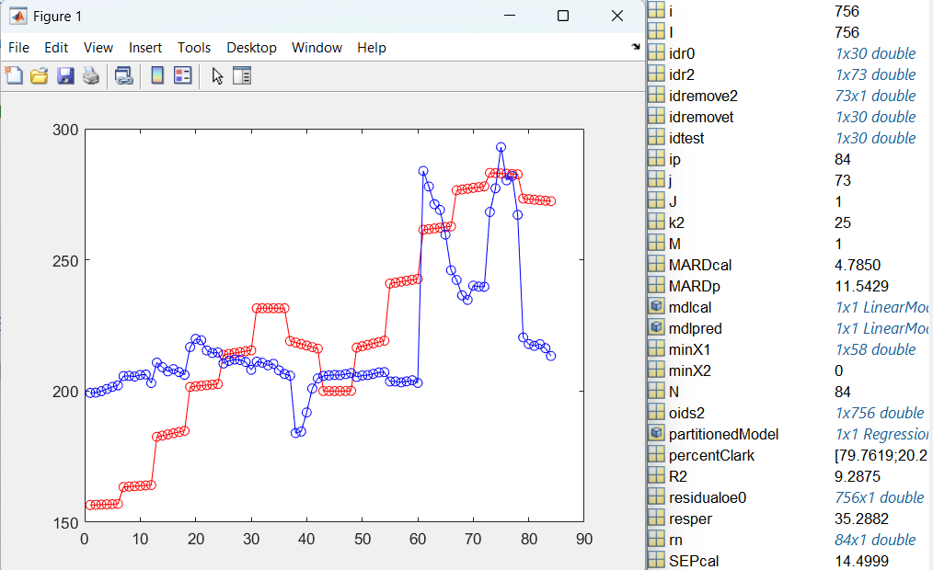
C:\Users\HP\Documents\MATLAB\WIP\Mike_Regression6\session_d1r0c0s030610141720PamDC2
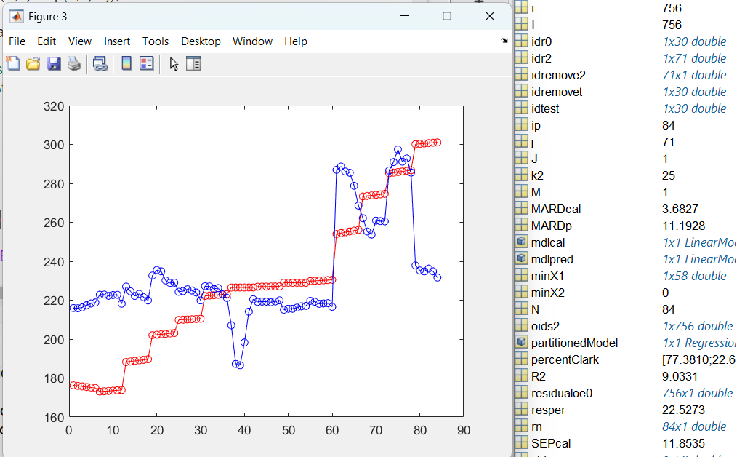
C:\Users\HP\Documents\MATLAB\WIP\Mike_Regression6\session_d1r0c0s030610141720PamDC1
Comparison of Glucose readings Pam CGM y1xxx to Onetouch y2xxxx
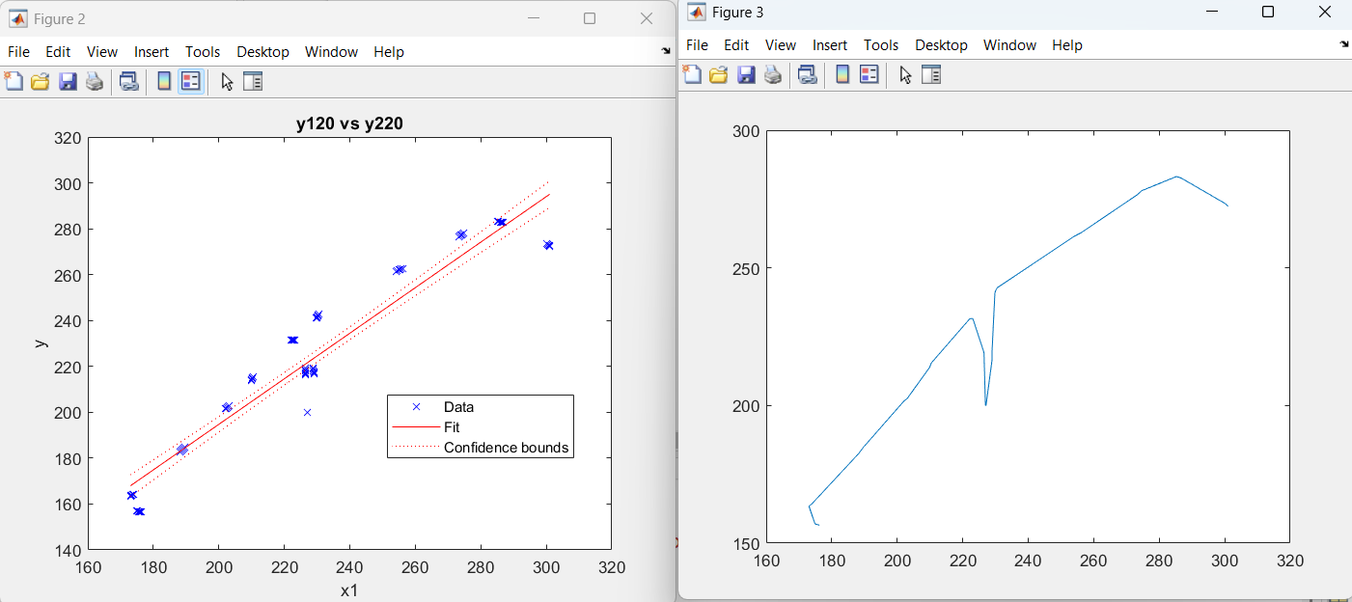
Dive is at x226,935 y200.016 CGM reading must be erroneous
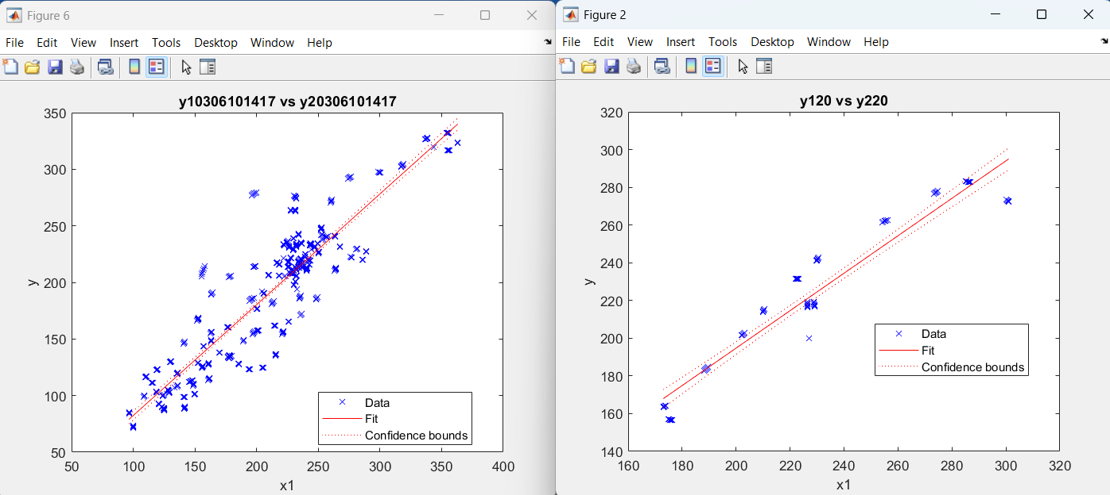

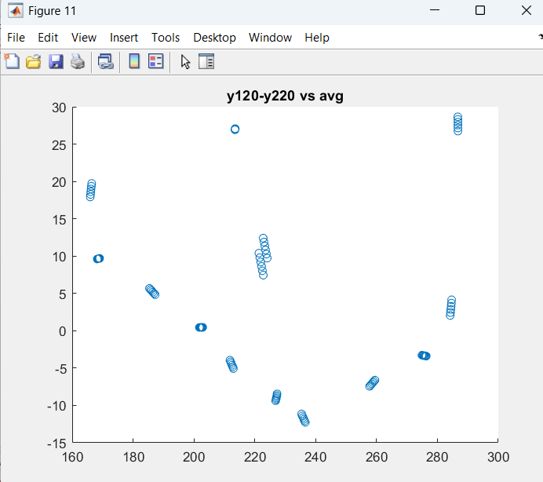
Difference vs average (middle clusters)
NEW DATA and PROGRAM Names

Note starting with this session meter # changed from 2 to 5
> %[104.367243029172] session 7 Mike
>> 192+102+114+222+144+168 = 942 sessions 1-6
So session 7 starts at index 943
Pams CGM has always been meter 1

Data_id9_CAL_XXXXX.m data_screen1_xxxxx.m
Regress_cal9_xxxxx.m data_cal1_xxxxx.m
Regres_prd9_xxxxx.m data_pred1_xxxxx.m

Spe_d1c0r0s20122b
Contains all spectra original pds from session sitabs normalized x01:x22 plus x1pd01;x1pd22 pds from session and
X1ac, x1dc, x1ad, x1dk also from session

sgl_d1r0c0s0122b4
contains Pam glucose taken with CGM y1xx (ex y120) and taken with OneTouch (ex y20)
sgl_d1r0c0s0122b
contains all glucose y2xx is one touch and
y1xx is cgm

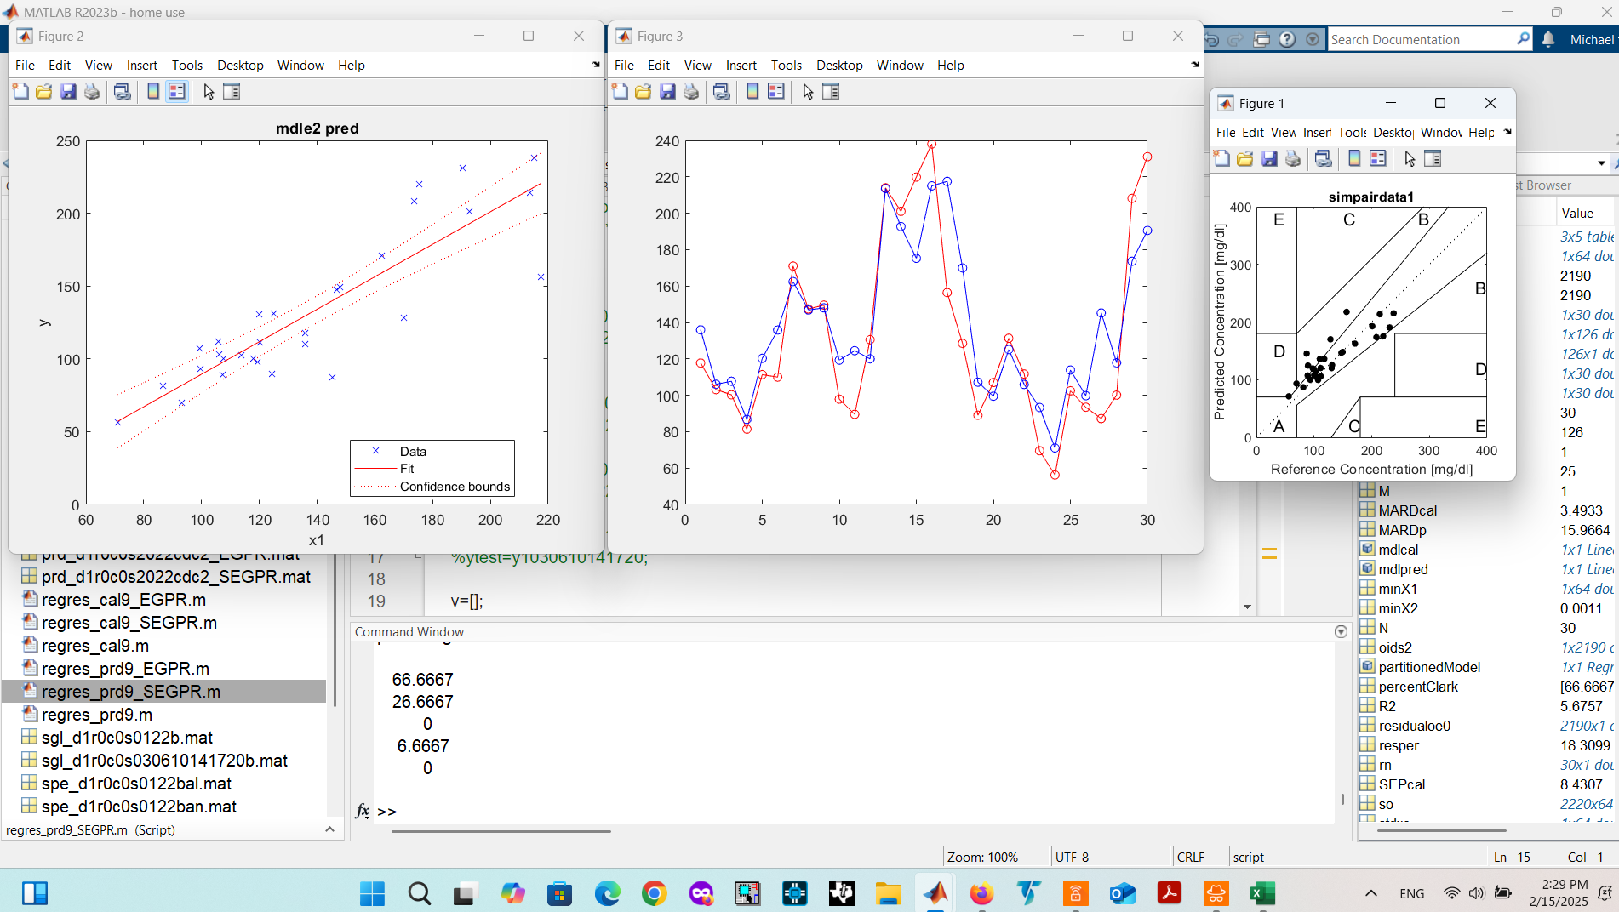
Sessions 1-19 cal. Pred with test spectra left out. Exponential GPR isotropic.
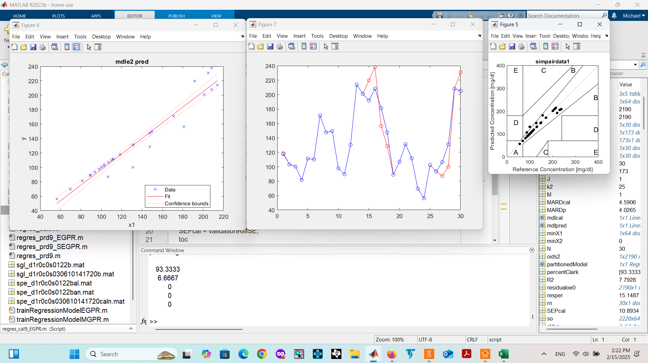

Sessions 1-19 cal. Pred with test spectra left out. Square Exponential GPR isotropic.

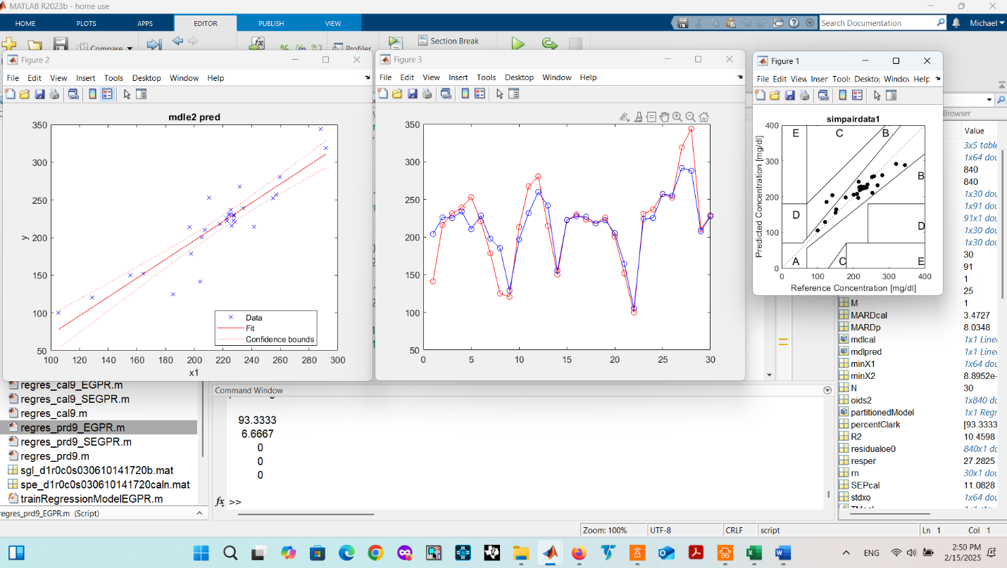
Sessions 1-19 cal. Pred with test spectra left out. Square Exponential GPR isotropic

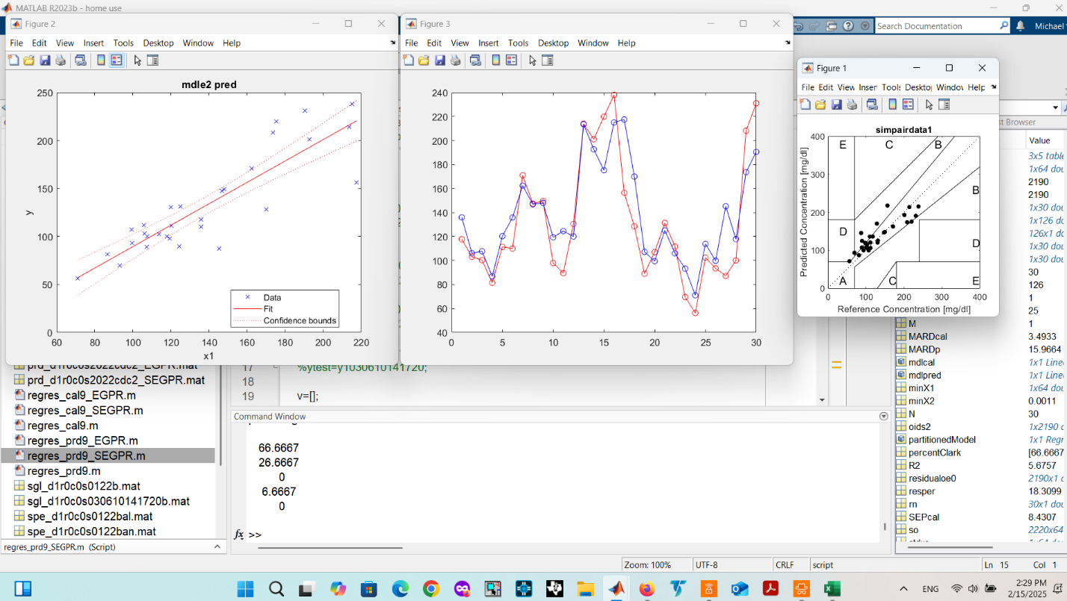
Sessions 1-19 cal. Pred with test spectra left out. Exponential GPR isotropic
%Mike Sessions: x1pd/y2v 01,02,07,09, 12
Prediction: 07
Calibration: 01,02,09,12
%Pam Sessions: x1pd/y2v (03),06,10,14,17,20
Prediction: 14
Calibration: 06,10,17,20
%Jake Sessions: x1pd04,13,15,18,21
Prediction: 01
Calibration: 41,13,18,21
%Univ Sessions: all above
Prediction: 07,14,15
Calibration: 01,02,040,06,09,10,12,13,14,17,18,21
Universal Sessions: X1pdUniv/y2vUniv 01,02,04,06,09,10,12,13,14,17,18,21

Pam sessions: x1pd/y2v and x1dc/y1v 06,10,14,17,20

x1pdPRD/y2vPRD x1pd/y2v 06,07,11,13,19
x1pdCAL/y2cCAL x1pd/y2v 01,02,04,05,08,09,12,14,15,16,17,18,20,21,22

remove3 Anomalies
remove2 Residuals
removen Novelties
%Note x2022nx is actually dc not pds nx is x2022n in spect_d1s0122c2

Data Filename and Variable Coding

Protosession Related
‘d1 protosessions64_25hz.mat
‘d2 protosessions64_12hz.mat
‘d3 protosessions64_125hz.mat
‘d4 protosessions256_125hz.mat

Averaging Related with data from protosession256_125hz
‘r0c0 raw, no averaging (256/125, 2478x256 data matrix)
‘r1c0 average rows 6to1, average cols no (256/25, 413x256 data matrix)
‘r1c1 average rows 6to1, average cols 4to1 and (64/25, 413x64 data matrix)
‘r0c1 average rows no, average cols 4to1 (64/125, 2478x64 data matrix)

Session Data Designator
‘c combwined sessions
‘I individual sessions
‘b both, combined and individual sessions
‘s01 session 1
‘s22 session 22
‘s0119 sessions 1-19
‘s2022 sessions 20-22
‘s0122i sessions 1-22 in individual session variables
‘s01222 sessions 1-22 in combo one variable

Type Related
ac ac
dc dc
ad acdc
pd pds
dk dark
al all

Spectra Data Variable Names
x1 unormalized spectra data r0c0
x2 unormalized spectra data r1c0
x3 unormalized spectra data r1c1
x4 unormalized spectra data roc1

Headers
‘spe spectra data input to data_id_spectraN_CAL/PRD script
‘sgl glucose data corresponding to above spectra data input to data_id_spectraN_CAL/PRD script
‘dat output of data_id_spectraN_CAL/PRD script (finds outliers in calibrtaion dataset or in prediction dataset equivalently)
‘cal output of regres_calN_CAL/PRD script (trains calibration model on calibration data or prediction dataset (not necessary)
‘prd output of regres_predN_CAL/PRD script

Examples
‘spect_d4r0c0s0122bal.mat spectra data from protosession256_125hz, of sessions 01-22, both combo and individual, averaged pixels 4to1, all type.
‘sgluc_d1r0c0s0122b.mat spectra glucose reference readings from protosession64_25hz,both, no averaged rows. Note column averaging is irrelevant averaged pixels is irrelevant in this case.

Addition of dc to ad

Cross-Validation
-60mV 4.4290
-30mV 4.3579
0 4.3413
+30mV 4.5761
+60mV 4.5313

Prediction Min
+6.45mV 21.0 -1.2% lower than 0mV

Raw Observed minus fitted values
Pearson Raw residuals divided by the root mean squared error (RMSE)
Standardized Raw residuals divided by their estimated standard deviation
Studentized Raw residual divided by an independent estimate of the residual standard deviation. The residual for observation i is divided by an estimate of the error standard deviation based on all observations except observation i.

Leverage Diagonal elements of HatMatrix Leverage for each observation indicates to what extent the fit is determined by the observed predictor values. A value close to 1 indicates that the fit is largely determined by that observation, with little contribution from the other observations. A value close to 0 indicates that the fit is largely determined by the other observations. For a model with P coefficients and N observations, the average value of Leverage is P/N. A Leverage value greater than 2*P/N indicates high leverage.
CooksDistance Cook's distance CooksDistance is a measure of scaled change in fitted values. An observation with CooksDistance greater than three times the mean Cook's distance can be an outlier.
Dffits Delete-1 scaled differences in fitted values Dffits is the scaled change in the fitted values for each observation that results from excluding that observation from the fit. Values greater than 2*sqrt(P/N) in absolute value can be considered influential.
S2_i Delete-1 variance S2_i is a set of residual variance estimates obtained by deleting each observation in turn. These estimates can be compared with the mean squared error (MSE) value, stored in the MSE property.
CovRatio Delete-1 ratio of determinant of covariance CovRatio is the ratio of the determinant of the coefficient covariance matrix, with each observation deleted in turn, to the determinant of the covariance matrix for the full model. Values greater than 1 + 3*P/N or less than 1 – 3*P/N indicate influential points.
Dfbetas Delete-1 scaled differences in coefficient estimates Dfbetas is an N-by-P matrix of the scaled change in the coefficient estimates that results from excluding each observation in turn. Values greater than 3/sqrt(N) in absolute value indicate that the observation has a significant influence on the corresponding coefficient.
HatMatrix Projection matrix to compute fitted from observed responses HatMatrix is an N-by-N matrix such that Fitted = HatMatrix*Y, where Y is the response vector and Fitted is the vector of fitted response values.
Look at
session_0119and2022x
for meter 3 glucose readings processing
and for
outlier method comparisson
Data via regular scripts

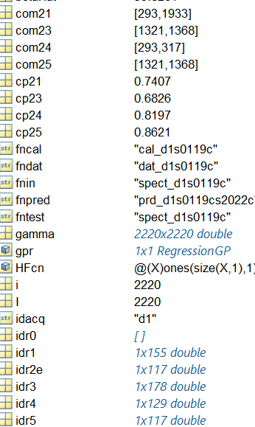

- spect_d1s0119c.mat data_id_spectra6_CAL.m dat_d1s0119c_CAL,mat
regres_cal6_CAL cal_d1s0119c_CAL.mat
- spect_d1s2022c.mat regres_cal6_PRD.m dat_d1s2022c_PRD.mat
- regres_pred6_CAL.m prd_d1s0119c_CAL.mat

spect_d1s2022c
data_id_spectra6_PRD
dat_d1s2022c_PRD

regres_cal6_PRD
regres_pred6_CAL
regres_pred6_PRD

See
data_id_outliers.m
data_id_metric.m
Method 5 exGPR picks most prediction outliers (new x-data) common to calibration residuals also by exGPR
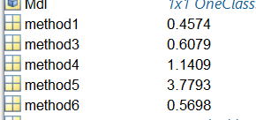
Method 6 does too
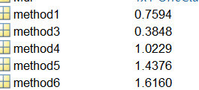
But 4 shouldn’t be ignored. It is however PLS based. So there is duplication with 5.
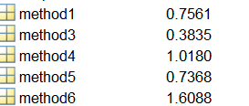
So just use 5 and 6.
Data via _CAL and _PRD versions
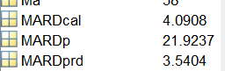
Cal SEP=10.7 MARD=4.09
Pred MARD=21.9 fractionaly lower with no outliers remeoved
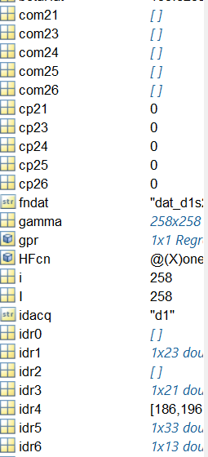

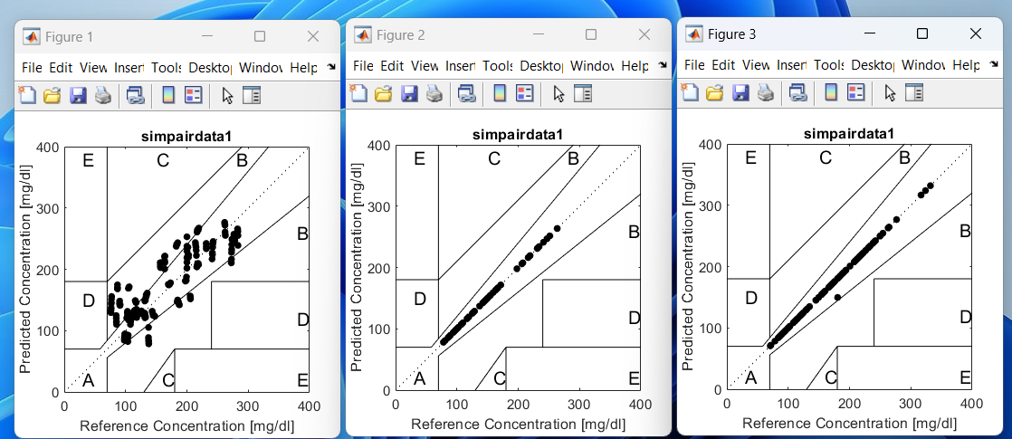
Used sessions 1-19 for calibration and 20-22 for independent prediction (l), test spectra set aside and removed from session 1-19 data set before calibration (m), and spectra removed from session 1-19 data set based on residuals > 25 mg/dL (r). Point off is x=70, y=56.

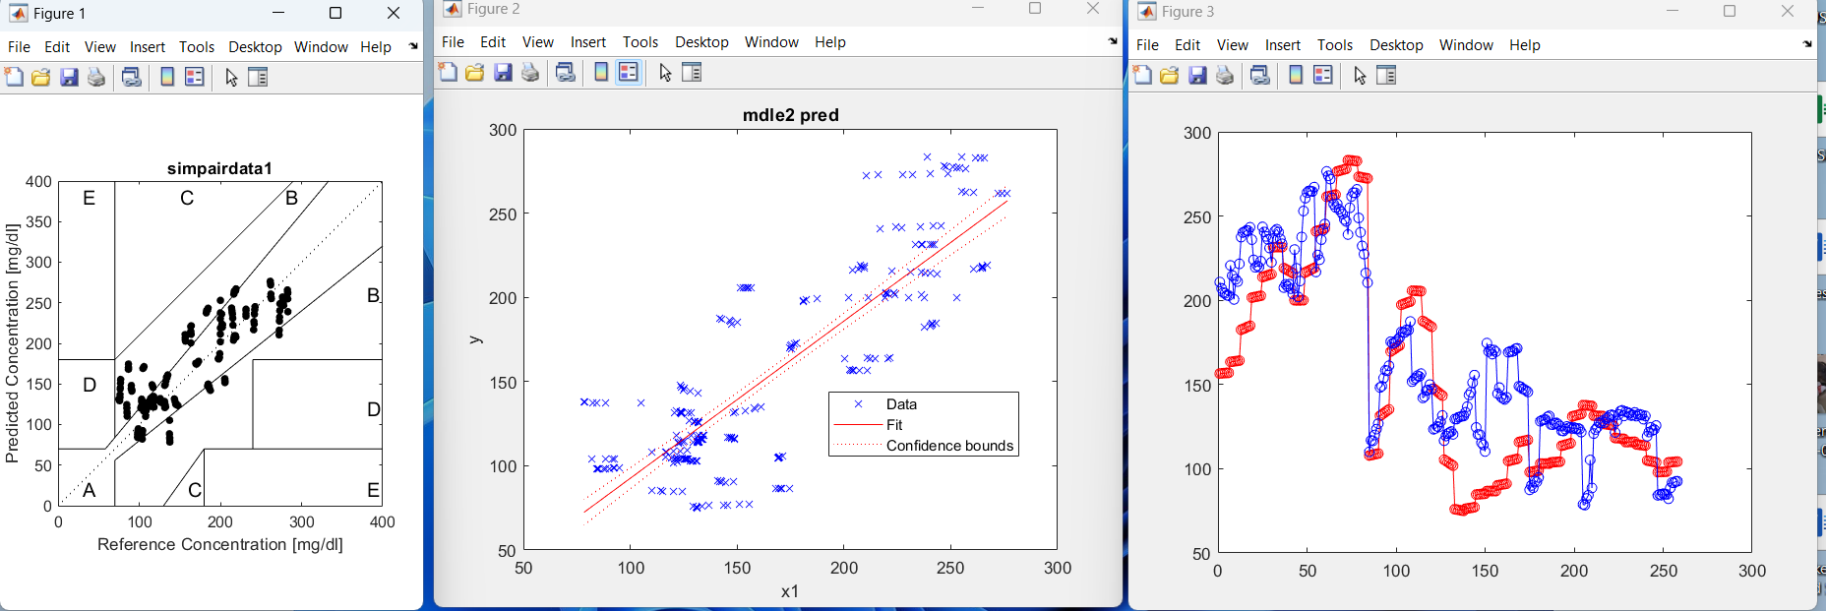
Independent prediction: Clark error grid (l), regression plot (m), predicted (blue) and reference concentration (red) vs record number (time).

- Model Validation: SEP = 11.2 mg/dL, MARD = 4.4%
- Prediction: MARD = 22.1%
- Clark Error Grid: zone A = 61.2%, zone B = 38.8%

mike pitsakis invited you to a Microsoft Teams Meeting:
CoraLuma Meeting
Saturday, January 4, 2025
1:00 PM - 1:30 PM (EST)
Meeting link: https://teams.live.com/meet/9342964729935?p=K6lSZofESqmQWtdU4K
Standardized acdc
Insion
Microbotd
Microparts
Q tune cnadian

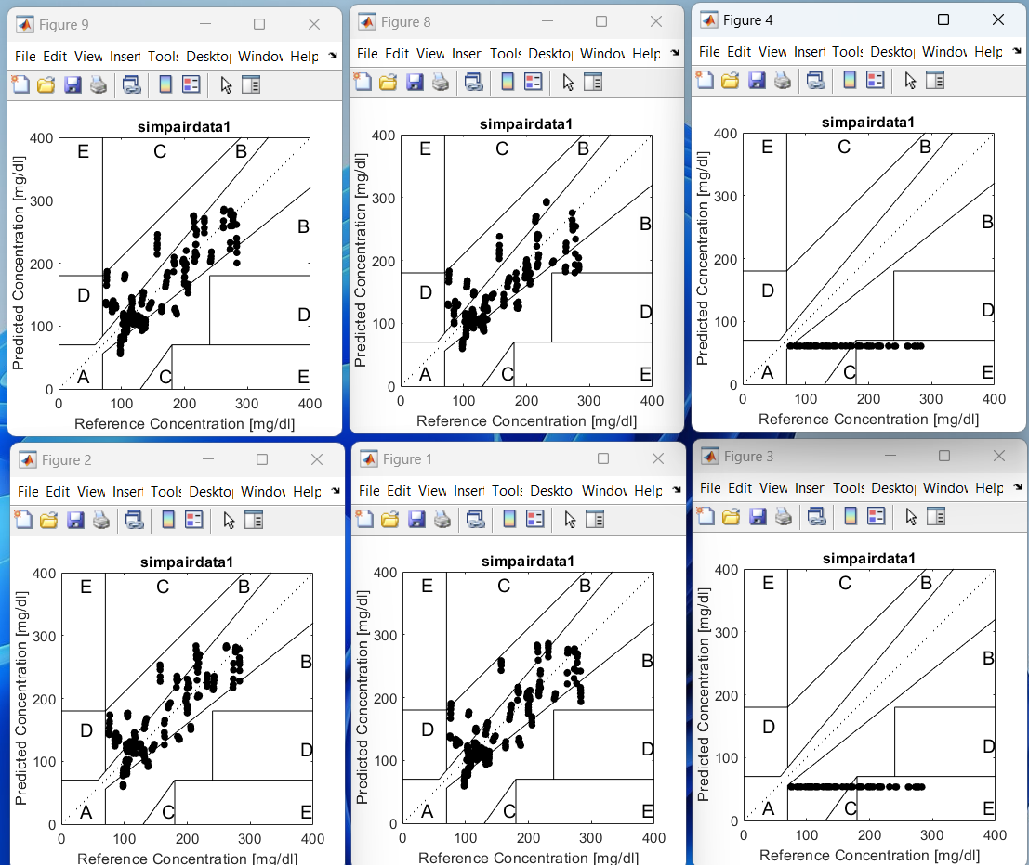
ACDC cal DC pred ACDC pred AC pred
DC cal DC pred ACDC pred AC pred

80 84
Tst_d1s20k1154.mat
2.723722885684039e+02
1.170908823611373e+02
1.168420026697518e+02
1.042381812942970e+02

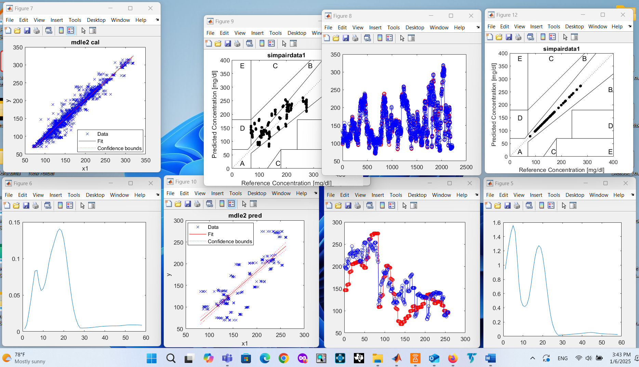
Sessions 1-19 use for cala md 20-22 for pred. Glucose vales are either meter 3 (lite) or reference to it.
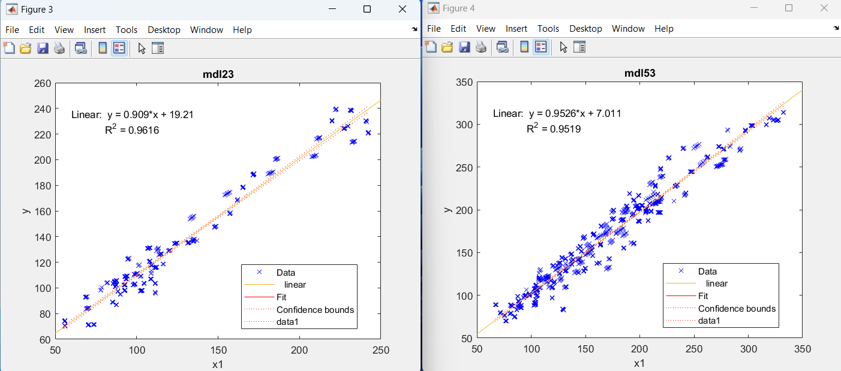
Session 456 meter 2 (ultra) vs meter 3 (lite) session 9, 13-22 meter 5 (verio) vs meter 3 (lite)

W2
215 pixel index corresponds to 1699.39212100000 nm
In 1:64 this corresponds to 54 index

[1:28 35:64]
1)Dark all anomaly and relation to outliers (skin anomaly and residuals)
data_concat_darks.m Script concatenate all dark sessions from a protosession
data_darkallsessions.mat concatenated dark of all session (dses and dsit variables)
data_anomalyocsvm.m anomaly detection script
data_anomaly_darkall.mat workspace
data_skin_index.mat
data_dark_index.mat
data_darknskinindex.mat
data_anomaly_darknsknindex.mat
data_anomaly_darknsknindex.txt
Note: Dark anomalies much those of skin. Need repeat to confirm
Dark
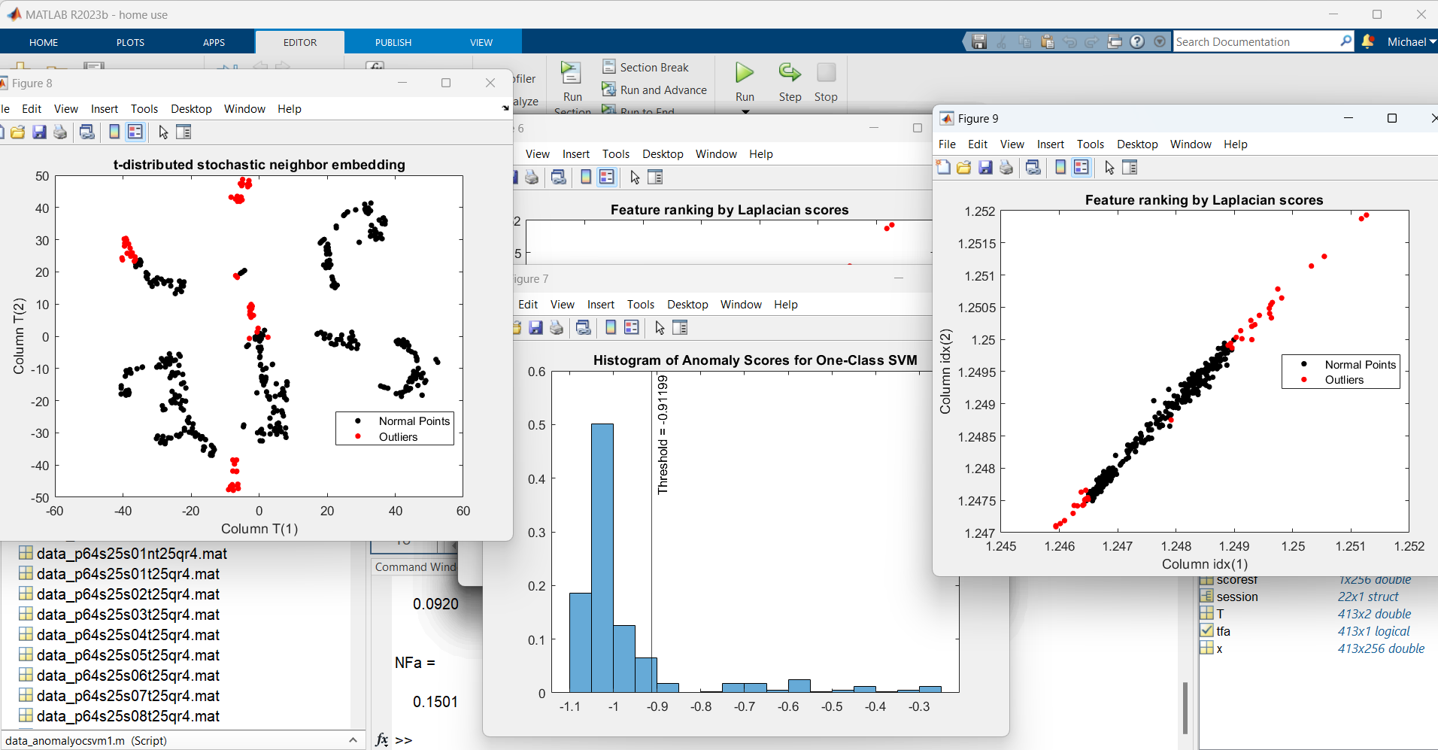

skin
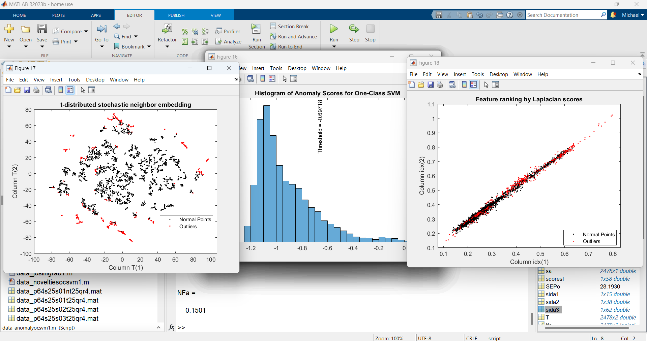
data_skinxndarkdses.mat includes dark dses and skin x of all sessions plus examples of raw skin dark and reference (datap, datad, datar, see csv files in folder). Get anova and covariance by data_anova.m
Look at common1 variable that is the result of intersection of ida3 and idcaln (anomalies and residuals) and common2 variable intersection of sida3 and above. However in latter case, sida3 and the rest have no time synchronization.
Bottom line is how you sync dark to adjusted skin signal when the first is 413 x 256 and the second is 7500 x 58? Look at untitled400.m

2) Cal all minus tests and cal all minus residuals and cal all minus anomaly on xbn and comparison
Cal_p64s25s0122clt25r1.mat
Cal_p64s25s0122cqt25r6.mat
Got xbn based on xn, which is less than half the original x size) but not clear to remove outliers
Should try xb based on x not xn
Need to repeat see
cal_p64s25s0122colt25r1.mat and
cal_p64s25s0122coqt25r6.mat

3) Tried to cal with fewer than 58 pixels and got error from GPR function. See spect_x01short.mat
For 50,44,36,32 pixel xo1 data. Found out that the GPR function is strictly for 58 pixels as saved from the Learner.
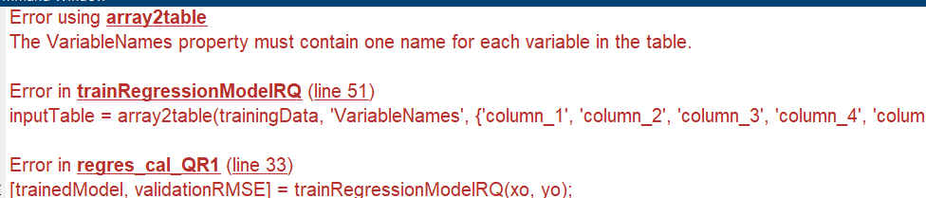

4) Jerry’s GPRMathSteps.m, which variable is considered b vector? Note: loads x.mat in folder and calls trainedModelGPR_RQ.m function.

5) Joslin data (j017.mat) JoslinRegressionLearnerSession (2).mat running with either script
regres_cal_LR5.m or regres_cal_QR5.m gives same error as 3).
NOTE: These two scripts remove test spectra only and run cal (no residuals)

6) increasing k of anomalies to 0.3 seems to match the number of anomalies to residuals at 25mg/dL, that is 743 vs 775 (going to 0.35 exceeds 867). Use data_anomaly_extra.m for beyond k=0.15.
7) Assuming that large prediction error beyond calibration is due to lower SNR and drift.
a. Determine how bad drift is by tracking it vs time. If an issue, you can possibly ratio it out by getting a reference sample spectra at calibration time (an average of all reference readings at all sittings) and thereafter scale skin spectra by multiplying by current reference reading to calibration reading.
b. Pick high ac sittings/spectra and use only them to calibrate. Then run predictions only using high ac sittings. Does prediction error become manageable?

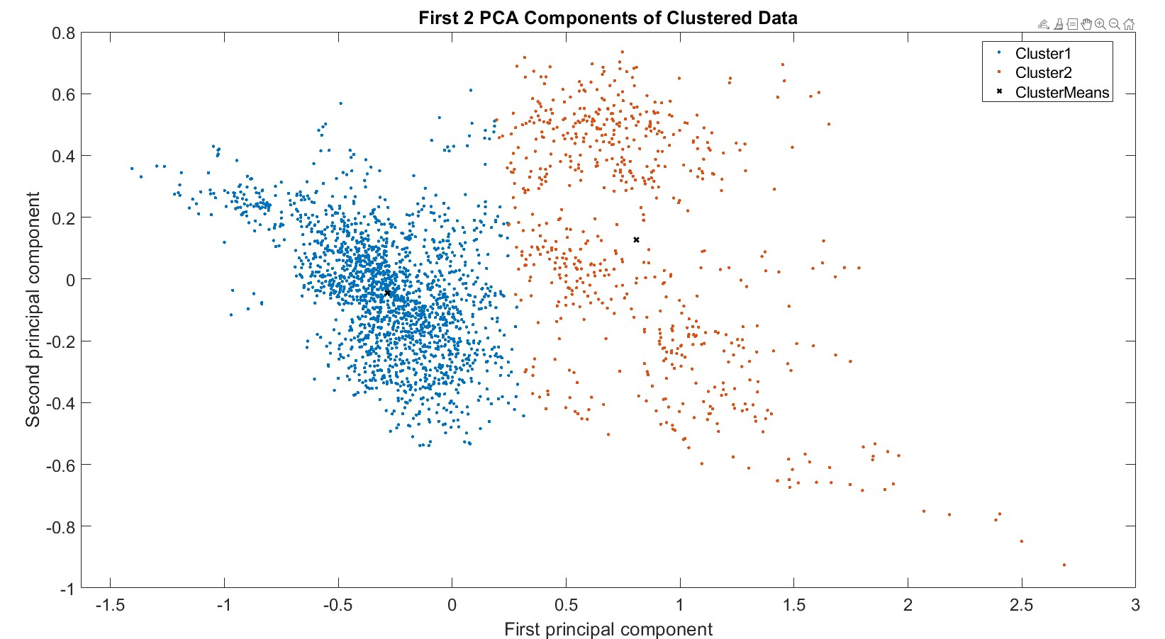

Jerry: Cluster of 64 pixel 0-1 pds spectra. Text Oct 31 at noon
For either objective, it can be shown that the principal components are eigenvectors of the data's covariance matrix. Thus, the principal components are often computed by eigendecomposition of the data covariance matrix or singular value decomposition of the data matrix. PCA is the simplest of the true eigenvector-based multivariate analyses and is closely related to factor analysis. Factor analysis typically incorporates more domain-specific assumptions about the underlying structure and solves eigenvectors of a slightly different matrix. PCA is also related to canonical correlation analysis (CCA). CCA defines coordinate systems that optimally describe the cross-covariance between two datasets while PCA defines a new orthogonal coordinate system that optimally describes variance in a single dataset.[2][3][4][5] Robust and L1-norm-based variants of standard PCA have also been proposed.[6][7][8][5]
Jerry
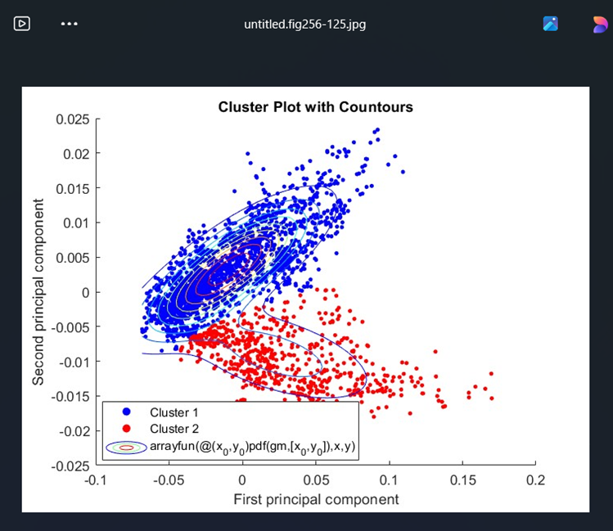
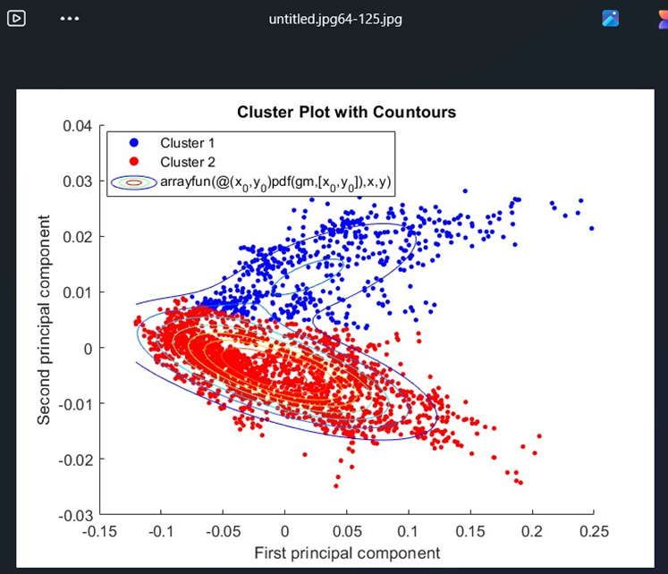
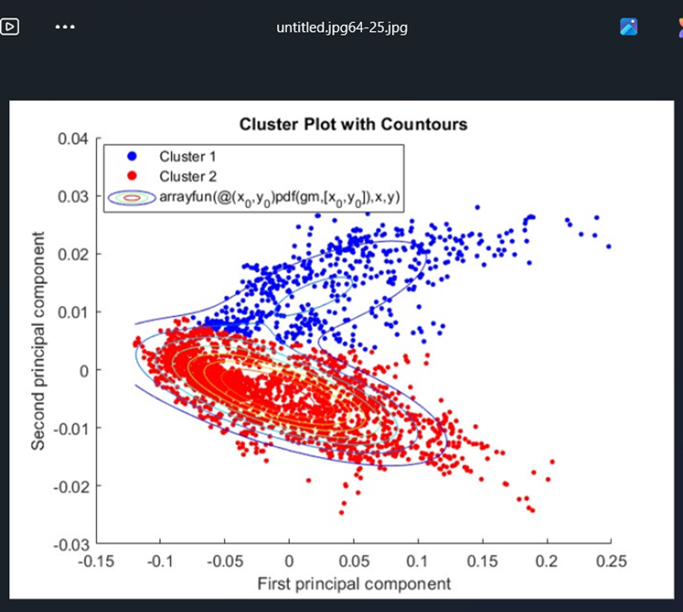
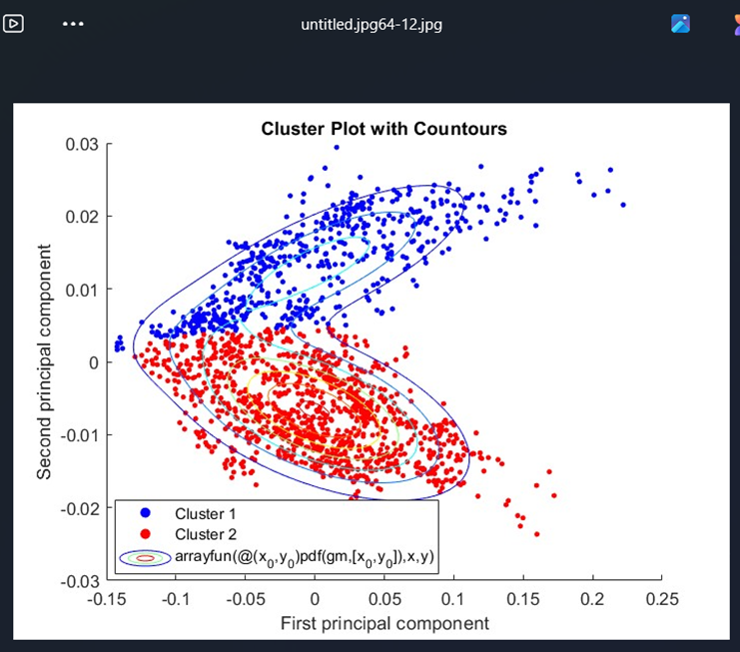
Ok ... I did do a quick check on the residuals for each cluster the hierarchical approach found (i set the limit 2-5 and it found 5). Some clusters have fewer occurrences of high magnitude residuals than others. None of the clusters had ALL residuals in the <15% range. This is all wrt a single GPR rational quadratic regression on all of the data. I have not built individual cals for each cluster yet. I also have not checked the regression or cluster tools to see if they produce any "artifact" indicators
Jerry
Been trying to relate outliers to residuals (conclusively) for months now.
That said, using the GPR-RQ regression then plotting residuals for a given cluster definitely shows some clusters have a residual distribution closer to zero than others.
RE Ogawa, he mentions removing samples with "artifact" but doesn't say if the "artifact" value is produced by the ML-regression step or by a classification/cluster step. I haven't downloaded the python toolbox to see if i could deduce that from the toolboxes
Jerry
gmm stands for Gaussian Mixture Modelling. Version2=2 clusters, 3=2 clusters.
kmeans allows to define number of clusters 2:4.
I include loadandpick for a quick evaluation of the above as it needs to run first.
Looks like kmeans method partitions along the 1st PC.
1) The m files need validation. Please help with that.
2) We can pick outliers based on posterior probability but need to set thresholds to do so.
3) Then related outliers to spectra and exclude from calibration.
Mike
Use gmm2a.m and loadandpick2a.m gmm2b.m

Steps to Perform PCA Using Linear Algebra

1. Standardize the Data:
Before PCA, it’s essential to standardize the data, meaning each feature should have a mean of 0 and a standard deviation of 1. This ensures that all features contribute equally to the analysis.
Z = (v – mean)/stdev
2. Compute the Covariance Matrix:
With standardized data, calculate the covariance matrix to capture the relationships between features.

Cov Z = Z * Z’
3. Calculate Eigenvectors and Eigenvalues:
Decompose the covariance matrix to get its eigenvectors and eigenvalues. These eigenvectors represent the principal components of the data.
4. Sort Eigenvectors by Eigenvalues:
The eigenvector with the highest eigenvalue represents the most significant principal component, and so on.
5. Transform Original Data:
Multiply the standardized data by the selected (top) eigenvectors to transform it into the reduced-dimensional space.
Final Data Set = Feature Vector’ * Standardized Original Data Set’

NOTE: All below work based on load('protosessions64_25hz.mat')
Clustering
11/7/24
Have programmed cluster grouping script based on Gaussian
Removing one of two PCA clusters of a session resulted in worse val MSE calculated on 1st and 2nd components
Removing PCA “outliers” of a session resulted in worse val MSE calculated on 1st and 2nd components
Have not used more than 1st and 2nd components for val Should try.
Val/Test
11/17/24
Have all sessions (1-22) individual in a mat file (for 1-6 one touch 7-22 Verio)
Have all initial sessions (1-22) combined in a mat file (for 1-6 one touch 7-12 Verio)
Have all later sessions combined (after light leak fix 14-22 Verio) in a mat file
Appears Rational Quadratic Gaussian Process Regression produces lowest MSE and Optimizable GPR s bit better
Val within each session has reasonable MSE even for Pam
Test within each session has excellent MSE
Cross test even for same person shows high MSE
Tried val using 1st and 2nd component MSE not as good. Should try more components and compare
Also need need to try recombosition of x matrix from PCA components
Val using group of combined sessions 14-22 has decent MSE and Test with has excellent MSE (is this indication of group calibration possible) but Test outside group shows results to similar to single sessions
Cross tests show varying MSEs some not bad but why some bad and some not bad
11/19/24
Calibrations Validations by RQGPS on group of sessions 1-12 combined shows sep ~27 while on group of sessions 13-22, shows sep~28. This probably means that light leak doesn’t contribute to sep. However, I’d expect stray light to increase shot noise.
Prediction Tests by RQGPS using sessions within above groups show extremely low sep<1 (it doesn’t jive with 27-28 of val, so too good to be true).
Prediction Tests by RQGPS using sessions outside above groups show high sep>30.
Calibration Validations by RQGPS on group of sessions 1-12 combined and using all 58 principle components instead of x shows sep ~36 while on group of sessions 14-22, shows sep~45. Both seps are much higher than regressions on x matrices.

1-12
26.8 58
41.7 2
36.9 20
36.8 28
35.7 58
32.7 264
1-22
38.4 264

Anomalies and Novelties
11/17/24
Have m file for both above based on One Class Support Vector Machines OCSVM
Ran a few sessions and they shows a few outliers but novelties show differences between val and test. Need to investigate.
11/19/24
Focused on anomalies script (because it can detect outliers in x data alone so it can be applied to prediction tests) and improved. Now need to preselect a percentage of anomalies expected in data (same as help script).
Note that novelties test, which requires both x and y, can be applied to an iterative calibration but also to prediction test on the fly to some extent.

Classification
11/7/24
Jerry got Classification Learner trained on a k-mean 9 clusters. 40 out of 2700 get misclassified. He is going to do vals per class

RCA
t-distributed stochastic neighbor embedding (t-SNE) is a statistical method for visualizing high-dimensional data by giving each datapoint a location in a two or three-dimensional map. It is based on Stochastic Neighbor Embedding originally developed by Geoffrey Hinton and Sam Roweis,[1] where Laurens van der Maaten and Hinton proposed the t-distributed variant.[2] It is a nonlinear dimensionality reduction technique for embedding high-dimensional data for visualization in a low-dimensional space of two or three dimensions. Specifically, it models each high-dimensional object by a two- or three-dimensional point in such a way that similar objects are modeled by nearby points and dissimilar objects are modeled by distant points with high probability.
The t-SNE algorithm comprises two main stages. First, t-SNE constructs a probability distribution over pairs of high-dimensional objects in such a way that similar objects are assigned a higher probability while dissimilar points are assigned a lower probability. Second, t-SNE defines a similar probability distribution over the points in the low-dimensional map, and it minimizes the Kullback–Leibler divergence (KL divergence) between the two distributions with respect to the locations of the points in the map. While the original algorithm uses the Euclidean distance between objects as the base of its similarity metric, this can be changed as appropriate. A Riemannian variant is UMAP.

NOTE
yc0=cat(1,session.glu); %grab glucose reference readings (response) from session structure
y0(1:942)=yc(1:942,2) ;%pick one of two meters, col 2 of glu is the Ultra, col 5 is the Verio.
y0(943:1950)=yc(943:1950,5); %pick one of two meters, col 2 of glu is the Ultra, col 5 is the Verio.
y=y0';
xc=cat(1,session.sitabs); %grab normalized absorbance matrix (predictor) from session structure
x=xc(1:1950,[1:28 35:64]); %pick 58 of 64 pixels

Session | Meter | #Lines | From | To
1:6 | 2 | 942 | 1 | 942
7:12 | 5 | 648 | 943 | 1590
13 | 5 | 126 | 1591 | 1716
14:22 | 5 | 762 | 763 | 2478
 |  | 2478

2 ultra and 3 lite sessions 4-6
5 vario and 3 lite sessions 9,13-22

basic.absorbance
1 Data Type (4= ref, 2=dark, 1=ctrl, 5=skin)
2 Time Stamp
3 Patient ID
4
5:68 Spectra
69:80 Sensors
68 sessions 408 sittings
raw.rawdata
1 Data Type (4= ref, 2=dark, 1=ctrl, 5=skin)
2 Time Stamp
3 Patient ID
4 counts column 7 loops
5 sitting 1:408
6 session 1:68
7 loops 1:16 and over again
8:71 Spectra
72:81Sensors

%The following while loop reads all of the .PD file into a numeric matrix of the following format:
%Data type, Time Stamp, Patient ID, Serial Number, Spectrum Type, Mode, Sitting Count, Session Count,
% 1 , 2 , 3 , 4:15 , 16 , 17 , 18 , 19 ,
%SubSession Count, BinCode, Invasive, D2K Prediction, Control, QM Flag, Status, Bias Correction,
% 20 , 21 , 22 , 23 , 24 , 25 , 26 , 27 ,
%Alert, 64 Pixels and 11 Sensors
% 28 , 29:103
numeric matrix of the following format:
1 Data type,
2 Time Stamp,
3 Patient ID,
4 Serial Number,
5 Spectrum Type,
6 Mode,
7 Sitting Count,
8 Session Count,
SubSessionCount,
BinCode,
Invasive,
D2K Prediction,
Control,
QM Flag,
Status,
Bias Correction,
% 20 , 21 , 22 , 23 , 24 , 25 , 26 , 27 ,
%Alert,
64 Pixels and
11 Sensors

