1200-1800 nm
Semiconductor Laser Array

Presented to:
Keith Keeling
Dominion Asset Finance Corporation

Proprietary Information
The information contained in this document is proprietary to QPC Lasers, Inc. (QPC) and should not be disclosed, copied, reproduced or distributed without the written permission of QPC.

Prepared, reviewed, or approved |  | Function | Date
P R A | Paul Rudy, Ph.D. | VP Marketing and Sales | March 9, 2007
RA | Ed McIntyre | Director of Marketing | March 9, 2007
RA | Jeffrey Ungar, Ph.D. | CEO, President | March 9, 2007

Introduction
QPC Lasers, Inc. (www.QPClasers.com) is a world leader in the development and commercialization of high brightness, high power semiconductor lasers for the defense, homeland security, industrial, and medical markets. Founded in the year 2000, QPC is vertically integrated from epitaxy through packaging and performs all critical fabrication processes at its state-of-the-art high-technology semiconductor laser fabrication facility in the Los Angeles suburb of Sylmar, CA. QPC is ISO certified and holds 15 patents on semiconductor laser technology. QPC is a publicly traded U.S. company (NASD: QPCI).
This document describes the non-recurring engineering funding required for the development and delivery of 1200-1800nm Individually Addressable Internal Grating Stabilized High Power Single Mode Surface Emitting Semiconductor Laser Arrays, hereinafter called the “Product”.

Analysis of the blood glucose monitoring laser specification
QPC has considered the technical requirement for this blood glucose monitoring applications. Several important technical requirements are noted:
- Low cost, high volume architecture: The lowest cost structure and highest volume manufacturability is achieved with a single laser ship solution. QPC has patented the world’s only high power surface emitting laser array (HPSEL) which enables a revolutionary decrease in cost, size, and weight.. Based on this semiconductor laser chip technology, QPC has won several competitive development contracts from the U.S. Navy and Department of Defense Advanced Research Projects Agency to develop laser chips for high energy weapons applications.
- Narrow line width and precise control of center wavelength of each laser line: An internal grating is required since typical high power semiconductor lasers in the 1200-1800nm range emit light with 8-10nm linewidth. Achieving <2nm FWHM is only possible in a low cost application with an internal grating in the chip since external stabilization optics/gratings will add unnecessary cost, expensive high precision alignment, and reliability issues. QPC is the industry leader for Internal Grating technology and has developed lasers with Internal Gratings at 808, 976, 1470, 1532, and 1550 nm.
- All emitters to focus to a 200um spot: This requirement is best met with single transverse mode performance. QPC has the highest power single mode 1550nm device which is also single frequency with narrow spectrum achieved with Internal Gratings.
- Broad wavelength range at 1200-1800nm: This requires extensive experience in the Indium Phosphide semiconductor laser material system. QPC has excellent efficiency from conduction cooled linear arrays and has offered industry leading products in the 1300-1600nm regime with excellent reliability for the past several years.
- Individual addressability of each emitter: QPC offers the 1550nm single mode single frequency laser product today with segmented emitters that enable independent driving of sections within the chip with small bond pads for high speed high power switching.
QPC’s HPSEL, Internal Gratings, and BrightLaseTM single mode laser technology
QPC has identified a low cost solution suitable for high volume production that meets the specification. The technology required is a QPC two dimensional high power surface emitting laser array with single mode emitters with internal grating.
As part of QPC’s technology roadmap, QPC has previously developed and demonstrated the unique and proprietary semiconductor laser technologies which are required for the 1200-1800nm surface emitting semiconductor laser array. This NRE proposal describes the funding required to join the technologies which have demonstrated independently into a product. Specifically, QPC has demonstrated two types of devices which, when joined together, will meet the requirement for blood glucose monitoring laser array:
- High Power Surface Emitting Lasers (HPSEL) with Internal Gratings: QPC has fabricated semiconductor laser array with >100 lasers on a single 2D chip that achieve narrow linewidth, precise emitter alignment for lensing, and low cost structure for high volume. This development effort was associated with a previously successful U.S. Navy contract where QPC demonstrated >300W 980nm Internal Grating Stabilized High Power Multi Mode Surface Emitting Semiconductor Laser Arrays with spectrum <1nm FWHM. The laser chip QPC developed is shown in Figures 1-3.
- 1550nm BrightLaseTM Single Mode Lasers with Internal Grating: QPC has fabricated high power >1W single mode single frequency emitters based on QPC’s proprietary InP material system. This development effort was associated with a previously successful U.S. Missile Defense Agency contract where QPC demonstrated high spatial brightness and excellent spectral brightness and stability which allows the laser beams to be focused to a small spot with a precise and narrow wavelength emission. The devices are edge emitting semiconductor lasers with individually addressable sections within the chip that can be driven quickly (>GHz). The laser chip performance is shown in Figure 4.
The two previously demonstrated laser device technologies were the result of successful development programs. This proposal describes a product development effort that combines these elements above and extending the wavelength range.
Beam Exit Window
Gain Layer
Transparent Substrate
Beam Deflector
DFB Section
Output Beam
Internal Beam
Figure 1: HPSEL device architecture
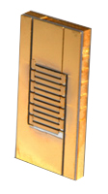
Figure 2: HPSEL device; roughly 1 cm x 1.5 cm

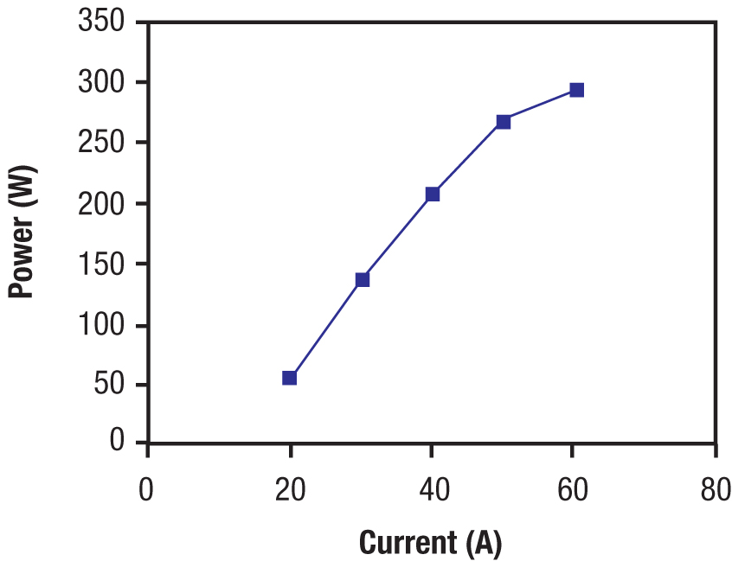 |  | 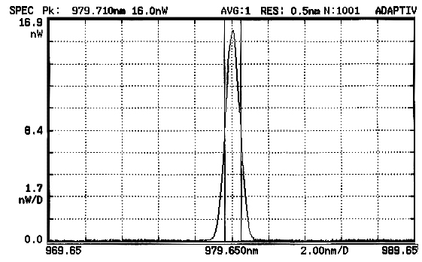
Figure 3: HPSEL device performance showing 300W at 980nm with spectrum <1nm FWHM.

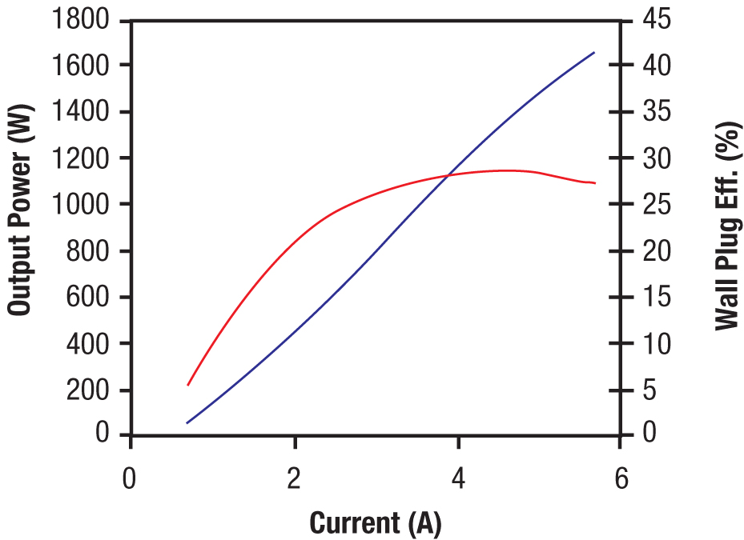 | 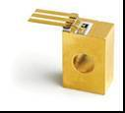 | 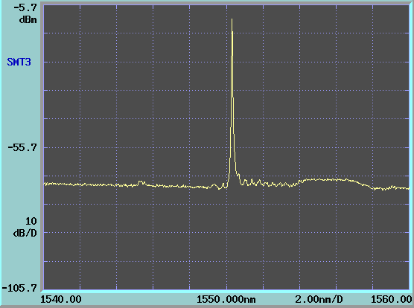
Figure 4: Single mode 1550nm edge emitting lasers showing >1W single frequency performance.

Advantages of QPC Semiconductor Lasers with Internal Gratings
QPC has demonstrated high power semiconductor lasers with internal gratings at 808 nm, 976 nm, 1470 nm, 1532 nm, and 1550 nm that narrow the linewidth, reduce the wavelength-temperature sensitivity, and ensure that the device operates at the desired center wavelength. Products are available at 808nm and 1550nm today, and other wavelengths and are available with NRE funding.
The performance of the InP semiconductor laser with an internal grating differs fundamentally from a conventional high power InP diode without the internal grating or from a conventional InP diode with an external grating. First, the ~ 1nm FWHM spectrum is significantly narrower than the 8-10 nm FWHM typically achieved in conventional high power diode lasers without a grating.
Another major difference between devices with an internal grating and conventional diode lasers is the lower wavelength – temperature coefficient. For conventional laser diodes, this coefficient is 0.35nm/ºC while for devices with internal gratings, it is 0.15nm/ºC. This reduction in temperature sensitivity relaxes the requirement for thermal stabilization, enabling systems with reduced size and weight.
A third major difference is the significantly improved center wavelength accuracy achieved in the manufacturing process. Conventional laser diodes are provided with a +/- 10nm center wavelength tolerance due to growth control and uniformity factors. On the other hand, the wavelength of devices with internal gratings is determined by the period of the grating which can be controlled accurately and is not affected by growth uniformity. This enables a +/- 1.0nm spread in devices from growth to growth, and wafer to wafer.
QPC internal grating approach offers high spectral brightness and stability in a robust design. The QPC internal grating approach offers several advantages over external grating approaches:
- QPC internal gratings eliminate the need for costly external optical stabilization elements and their associated costly high precision alignment
- QPC internal gratings offer a broad and robust temperature locking range as compared with the narrow temperature range of performance associated with external optical stabilization
- QPC internal gratings eliminate the failure mechanisms associated with external optical stabilization; even modest misalignment of an external grating may lead to device failure
- QPC internal gratings device performance is insensitive to bar smile and micro-optic alignment; devices built with external gratings are quite sensitive to drift of the micro-lens, changes in the the grating alignment, and any changes in the bar smile which may be induced by environmental changes over the life of the product
- QPC internal gratings eliminate the additional noise in both power and spectrum that associated with external optical stabilization techniques which exhibit time dependent noise associated with the mechanical instability of the external elements
Product Specification
The development of the Product is segmented into 2 Milestones.

Milestone 1
The deliverables of this milestone are fiber coupled devices that feature edge emitting internal gratings. One device will be delivered at every 5 nm over the 1200-1860nm wavelength range. The devices will be packaged in a Mini-Dil housing with the following geometry:
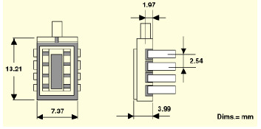
Each device will have the following specifications:
PARAMETER | QPC Specification
Power | 25mW minimum
Wavelength | 1200, 1205, 1210, … 1850, 1855, 1860nm
Pulse length/Duty cycle | 10usec, 0.2%, For 100usec, 0.4% peak power to be reduced.
Wavelength Tolerance | ± 1.5nm
Spectral Width (FWHM) | ≤ 2nm
Operating Current | ≤ 2A
Operating Voltage per emitter | ≤2V
Temperature tuning coefficient | <0.15 nm/°C
Operating conditions | 20^{O}C
Fiber diameter | 50 micron core or less
Rise time | <5 ns per element
Milestone 1 Pricing: NRE: $1,800,000
Milestone 1 Delivery Schedule for Deliverables:
- Phase 1 Project Initiation Report: This will be attached to the order acknowledgement and summarizes the key project elements such as design, documentation, fabrication, testing.
- Monthly Development Reports: Last day of each month
- Delivery for Devices: 6 months ARO
Milestone 1 Payment Terms:
Phase 1 Project Initiation | $130k Net 30 days after receipt invoice | $128k Net 180 days after receipt invoice
Month 1 Deliverable | $129k Net 30 days after receipt invoice | $128k Net 150 days after receipt invoice
Month 2 Deliverable | $129k Net 30 days after receipt invoice | $128k Net 120 days after receipt invoice
Month 3 Deliverable | $129k Net 30 days after receipt invoice | $128k Net 90 days after receipt invoice
Month 4 Deliverable | $129k Net 30 days after receipt invoice | $128k Net 60 days after receipt invoice
Month 5 Deliverable | $129k Net 30 days after receipt invoice | $128k Net 30 days after receipt invoice
Month 6 Deliverable | $129k Net 30 days after receipt invoice | $128k Net 30 days after receipt invoice
Milestone 2
The deliverables in this milestone feature edge or surface emitting arrays with internal gratings. Each element is individually addressable over a 1200-1860nm wavelength range. Three (3) prototypes of 20 x 7 arrays will be delivered with the following configuration of wavelengths:

1200 | 1205 | 1210 | 1215 | 1220 | 1225 | 1230 | 1235 | 1240 | 1245 | 1250 | 1255 | 1260 | 1265 | 1270 | 1275 | 1280 | 1285 | 1290 | 1295
1300 | 1305 | 1310 | 1315 | 1320 | 1325 | 1330 | 1335 | 1340 | 1345 | 1350 | 1355 | 1360 | 1365 | 1370 | 1375 | 1380 | 1385 | 1390 | 1395
1400 | 1405 | 1410 | 1415 | 1420 | 1425 | 1430 | 1435 | 1440 | 1445 | 1450 | 1455 | 1460 | 1465 | 1470 | 1475 | 1480 | 1485 | 1490 | 1495
1500 | 1505 | 1510 | 1515 | 1520 | 1525 | 1530 | 1535 | 1540 | 1545 | 1550 | 1555 | 1560 | 1565 | 1570 | 1575 | 1580 | 1585 | 1590 | 1595
1600 | 1605 | 1610 | 1615 | 1620 | 1625 | 1630 | 1635 | 1640 | 1645 | 1650 | 1655 | 1660 | 1665 | 1670 | 1675 | 1680 | 1685 | 1690 | 1695
1700 | 1705 | 1710 | 1715 | 1720 | 1725 | 1730 | 1735 | 1740 | 1745 | 1750 | 1755 | 1760 | 1765 | 1770 | 1775 | 1780 | 1785 | 1790 | 1795
 |  |  | 1800 | 1805 | 1810 | 1815 | 1820 | 1825 | 1830 | 1835 | 1840 | 1845 | 1850 | 1855 | 1860 | 1865

Each emitter will have the following specifications:
PARAMETER | QPC Specification
Spatial mode | Single mode or 50 micron emitters
Power | 25mW minimum
Pulse length/Duty cycle | 10usec, 0.2%, For 100usec, 0.4% peak power to be reduced.
Wavelength Tolerance | ± 1.5nm
Spectral Width (FWHM) | ≤ 2nm
Operating Current | ≤ 2A
Operating Voltage | ≤2V
Temperature tuning coefficient | <0.15 nm/°C
Package type | Roughly 1cm x 1.5cm
Operating conditions | 20^{O}C
Rise time | <5 ns per element
Optical power variance | < 5% (<.1% preferred) per element (repeatability)
Warm up time to stability | < 30 s
Max optical power variance | < 50% between elements if 300mW not achievable on all elements  (min power per element is 25mW)
Addressability | Each element, firing sequence not successive with wavelength
Milestone 2 Pricing
- NRE: $1,000,000
- NRE for Microlens array option to collimate the emitters: $250,000
Milestone 2 Delivery Schedule for Deliverables:
- Monthly Development Reports: Last day of each month
- Prototypes: 6 months after completion of Milestone 1
Milestone 2 Payment Terms:

Month 7 Deliverable | $209k Net 30 days after receipt invoice
Month 8 Deliverable | $209k Net 30 days after receipt invoice
Month 9 Deliverable | $208k Net 30 days after receipt invoice
Month 10 Deliverable | $208k Net 30 days after receipt invoice
Month 11 Deliverable | $208k Net 30 days after receipt invoice
Month 12 Deliverable | $208k Net 30 days after receipt invoice

Other terms and conditions:
- Other terms and conditions shall be as per QPC’s standard terms and conditions.
- This proposal shall be valid for 90 calendar days from March 9, 2007.

Point of Contact
All communication relative to this proposal should be directed to:

Paul Rudy, Ph.D.
VP Marketing and Sales
QPC Lasers, Inc.
15632 Roxford Street
Sylmar, CA 91342-1265
818-986-0000
818-833-4688 direct
408-921-6948 mobile
818-698-0428 fax
PRudy@QPClasers.com
www.QPClasers.com

