NewsFlash: Abbott Recalls FreeStyle Strips & Meters
By AmyT
Diabetes Mine - on February 21, 2014

Many of you have already heard about the double product recalls issued by Abbott Diabetes Care about 48 hours ago.

This is huge, especially for everyone using the OmniPod system, because the recalled strips are those used in the PDM’s built-in FreeStyle meters!

Abbott hasn’t yet contacted customers directly, but say they’re in the process of sending out letters — but the D-Community hasn’t yet received those and many are confused about what’s going on. We’ve got some pertinent info to share, and will update this post as details come in.

A news release on the Abbott Diabetes press room page details the issue and has recommendations from Kelly Duffy, VP of Quality Assurance and Compliance: Recently, it has come to our attention that FreeStyle Blood Glucose Test Strips may produce erroneously low blood glucose results when using the FreeStyle blood glucose meter built into the OmniPod Insulin Management System. Erroneously low blood glucose results that are not recognized may pose significant risks to your health.
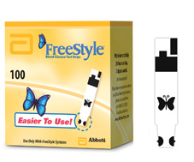

In a second related recall, the same is apparently true for the FreeStyle Flash and older FreeStyle blood glucose meters (both of which are no longer made), i.e. they “may produce erroneously low blood glucose results when using FreeStyle Lite and FreeStyle blood glucose test strips.”
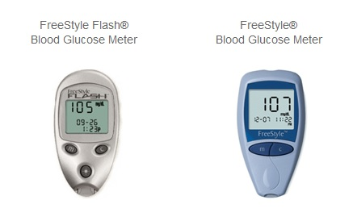

What should you do if you use any of these? Abbott is recommending that you discontinue use of the effected strips and meters immediately, and call for replacements:
- For the OmniPod Personal Diabetes Manager (PDM) - to receive replacement strips at no cost contact Abbott Diabetes Care Customer Service at 1-877-584-5159.
- We’re being told they’ll replace up to 400 strips immediately, and more can be replaced later once they have more supplies stocked up.
- When you call, be ready with the following information: test strip info (lot numbers and expiration), the pharmacy you get your test strips from (phone and location), your insurance info, and the phone and address of your doctor.
- Authorities tells us that you can and should continue using your OmniPod to deliver insulin, as the system is not compromised in any way.
- “While waiting for your replacement strips to arrive, use the FreeStyle Freedom blood glucose meter that you may have previously received with your welcome pack. FreeStyle test strips when used the FreeStyle Freedom blood glucose meter will produce accurate blood glucose results,” Abbott states on their website.
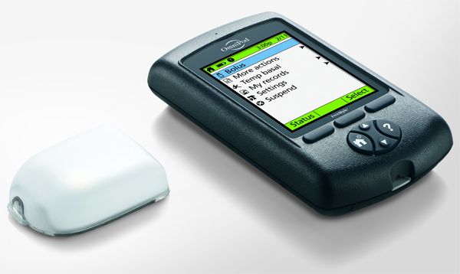

For the FreeStyle Flash or FreeStyle meters – call Abbott Diabetes Care Customer Service at 1-888-345-5364 to have Abbott send you a new FreeStyle-branded meter at no charge.

“If the only meter you have available is a FreeStyle or FreeStyle Flash, do not stop testing your blood glucose. Control solution should be used to check the performance of your test strips and meter until you receive your replacement meter. However, if any reading from a strip appears lower than you would expect or does not seem to match the way you are feeling, you should contact your health care provider. Pay special attention to signs and symptoms of high blood sugar (hyperglycemia),” Abbott states.

People are also being told to use the alternative FreeStyle Freedom meters, if they have one.

What’s the Deal?
We haven’t been able to get any substantive response from Abbott Diabetes Care as of mid-afternoon today, but did connect with Insulet’s manager of consumer marketing Hjalte Hojsgaard, who says they are working with Abbott to mail out physical letters to all of their customers today (Friday, Feb. 21)

“We would have liked to get the letter out even sooner, and get the word out on our website and social media, but these things sometimes take some time. It really is an issue with the Abbott strips so the ball is mainly in their court… But we’re working hard to make sure all of our OmniPod customers get the information they need,” Hojsgaard said.

He explained that the issue is strictly with the test strips used in the built-in Abbott glucose meters on both the older-generation blue OmniPod PDM and the newer black model. The glucose meter itself works fine, but an entire run of test strips has been identified to have a defect that can cause false low readings.

Newer models of Abbott glucose meters apparently have the capability to “eliminate the noise” caused by these test strips. But models developed earlier — including the meter in the OmniPod system and the FreeStyle Flash and older basic FreeStyle meter — do not. This is why Abbott is issuing two separate recalls; from their side, it’s easier to simply upgrade customers to a newer meter model, but since the OmniPod has the meter built-in, the solution there is to replace customers’ current stores of test strips.

This post will be updated as new details come in.
Posted in:
OmniPod
Tagged:
Abbott Diabetes
Abbott Diabetes Care
Abbott Diabetes recalls
Abbott Freestyle Flash
Abbott Freestyle recall
Abbott FreeStyle recalls
Abbott FreeStyle test strip recall
Abbott recall, blood glucose
blood sugar
diabetes community
diabetes devices
diabetes management
diabetes product recall
diabetes recalls, ePatients
FreeStyle
FreeStyle recall
FreeStyle test strips
glucose meter recall
Insulet
Insulet and Abbott Diabetes
OmniPod
OmniPod PDM
OmniPod test strip recall
product recall
recall
recall notices
test strip recall
########
IMPORTANT: URGENT PRODUCT RECALL
FreeStyle® Blood Glucose Monitoring System
February 19, 2014

Dear Valued OmniPod® Customer,

Recently, it has come to our attention that FreeStyle® Blood Glucose Test Strips may produce erroneously low blood glucose results when using the FreeStyle® blood glucose meter built into the OmniPod® Insulin Management System. Erroneously low blood glucose results that are not recognized may pose significant risks to your health.

Please take the following steps:
- If you are using the FreeStyle® Blood Glucose Meter built into the OmniPod Personal Diabetes Manager (PDM), you must discontinue use of any FreeStyle® Blood Glucose Test Strips you may have until you obtain replacement strips from Abbott Diabetes Care. To receive replacement strips at no cost contact Abbott Diabetes Care Customer Service at 1-877-584-5159.
- Continue using your OmniPod Insulin Management System (OmniPod) to deliver your insulin therapy. While waiting for your replacement strips to arrive, use the FreeStyle® Freedom blood glucose meter that you may have previously received with your welcome pack. FreeStyle® test strips when used the FreeStyle® Freedom blood glucose meter will produce accurate blood glucose results. If you would like to continue using the OmniPod system to recommend dosing, follow your OmniPod® Insulin Management System instructions for manually entering blood glucose readings. As always, control solution should be used to check the performance of your test strips and meter until you receive your replacement test strips. If any reading from a strip appears lower than you would expect or does not seem to match the way you are feeling, you should contact your health care provider immediately. Pay special attention to signs and symptoms of high blood sugar (hyperglycemia). Symptoms of high blood sugar may include: Excessive thirst, excessive urination, blurred vision, weakness, nausea, vomiting, and abdominal pain. If you are experiencing any of these symptoms or are not feeling well, contact your health care professional immediately.
- Abbott Diabetes Care will provide further information when you call on the process to obtain your test strips going forward. FreeStyle® Blood Glucose Test Strips are the only strip type that is approved for use with your OmniPod® Insulin Management System. Please read your product information booklet and test strip insert carefully to ensure that you are using the correct test strip type for your OmniPod® Insulin Management system. OmniPod® Insulin Management System is not labeled for use with FreeStyle Lite® Blood Glucose Test Strips.

We recognize the importance of blood glucose testing and are committed to responding quickly to customers' requests for replacement test strips.

We want to assure you that our first priority is you, our customer. We sincerely regret any inconvenience this situation may cause. If you have any further questions, please call Abbott Diabetes Care Customer Service.
Sincerely,
Kelly E. Duffy
Division Vice President
Quality Assurance and Compliance
Abbott Diabetes Care
########
February 19, 2014
Dear Valued Customer,

Recently, it has come to our attention that FreeStyle Flash® and FreeStyle® Blood Glucose Meters may produce erroneously low blood glucose results when using FreeStyle Lite® and FreeStyle® Blood Glucose Test Strips. Erroneously low results that are not recognized may pose significant risks to your health.

No action is required if you do not use the meters pictured below.
FreeStyle Flash® FreeStyle®
Blood Glucose Meter Blood Glucose Meter

If you are currently using either of the meters pictured above, please take the following steps:
- Discontinue use of your FreeStyle Flash® or FreeStyle® Blood Glucose Meter and call Abbott Diabetes Care Customer Service at 1-888-345-5364. When you call, Abbott will send you a new FreeStyle® branded meter at no charge.
- If the only meter you have available is a FreeStyle® or FreeStyle Flash® Blood Glucose Meter, do not stop testing your blood glucose. Control solution should be used to check the performance of your test strips and meter until you receive your replacement meter. However, if any reading from a strip appears lower than you would expect or does not seem to match the way you are feeling, you should contact your health care provider. Pay special attention to signs and symptoms of high blood sugar (hyperglycemia).
- Symptoms of high blood sugar may include: Excessive thirst, excessive urination, blurred vision, weakness, nausea, vomiting, and abdominal pain. If you are experiencing any of these symptoms or are not feeling well, contact your health care professional immediately.
- Upon receiving your new replacement meter, please immediately dispose of your old meter in accordance with your local and state disposal regulations.

There are no other Abbott Diabetes Care products impacted by this issue.

A test strip insert is included with every carton of FreeStyle® and FreeStyle Lite® Blood Glucose Test Strips, and provides very important product information. Please read your test strip insert carefully to ensure that you are using the correct test strip type for your Blood Glucose Meter.

We recognize the importance of blood glucose testing and are committed to responding quickly to your needs. We want to assure you that our first priority is you, our customer. We sincerely regret any inconvenience this situation may cause.

We thank you for your continued support of the FreeStyle Blood Glucose Monitoring System and Abbott Diabetes Care. If you have any further questions, please call Abbott Diabetes Care Customer Service.
Sincerely,
Kelly E. Duffy
Division Vice President,
Quality Assurance and Compliance
Abbott Diabetes Care

Response
Keith Brooks February 21, 2014 at 3:10 pm
This is nothing new. Freestyle meters and strips haven’t read correctly since at least 2009. In 2009 my insurance switched from covering Lifescan meters to Freestyle meters. Once I started using their meters, I had frequent EMT visit’s. The meters always read my blood sugar as being 100+ higher, than what it actually was. The meter and strips passed their control solution tests. However, I was overdosing myself on insulin due to false high readings. I went back to Lifescan, after my doctor and I complained to my insurance and gave them EMT and emergency room records. Abbott products are worthless and I’ll never use them again.

Abbott Blood Glucose Product Line
Abbott Therasense
- FreeStyle Lite Meter
- FreeStyle Freedom Lite Meter
- FreeStyle Lite Test Strips
- FreeStyle InsuLinx Meter
- FreeStyle InsuLinx Test Strips

Abbott Medisense
- Precision Xtra Meter
- Precision Xtra Glucose Test Strips

