ABBOTT DEBUTS FLASH GLUCOSE MONITORING, A NEW ALTERNATIVE TO FINGERSTICKS
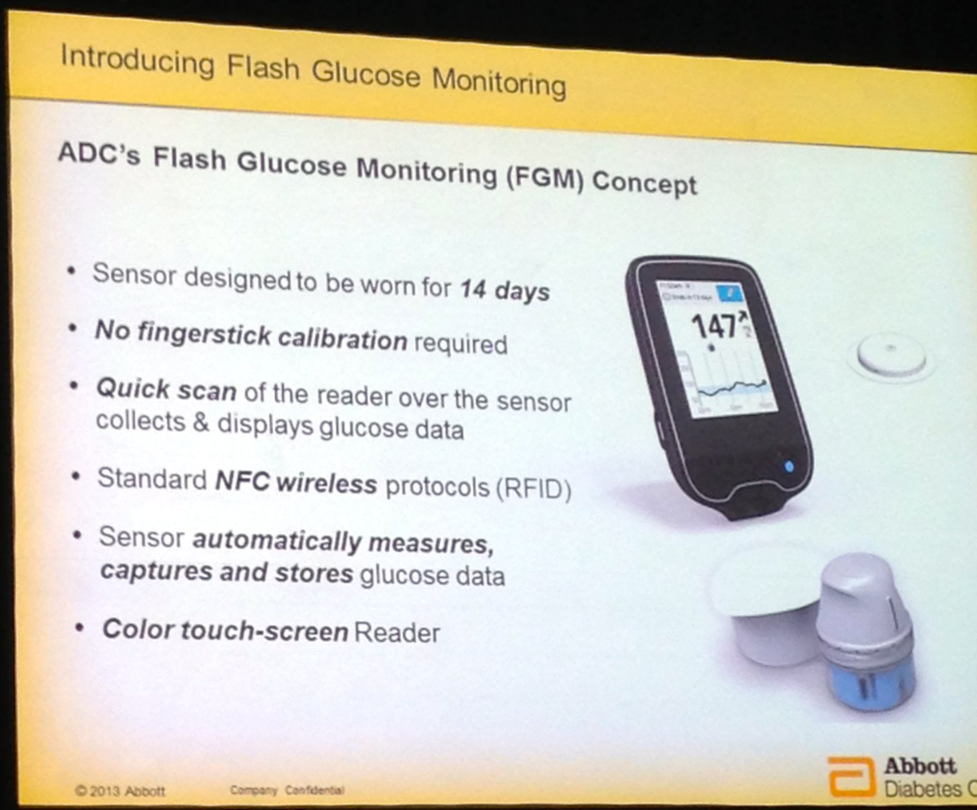

At the recent 2013 European Association for the Study of Diabetes (EASD) conference, Abbott debuted a new diabetes technology category called Flash Glucose Monitoring. Abbott’s investigational Flash Glucose Monitoring system is designed as an alternative to traditional blood glucose monitoring; instead of requiring traditional fingersticks, it collects continuous glucose data to enable generation of an advanced software report called the Ambulatory Glucose Profile (learn more here).
The Flash Glucose Monitoring system will involve use of a glucose sensor worn on the skin (like current CGM) for up to 14 days and a wireless touchscreen reader device. The patch worn on the body that contains the sensor is silver dollar-sized and about a finger-width thick. Users scan the touchscreen reader over the sensor patch to get their real-time sensor glucose value, a glucose trend arrow, and a trend graph showing the last eight hours. The system will be calibrated at the factory, meaning users will not need to enter any fingerstick values for calibration – this could be quite a game-changer if all goes well, as well as quite an engineering and manufacturing feat!
One difference between the new system and traditional CGM (e.g., Dexcom G4 Platinum, Medtronic Sof-Sensor/Enlite, Abbott FreeStyle Navigator) is that Abbott’s device will not have alarms, since data is not continuously sent to the reader device; the user must physically scan the reader over the patch to obtain real-time glucose data. The system is designed as an improvement over traditional blood glucose monitoring as well as overcoming some of the limitations of CGM (e.g., cost, need for calibration). One important note - it will be downloadable for both PC and Mac users, allowing creation of the Ambulatory Glucose Profile report.
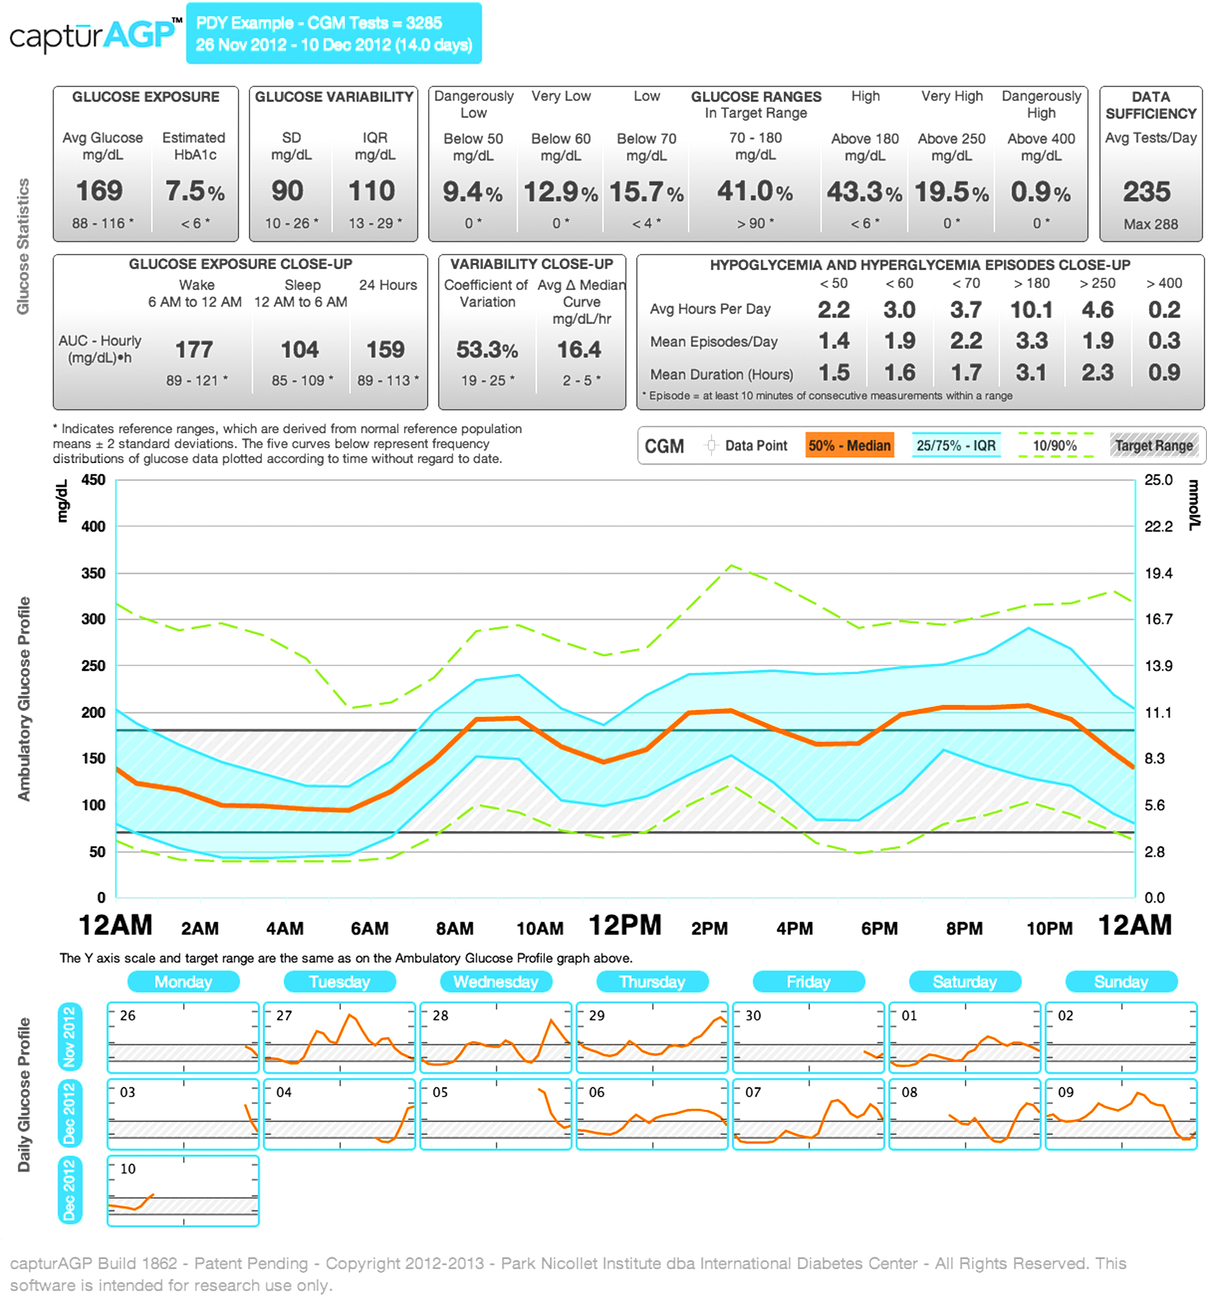
We look for the Flash Glucose Monitoring system to be available in Europe as soon as the second half of 2014. While there is no current timeline for the United States, we are hopeful Abbott will bring the product to the US. To learn more, you can visit Abbott’s website here and watch their presentation at EASD 2013 on the Ambulatory Glucose Profile and New Sensor Technology here.
Notably, the system would enable people to check their glucose many times without the limitations of traditional blood glucose monitoring (e.g., pain, visibility, incomplete data, and the cost of paying for every strip). The last will be important given increasing limitations on the number of strips available for people with diabetes to use. The Flash system could be particularly valuable for children and the elderly, who may feel the pain of fingersticks more than others, pregnant women who (ideally) test at least ten times per day, and hospital patients. People with prediabetes would also benefit from more frequent checks to monitor the progression of prediabetes and learn about what makes their glucose levels increase. The product’s associated software enables data collection for a Ambulatory Glucose Profile, which should make it much easier for patients to optimize their diabetes management using continuous glucose data – the example reports look to be quite well designed, straightforward, and full of actionable data. The biggest unanswered questions will be related to cost and pricing – we look forward to learning more on this front over the next year. –AB/KC

